Gregory Capobianco
Online C&S Gal & Dancig: FN 66–97
Editor: Jenna Cohen

Comments:
Relevant portions of a source that support the proposition are highlighted in green.
The directly relevant page numbers are highlighted in red.
Those pages before and after the supporting information are highlighted in yellow in order to mark the beginning and end of the excerpted sources.

The authors have a tendency to cite sources generally. This makes sense when the overriding idea of a source isn’t contained on any one page, but other times, it seems like a pin cite would be more appropriate. For those situations, I highlighted the specifically relevant portion, however, I did not modify the citation to make it a pin cite, in deference to the authors’ style. The authors have demonstrated that they do pin cite sometimes, so I am assuming that there is some reason they chose not to pin cite other sources.

There are multiple library retrievals:

FN67 Andrew Ashworth, Principles of Criminal Law 18 (6th ed. 2009)

FN68.1 Joel Feinberg, Doing and Deserving: Essays in the Theory of Responsibility 98 (1970)

FN72.1 Heather Strang, Repair or Revenge: Victims and Restorative Justice (2002)

FN76 Rashmi Goel, Aboriginal Women and Political Pursuit in Canadian Sentencing Circles: At Cross Roads or Cross Purposes?, in Restorative Justice and Violence Against Women 60 (James Ptacek ed., 2010)

FN79.2 Ezzat A. Fattah, A Critical Assessment of Two Justice Paradigms: Contrasting the Restorative and Retributive Justice Models, in Support for Crime Victims in a Comparative Perspective 99 (Ezzat A. Fattah & Tony Peters eds., 1998)

FN79.3 Howard Zehr, Changing Lenses: A New Focus for Criminal Justice (1990)

FN84 Mimi Kim, Alternative Interventions to Intimate Violence: Defining Political and Pragmatic Challenges, in Restorative Justice and Violence Against Women 196 (James Ptacek ed., 2010)

FN87 Lode Walgrave, Restorative Justice, Self-Interest and Responsible Citizenship 76 (2008)

FN90 George P. Fletcher, The Grammar of Criminal Law: Foundations, at ch. 5.3 (2007)

FN93.1 Martin Wright, Justice for Victims and Offenders: A Restorative Response to Crime, 133-135 (2d ed., 1996)

FN94 Lode Walgrave, Restorative Justice for Juveniles: Just a Technique or a Fully Fledged Alternative? 34 Howard Journal 228 (1995)

There are two sources for which I did not file a true library retrieval, because there is no place I could locate the source. I nonetheless entered a library retrieval without information as to where the source could be found.

FN74.1 See, e.g., Madelaine Adelman, Edna Erez & Nadera Shalhoub-Kevorkian, Policing Violence Against Minority Women in Multicultural Societies: “Community” and the Politics of Exclusion, 7 Police & Soc’y 105 (2003) (describing the complexity of policing domestic violence in Arab communities);

FN88 Robert White, Social Justice, Community Building and Restorative Strategies, 3 Contemp. Just. Rev. 55 (2000).

Gregory Capobianco, FN 66.1

FN 66.1: Braithwaite, supra note 56, at 123.

Referring To: John Braithwaite, Restorative Justice: Assessing Optimistic and Pessimistic Accounts, 25 Crime. Justice. 1, 60 (1999).

Comment: This pin cite is almost certainly wrong. Page 123 is the section of the Article where the author lists the academic references they made—there is nothing substantive on the page. I tried searching in the entire article for something that would support the authors’ proposition about needing to move towards more coercive measures if prevention does not materialize, but I could not find anything. Pages 53–56 is more on point regarding prevention, but nothing there directly supports the proposition, either.

There is also no other Braithwaite source that the Authors may have meant to supra to, which may have had a more relevant page 123.

Source Information:

25 Crime & Just. 1, *

Copyright (c) 1999 The University of Chicago
Crime and Justice
1999
25 Crime & Just. 1
LENGTH: 56203 words
ARTICLE: Restorative Justice: Assessing Optimistic and Pessimistic Accounts
NAME: John Braithwaite
[*122] Pontell, Henry. 1978. "Deterrence: Theory versus Practice." Criminology 16:3-22.
Posner, Richard A. 1977. Economic Analysis of Law. 2d ed. Boston and Toronto: Little, Brown.
Pranis, K. 1996. "A State Initiative toward Restorative Justice: The Minnesota Experience." In Restorative Justice: International Perspectives, edited by B. Galaway and J. Hudson. Monsey, N.Y.: Criminal Justice Press.
Pratt, John. 1996. "Colonization, Power and Silence: A History of Indigenous Justice in New Zealand Society." In Restorative Justice: International Perspectives, edited by Burt Galaway and Joe Hudson. Monsey, N.Y.: Criminal Justice Press.
Reed, P. 1986. "Developmental Resourcesand Depression in the Elderly." Nursing Research 36:368-74.
---. 1987. "Spirituality and Well-Being in Terminally Ill Hospitalized Adults." Research in Nursing and Health 10:335-44.
---. 1992. "An Emerging Paradigm for the Study of Spirituality in Nursing." Research in Nursing and Health 15:349-57.
Rees, Joseph V. 1988. Reforming the Workplace: A Study of Self-Regulation in Occupational Safety. Philadelphia: University of Pennsylvania Press.
---. 1994. Hostages of Each Other: The Transformation of Nuclear Safety since Three Mile Island. Chicago: University of Chicago Press.
Rensselaer, W. L., III. 1992. "Colombia's Cocaine Syndicates." In War on Drugs: Studies in the Failure of U.S. Narcotics Policy, edited by A. McCoy and A. Block. Boulder, Colo.: Westview.
Retzinger, Suzanne. 1991. Violent Emotions. Newbury Park, Calif.: Sage.
Retzinger, Suzanne, and Thomas J. Scheff. 1996. "Strategy for Community Conferences: Emotions and Social Bonds." In Restorative Justice: International Perspectives, edited by Burt Galaway and Joe Hudson. Monsey, N.Y.: Criminal Justice Press.
Rigby, Ken. 1996. Bullying in Schools and What to Do about It. Melbourne: Australian Council for Educational Research.
Rigby, Ken, Alison Whish, and Garry Black. 1994. "School Children's Peer Relations and Wife Abuse." Criminology Australia (August), pp. 8-12.
Roach, Kent. 1999. Due Process and Victims' Rights: The New Law and Politics of Criminal Justice. Toronto: University of Toronto Press.
Roberts, Julian V., and Loretta J. Stalans. 1997. Public Opinion, Crime, and Criminal Justice. Boulder, Colo.: Westview.
Robertson, Jeremy. 1996. "Research on Family Group Conferences in Child Welfare in New Zealand." In Family Group Conferences: Perspectives on Policy and Practice, edited by Joe Hudson, Allison Morris, Gabrielle Maxwell, and Burt Galaway. Sydney: Federation Press and Criminal Justice Press.
Ross, Rupert. 1996. Returning to the Teachings: Exploring Aboriginal Justice. London: Penguin.
Rumsey, Alan. 1999. "Women as Peacemakers in the New Guinea Highlands: A Case from the Nebilyer Valley, Western Highlands Province?" In Reflections on Violence in Melanesia, edited by Sinclair Dinnen and Allison Ley. Sydney: Federation Press.
[*123] Sandor, Danny. 1993. "Juvenile Justice: The Thickening Blue Wedge." Alternative Law Journal 18:104-8.
Scheff, Thomas J. 1990. Microsociology: Discourse, Emotion, and Social Structure. Chicago: University of Chicago Press.
---. 1994. Bloody Revenge: Emotions, Nationalism and War. Boulder, Colo.: Westview.
Scheff, Thomas J., and Suzanne M. Retzinger. 1991. Emotions and Violence: Shame and Rage in Destructive Conflicts. Lexington, Mass.: Lexington Books.
Scheingold, Stuart A., Jana Pershing, and Toska Olson. 1994. "Sexual Violence, Victim Advocacy, and Republican Criminology: Washington State's Community Protection Act." Law and Society Review 28(4):501-33.
Schiff, Mara F. 1998. "The Impact of Restorative Interventions on Juvenile Offenders." In Restoring Juvenile Justice, edited by Lode Walgrave and Gordon Bazemore. Monsey, N.Y.: Criminal Justice Press.
Schneider, A. 1986. "Restitution and Recidivism Rates of Juvenile Offenders: Results from Four Experimental Studies." Criminology 24:533-52.
---. 1990. Deterrence and Juvenile Crime: Results from a National Policy Experiment. New York: Springer-Verlag.
Scholz, John T., and Wayne B. Gray. 1990. "OSHA Enforcement and Workplace Injuries: A Behavioral Approach to Risk Assessment." Journal of Risk and Uncertainty 3:283-305.
Sessar, Klaus. 1990. "Tertiary Victimisation: A Case of the Politically Abused Crime Victims." In Criminal Justice, Restitution and Reconciliation, edited by B. Galaway and J. Hudson. Monsey, N.Y.: Willow Tree.
---. 1998. "Punitive Attitudes of the Public: Reality and Myth." In Restoring Juvenile Justice, edited by Lode Walgrave and Gordon Bazemore. Amsterdam: Kugler.
Sessar, K., A. Beuerskens, and K. Boers. 1986. "Wiedergutmachung als Konfliktregelungsparadigma?" Kriminologisches Journal 18:86-105.
Shapland, J., J. Willmore, and P. Duff. 1985. Victims in the Criminal Justice System. Cambridge Studies in Criminology. Brookfield, Vt.: Gower.
Shearing, Clifford. 1995. "Reinventing Policing: Policing as Governance." In Privatisierung staatlicher Kontrolle: Befunde, Konzepte, Tendenzen. Interdisziplinare Studien zu Recht und Staat 3:69-88.
---. 1997. "Violence and the Changing Face of Governance: Privatization and Its Implications." Cape Town: Community Peace Foundation.
Sherman, L. W. 1992. Policing Domestic Violence. New York: Free Press.
---. 1993. "Defiance, Deterrence and Irrelevance: A Theory of the Criminal Sanction." Journal of Research in Crime and Delinquency 30:445-73.
Sherman, L. W., and G. Barnes. 1997. "Restorative Justice and Offenders' Respect for the Law." RISE Working Paper no. 3. Canberra: Australian National University, Research School of Social Sciences, Law Program.
Sherman, Lawrence, Denise Gottfredson, Doris MacKenzie, John Eck, Peter Reuter, and Shawn Bushway. 1997. Preventing Crime: What Works, What Doesn't, What's Promising: A Report to the United States Congress. Washington, D.C.: National Institute of Justice.
Sherman, L. W., and H. Strang. 1997a. "The Right Kind of Shame for Crime [*124]

Gregory Capobianco, FN 66.2

FN 66.2: Many abolitionists hold a similar view. See Jim Thomas & Sharon Boehlefeld, Rethinking Abolitionism: “What Do We Do with Henry?” Review of de Haan, the Politics of Redress, 18 Social Justice 239 (1991).

Comment: The Article is said to have been published in 1991, though that is not clear from the pages of the Article itself. However, the journal’s website (http://www.socialjusticejournal.org/fliers/18-3flier.html) confirms that it was published in that year.

As for the title in the citation, because “The Politics of Redress” is italicized in the actual title, I changed it back to plain text in the citation, in order to distinguish it from the rest of the title that is otherwise italicized.

Source Information:

URL: http://www.jstor.org/stable/29766631

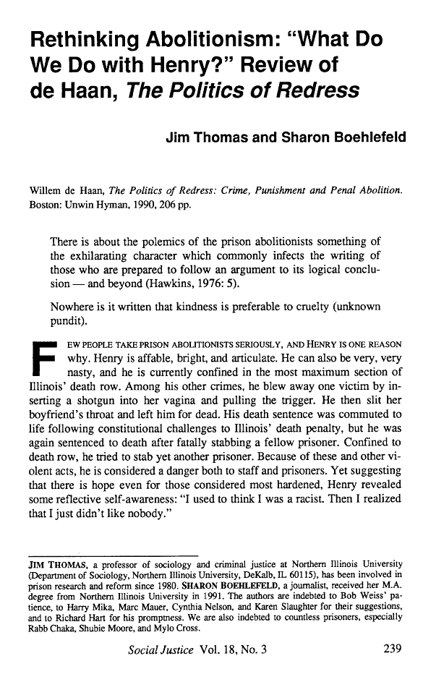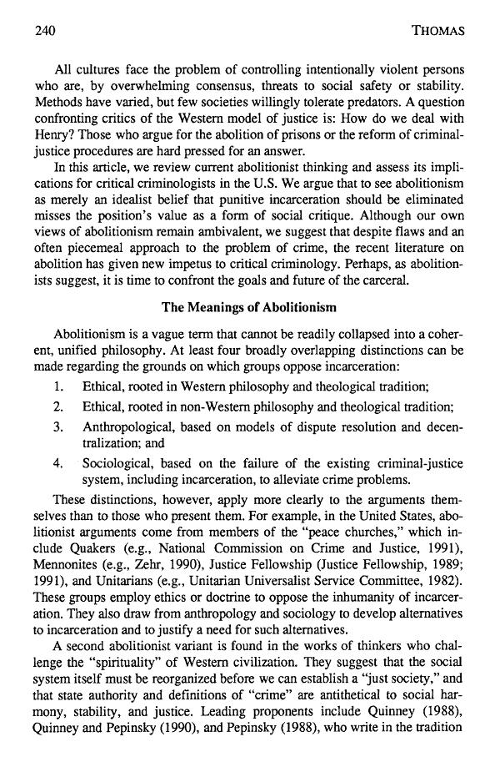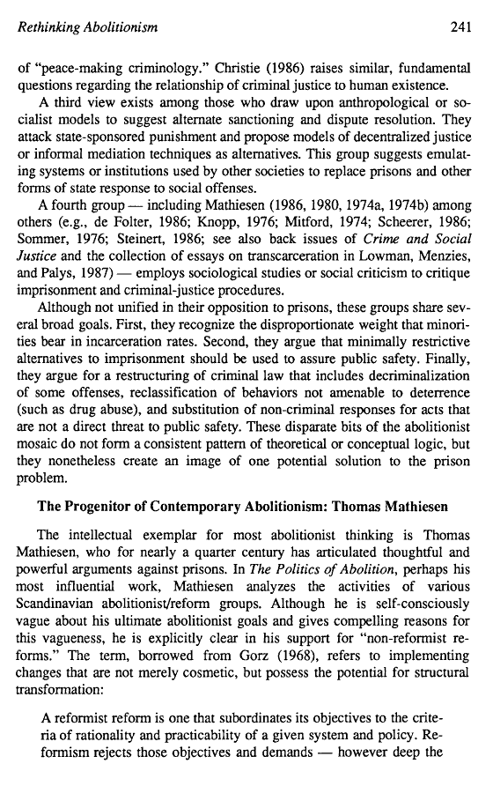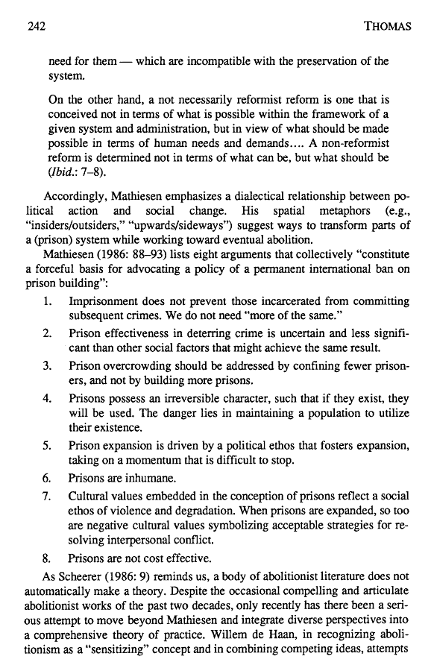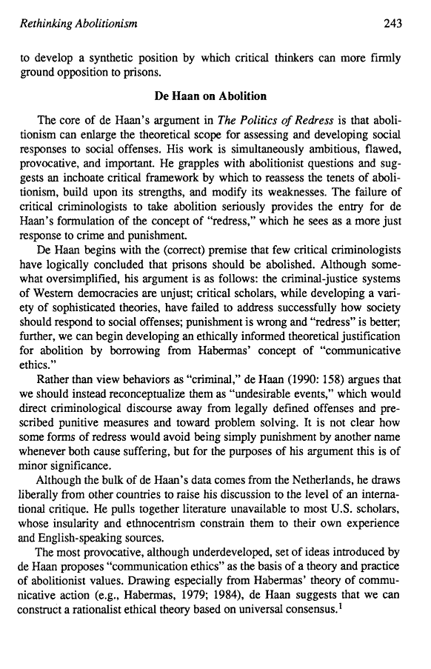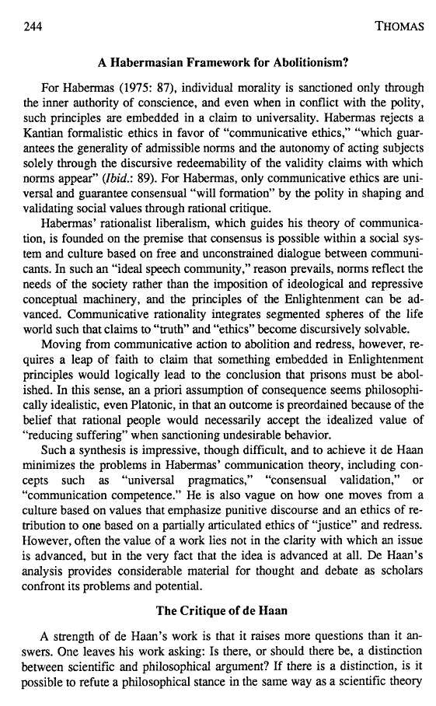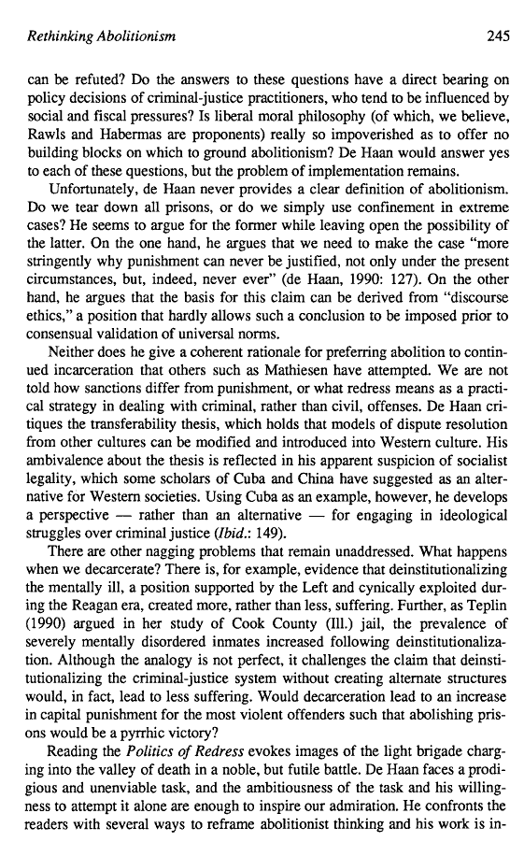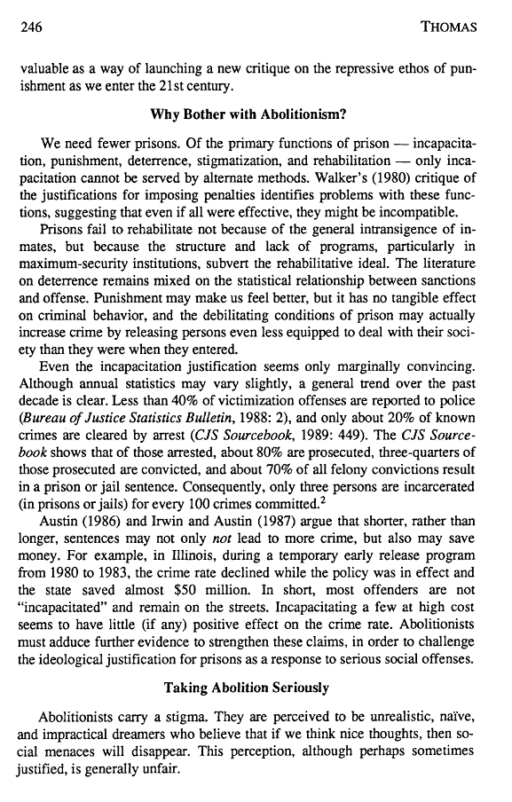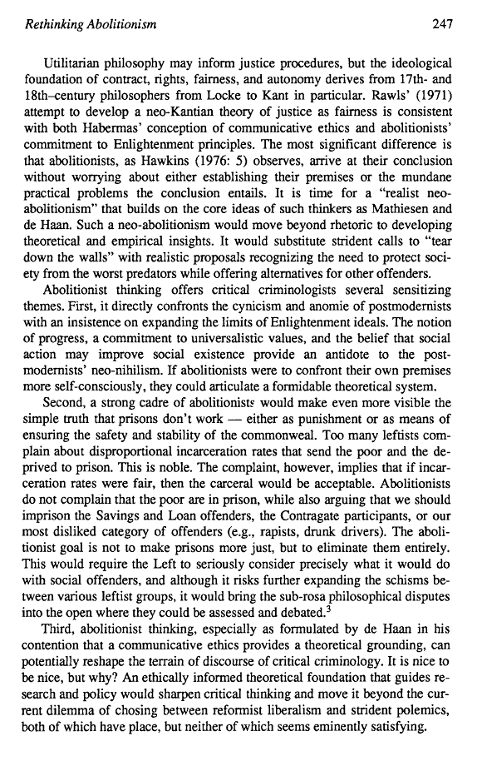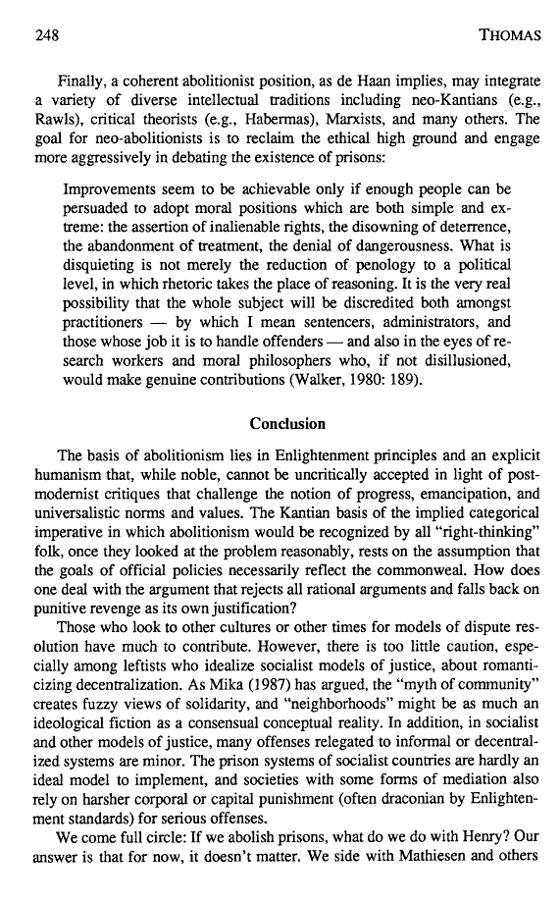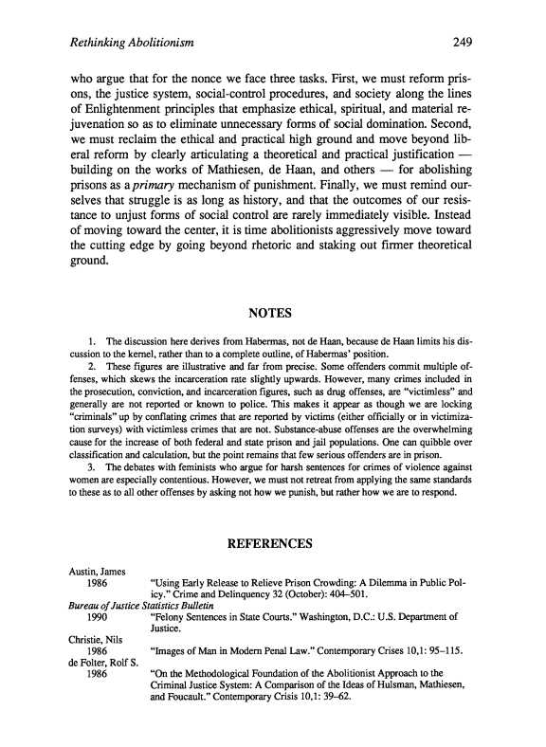

Gregory Capobianco, FN 67

FN 67: Andrew Ashworth, Principles of Criminal Law 18 (6th ed., 2009).

Comment: I have filed a library retrieval for this source.

Gregory Capobianco, FN 68.1

FN 68.1: See, e.g., Feinberg, supra note 44, at 98-99;

Referring To: Joel Feinberg, Doing and Deserving: Essays in the Theory of Responsibility 98 (1970) (proposing the term “hard treatment”).

Comment: This appears to be a book, which means the author’s name should be in small caps. But since I wasn’t able to locate this source, I’m not entirely certain.

I have filed a library retrieval for this source.

Gregory Capobianco, FN 68.2

FN 68.2: Kyron Huigens, Punishment and Crime: On Commonplace Punishment Theory, 2005 U. Chi. Legal F. 437, 441.

Comment: The highlighted portion only weakly supports the proposition. However, nothing else in the Article, even beyond the pin cited page, is any better. Assuming that it is not accidental that the authors cited to this Article, I believe the highlighted page is what best supports their above the line text.

Source Information:

URL: https://a.next.westlaw.com/Document/Id7bc67c04b2a11db99a18fc28eb0d9ae/View/FullText.html?transitionType=UniqueDocItem&contextData=(sc.Search)

2005 U. Chi. Legal F. 437
University of Chicago Legal Forum
2005
Punishment and Crime
Article
ON COMMONPLACE PUNISHMENT THEORY
Kyron Huigens^{d1}
Copyright © 2005 University of Chicago; Kyron Huigens

*440 questions, there are at least three major traditions in philosophical ethics on which we might want to draw for such explanations: utilitarianism or, more broadly, consequentialism; the deontological morality most prominently advocated by Immanuel Kant; and the virtue ethics of Aristotle and his philosophical heirs.⁷ Looking at punishment theory from this perspective, three important points can be made. First, punishment's justification by a particular end is not what defines theories of punishment. Much of commonplace punishment theory turns on the notion that a theory of punishment must take some one end of punishment as the primary justification of punishment, and that which end is chosen for this purpose defines each theory. For example, the so-called retributive theory of punishment says that punishment is justified by retribution,⁸ the so-called deterrence theory of punishment, says that punishment is justified by deterrence;⁹ and so on. But a more careful mapping shows that the field is more complex. For example, we can make connections between retribution as an end, consequentialism as a theory, and justification as an issue in need of explanation: consequentialism will deny that retribution has any justifying force—except perhaps indirectly through the consequence of public catharsis, which then becomes the consequentialist's reformulation of the end of retribution. Connections of this kind are concealed by conventional wisdom, which offers a choice between retribution as our theory and justification of punishment or deterrence as our theory and justification of punishment. At a minimum, to map things more carefully makes the point that whether or not retribution or deterrence is taken to justify punishment depends on the moral theory that is brought to bear on that function.
Second, this mapping reminds us that there is more work to be done by a theory of punishment than to answer the question about punishment's justification. The consequentialist needs to explain not only punishment's justification, but also the distinction between the practice of punishment and an instance of punishment, *441 particularly as the distinction bears on the nature of criminal wrongdoing and the meaning of proportionality in sentencing. Otherwise, it might appear that the deterrence theory of punishment authorizes imposing draconian penalties on scapegoats for the sake of maximum deterrence.¹⁰
Third, to distinguish end from theory can clarify each of the things so distinguished. The deontological theory of punishment justifies punishment by appeal to retribution: to take retribution on a wrongdoer is an unconditional duty.¹¹ This duty, of course, has nothing to do with vengeance. Retribution as an end of punishment is the restoration of a proper balance—of benefits and burdens¹² and of dignity¹³—between the offender, the victim, and society. Given that Kant's deontological moral theory is not the prevailing moral theory in our society, the deontological theory of punishment has never been very influential with lawyers, lawmakers, or judges. It hardly follows from this, however, that retribution ought to be rejected as an end of punishment or that retribution cannot be adduced as a justifying reason to punish under some other moral theory. And yet, retribution as an end of punishment has been chronically misconstrued as vengeance, and also has been rejected, in baby-bathwater fashion, along with the retributive theory of punishment.
Does this confusion matter? Of course it does. The most pressing issue in contemporary constitutional and criminal law is the validity of determinate sentencing schemes under the recent Supreme Court decisions Apprendi v New Jersey,¹⁴ Blakely v Washington,¹⁵and United States v Booker.¹⁶ This very lively controversy over the limits imposed on sentencing by the Sixth Amendment jury trial guarantee has exhibited both of the confusions *442 I mentioned just above. Some of the determinate sentencing systems, especially the Guidelines, impose draconian sentences. Any number of commentators have concluded that, because the sentences they impose are draconian, these schemes represent the triumph of a retributive theory of punishment.¹⁷ But while the draconian sentences handed out under these schemes might give vent to the public's urge to take revenge on criminals, they do not serve the aim of retribution. The imposition of a draconian penalty can upset the proper balance between society, the victim, and the offender just as surely as the crime itself has done.¹⁸ The point of reference for retribution is desert, and at least part of a draconian punishment is undeserved. Draconian punishments might often serve the end of revenge, but they will rarely, if ever, serve the end of retribution. Furthermore, the imposition of draconian sentences is not a victory for any theory of punishment, even if we grant the conflation of vengeance with retribution. To recognize the pursuit of retribution or vengeance as an end of punishment is insufficient to constitute a retributive theory of punishment, or even a vengeance theory of punishment. To identify one end of punishment hardly justifies punishment in the absence of some moral theory that can tell us whether and why it does so; and does not even make a start on answering other outstanding questions such as the nature of wrongdoing and its relationship to the excuses.
Second, consider a prominent disavowal of retribution as a theory of punishment that was mistakenly thought to entail the disavowal of retribution as an end of punishment. Stephen Breyer understands punishment well enough to have been the principal author of the Federal Sentencing Guidelines, and also well enough to recognize that retribution has to do with desert, not with vengeance.¹⁹But this is what he said about the theory of punishment that informs the Guidelines:
[S]ome students of the criminal justice system strenuously urged the Commission to follow what they call a *443

Gregory Capobianco, FN 69

FN 69: See Kahan, supra note 16 (discussing punishment having the function of reflecting the repugnance of the community, i.e., the “emotions of the community”).

Referring To: See Dan M. Kahan, The Anatomy of Disgust in Criminal Law, 96 Mich. L. Rev. 1621, 1641 (1998) (portraying crime as an act of communicating the offender’s disregard of social values).

Comment: The term “emotions of the community” do not appear in the source. But since this follows i.e., it should be fine.

Source Information:

URL: https://a.next.westlaw.com/Document/I6cf832215a2011dbbe1cf2d29fe2afe6/View/FullText.html?transahaitionType=UniqueDocItem&contextData=(sc.UserEnteredCitation)

96 Mich. L. Rev. 1621
Michigan Law Review
May, 1998
1998 Survey of Books Relating to the Law
IV. Legal Theory
THE ANATOMY OF DISGUST IN CRIMINAL LAW
The Anatomy of Disgust. By William Ian Miller. Cambridge, Mass.: Harvard University Press. 1997. Pp. 320. $24.95.
Dan M. Kahan^{a1}
Copyright (c) 1998 Michigan Law Review Association; Dan M. Kahan

*1640 sundry white collar crimes--and serve two years of jail time or less on average.⁶³ Criminologists of diverse ideologies have long opposed imprisoning offenders such as these on the grounds that it's unnecessary to incapacitate them and that their brand of criminality could be deterred just as well by alternative sanctions such as fines and community service.⁶⁴ But this shopworn case for alternative sanctions has made essentially no impression on legislators, judges, and sentencing commissioners.⁶⁵
The political resistance to alternative sanctions seems puzzling under the conventional theories of punishment. From an optimal deterrence point of view, the alternatives seem superior because they are just as effective and less costly to society.⁶⁶ Retribution insists that offenders be made to experience pain in strict proportion to the moral wrongness of their respective crimes, regardless of the effects of punishment.⁶⁷ But liberty deprivation isn't the only way to make offenders suffer; taking their property and appropriating their labor can do that, too. If we can translate short prison terms into equally painful fines or community service dispositions, retribution shouldn't as a conceptual matter foreclose alternative sanctions.⁶⁸ Indeed, if, as some argue, relatively well-to-do nonviolent offenders typically suffer more when imprisoned than down-and-out violent ones, then insisting that the former be imprisoned rather than fined or ordered to perform community service might inflict more pain on them for less serious crimes, in violation of the retributive norm of proportionality.⁶⁹
Elsewhere I've tried to solve the alternative sanctions puzzle with the expressive theory of punishment.⁷⁰ Punishment can't be reduced to the imposition of suffering. As Henry Hart long ago observed, a person can suffer just as much discomfort in the military as he can in prison, and yet only imprisonment--and not conscription--counts *1641 as “punishment,” because only imprisonment expresses moral condemnation.⁷¹ We expect punishment to voice our moral outrage, in addition to protecting us from harm and imposing deserved suffering. And that's the problem with fines and community service: they don't express condemnation, or at least don't express it as unequivocally as imprisonment.⁷²
But why is this the case? What determines whether a particular mode of affliction expresses condemnation or not? Obviously, there are many influences, most of which are likely to be a matter of historical happenstance.⁷³ But drawing on Miller, I want to argue in addition that the adequacy of a punishment along the expressive dimension will have a lot to do with whether it resonates with the public's disgust sensibilities.
On expressive grounds, serious crimes strike us as such--that is, as crimes and as serious--not just because they impair another's interests, but because they convey that the wrongdoer doesn't respect the true value of things.⁷⁴ To express condemnation, then, society must respond with a form of punishment that unequivocally evinces the community's repudiation of the wrongdoer's valuations. According to Miller, that's what we use “the idiom of disgust” for: “[i]t signals seriousness, commitment, indisputability, presentness, and reality” (p. 180); “it marks out moral matters for which we can have no compromise” (p. 194), harms “for which there could be no plausible claim of right” (p. 36). It follows that an expressively effective punishment must make clear that we are in fact disgusted with what the offender has done.
The conventional alternative sanctions don't do that. Fines, for example, seem to say that society is willing to put a price tag on a particular species of crime. That connotation is clearly incompatible with disgust: no morally upright person would consent to a disgusting act in exchange for cash! Community service, too, fails to evince disgust. Because we see nothing disgusting in repairing dilapidated low-income housing, educating the retarded, installing smoke detectors in old age homes, and the like, it's hard to see the seriousness and indisputability of society's commitment to condemning *1642 the behavior of offenders whom it sentences to engage in such services. Sensibilities like these are in fact commonplace.⁷⁵
Prison, in contrast, does unequivocally evince disgust in Miller's terms. By stripping individuals of liberty--a venerated symbol of individual worth in our culture--and by inflicting countless other indignities--from exposure to the view of others when urinating and defecating to rape at the hand of other inmates--prison unambiguously marks the lowness of those we consign to it. At the same time, imprisonment removes offenders from our midst, shielding us from their contaminating influence. Martha Grace Duncan emphasizes these themes in her recent work, Romantic Outlaws, Beloved Prisons,⁷⁶ which probes the social meanings of criminality and punishment. For her, it is popular disgust for criminals that explains the durability of the prison, which the public sees as “a suitably dark, filthy, and remote place” to dispose of the “filth” of criminality.⁷⁷
There's no reason to suppose, though, that imprisonment is the only form of punishment that evinces disgust. Duncan, for example, uses disgust sensibilities to explain Britain's establishment of a penal colony in Australia. Historians uniformly regard this policy as having been a grotesquely inefficient alternative to the simple expansion of prison space in Britain itself. But delving into the contemporaneous debates that surrounded this issue, Duncan shows how transporting criminals recommended itself to eighteenth and nineteenth century Englishmen because of its power to symbolize the nation's virtuous attempts to cleanse itself of “refuge” and “scum”--to expel, in Bentham's words, “the excrementitious mass” of criminality from the body politic.⁷⁸
For a contemporary disgust-evincing alternative to imprisonment, consider the revival of shaming penalties, which are now being used for a wide variety of common and white collar offenses that would otherwise be punished with imprisonment.⁷⁹ Such penalties typically involve an element of self-debasement: thus, burglars in Tennessee have been ordered to permit their victims to enter their homes and take items of the victims' choosing;⁸⁰ a New *1643

Gregory Capobianco, FN 70

FN 70: Kay Pranis, Conferencing and the Community, in Family Group Conferencing: New Directions in Community-Centered Child and Family Practice 40 (Gale Burford & Joe Hudson eds., 2000).

Source Information:

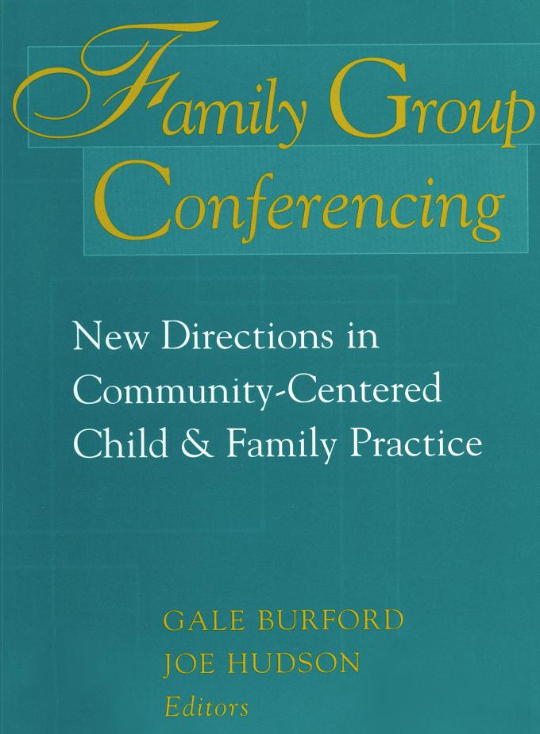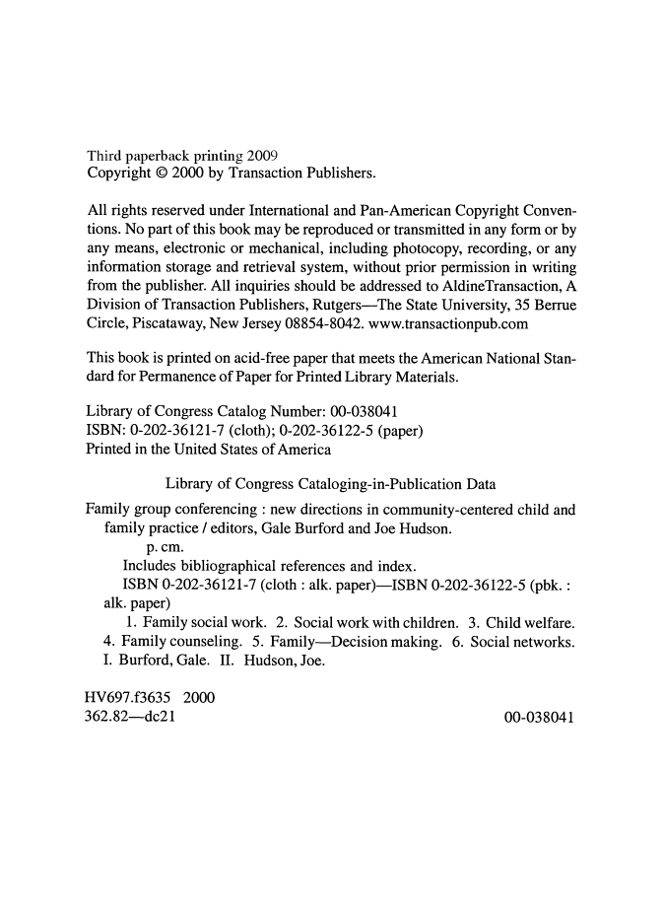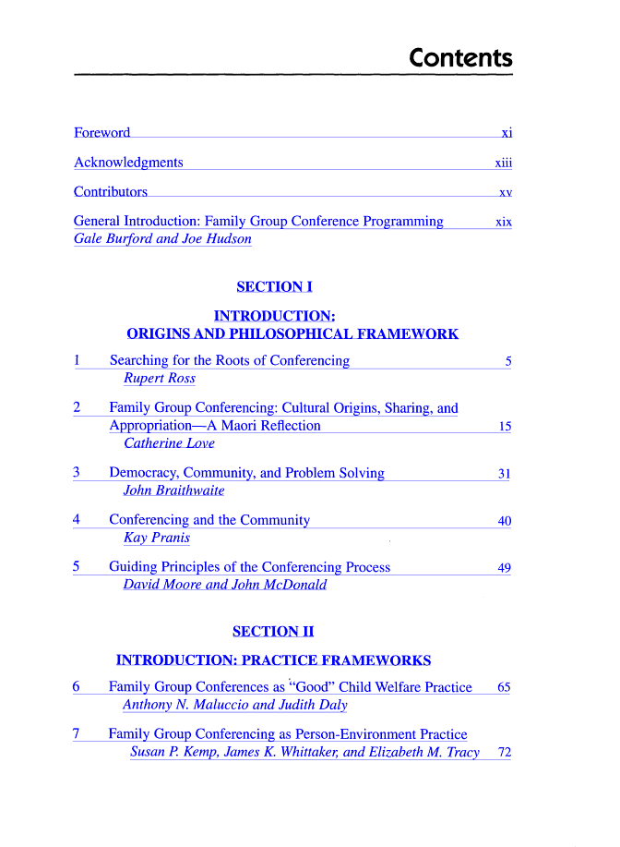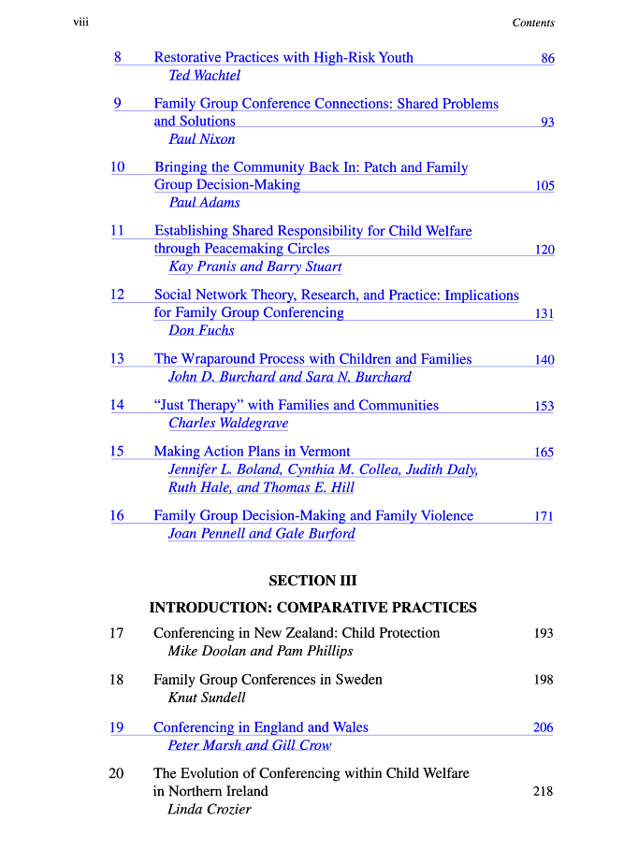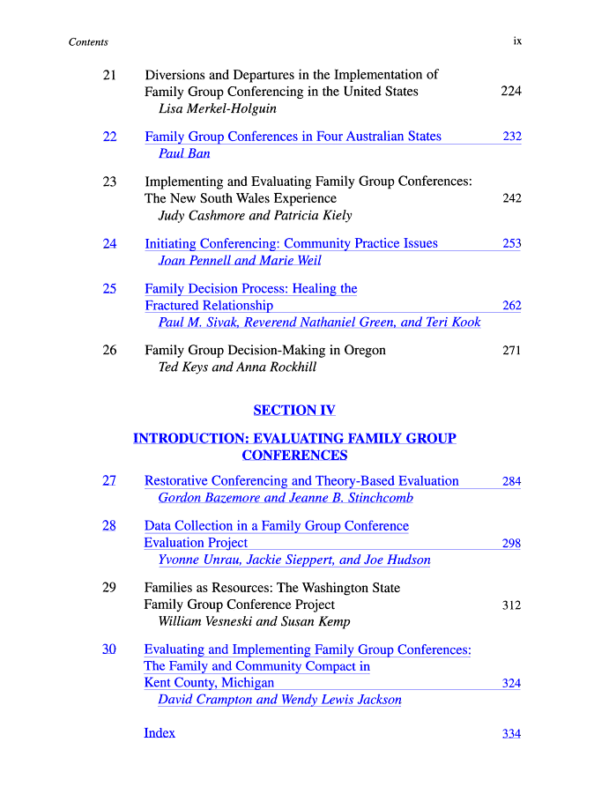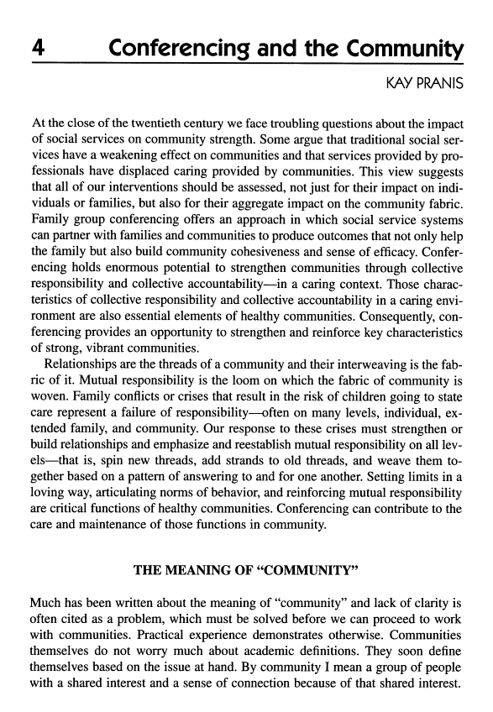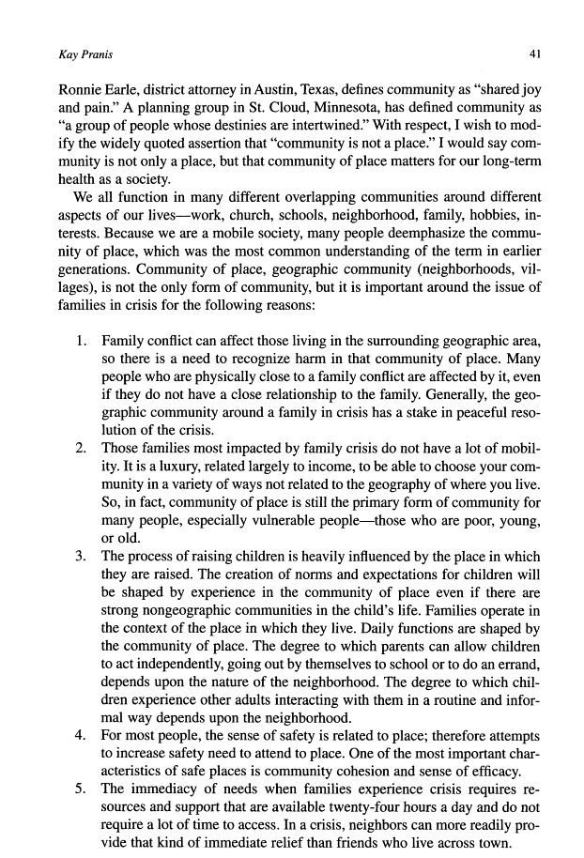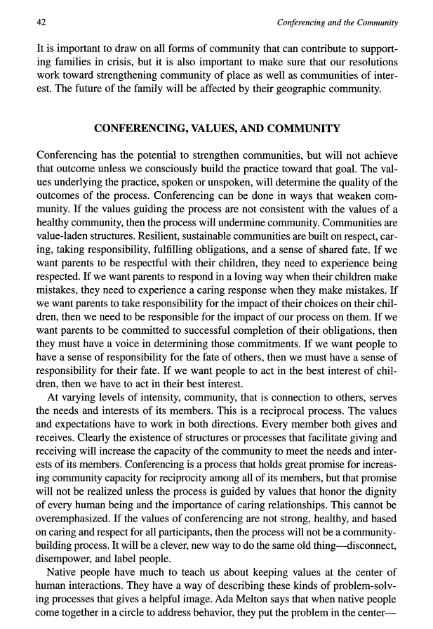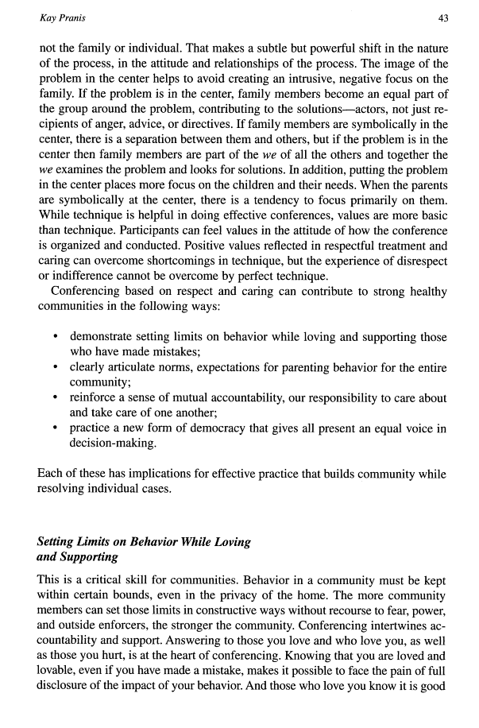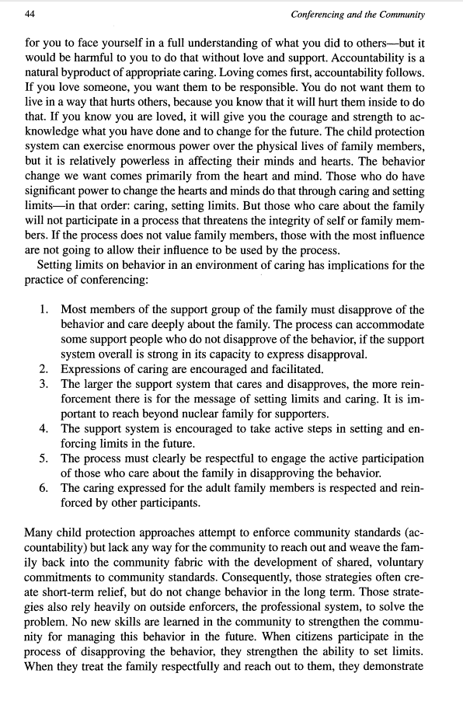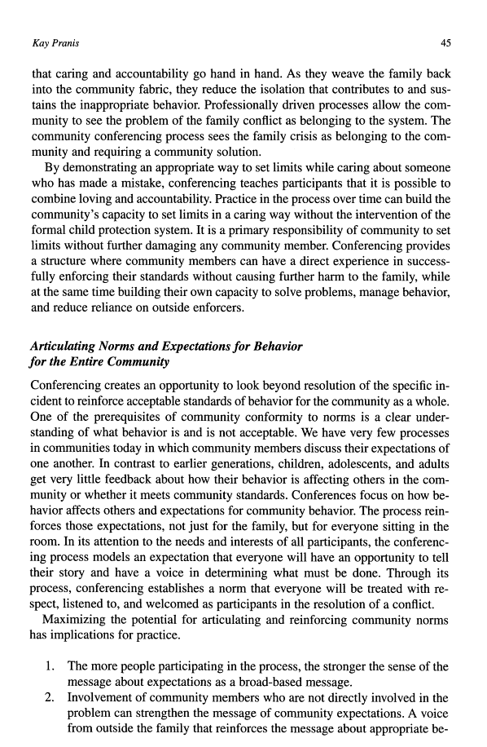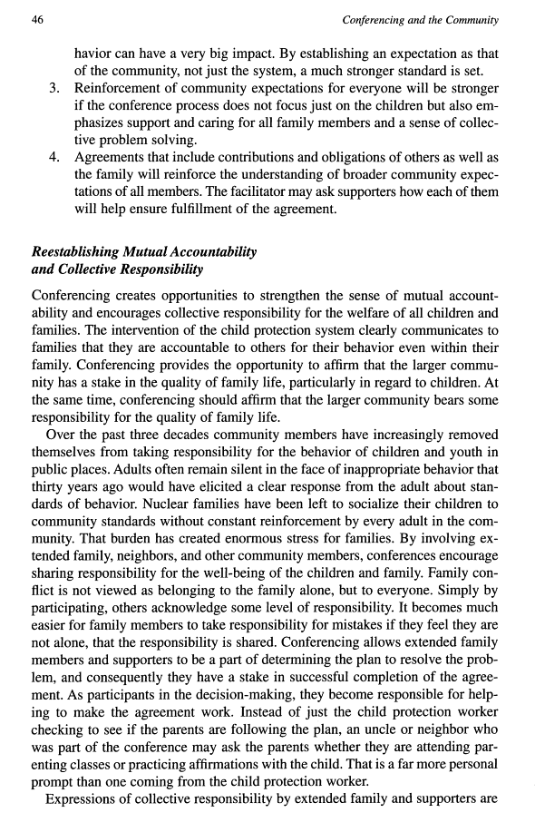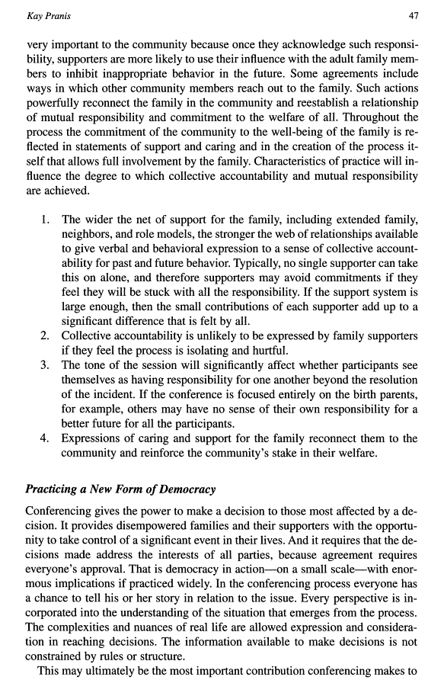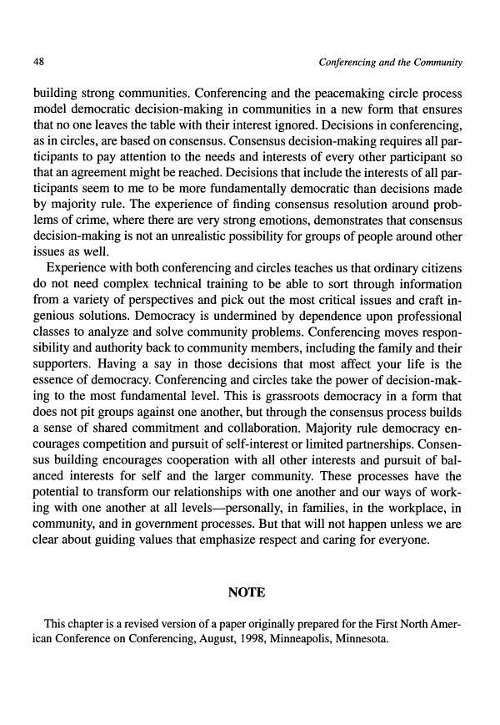

Gregory Capobianco, FN 71

FN 71: Barbara Hudson, Restorative Justice: The Challenge of Sexual and Racial Violence, 25 J. Law. Soc. 237 (1998) (emphasizing that the message is especially powerful when the reparation plan is backed by community and government services and supervised by the enforcement authorities).

Comment: The name of the journal is the Journal of Law and Society. I abbreviated the words according to Table 13, and then removed the space between “Journal” and “Law,” just as all of the “Journals of Law and _____” are styled.

For this source, I think the relevant text is found on page 252. In addition to the first 10 pages of the article, I also included the pages 251–53 and highlighted the important text. This is perhaps one of the sources that should be pin cited.

Source Information:

URL: http://www.jstor.org/stable/pdfplus/1410689.pdf?acceptTC=true

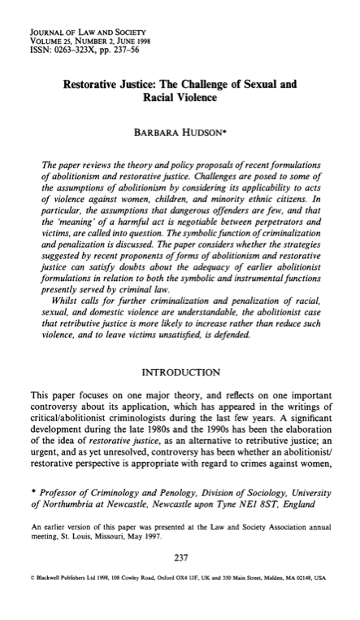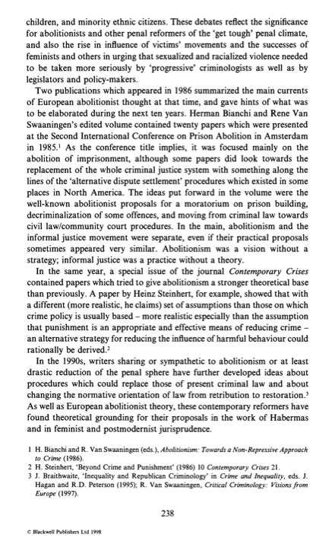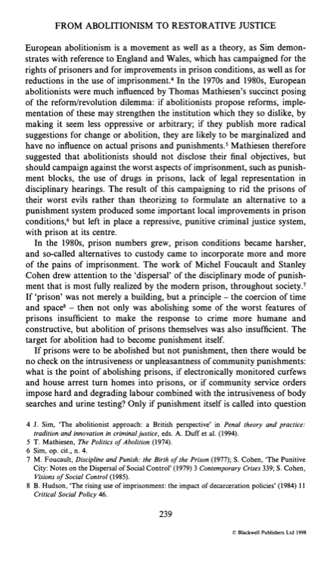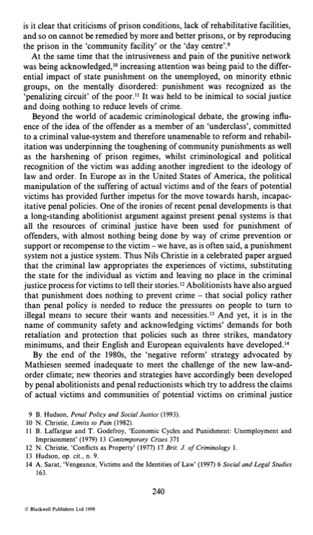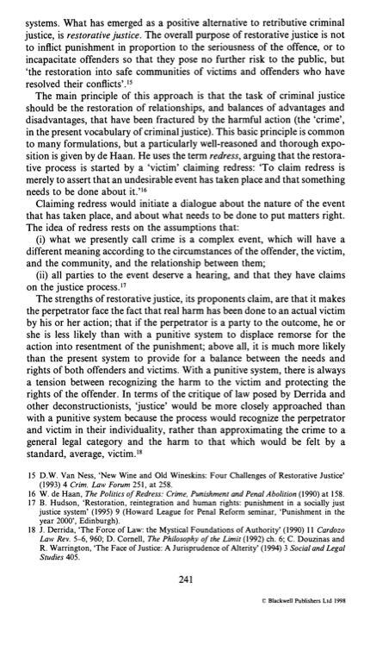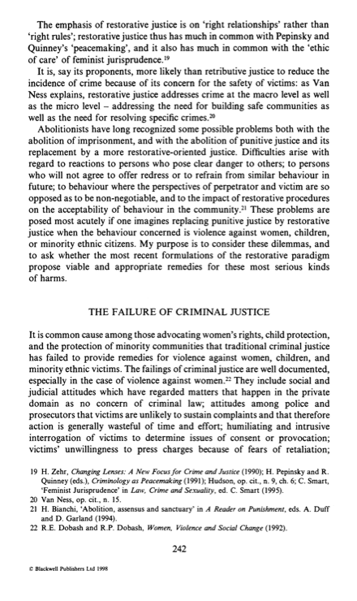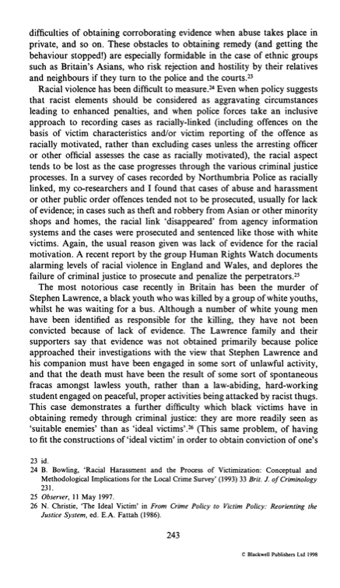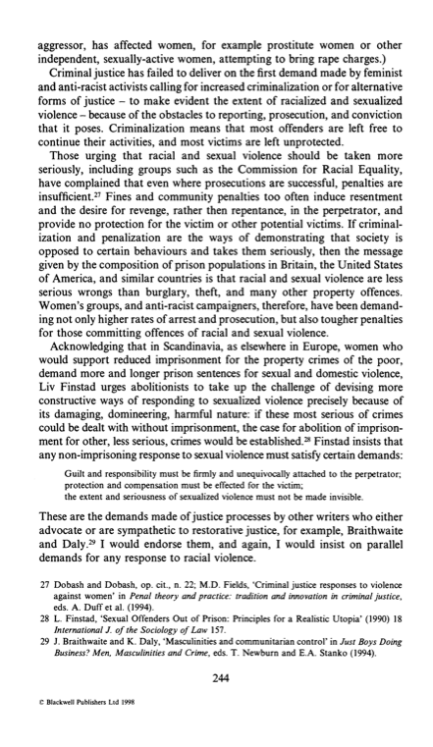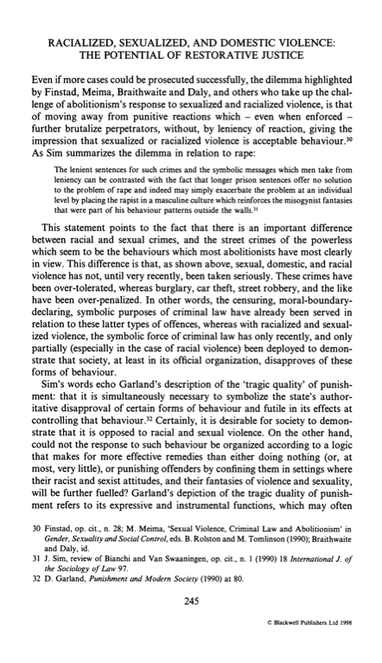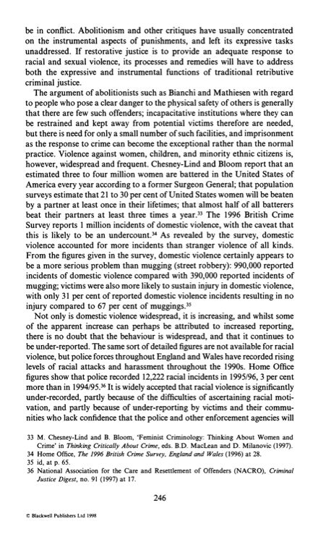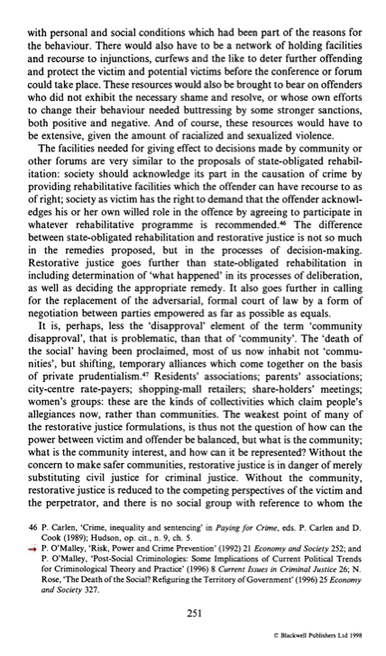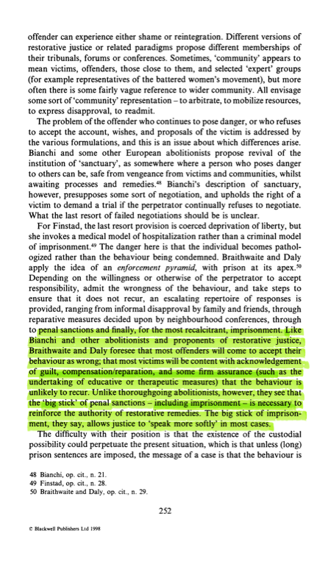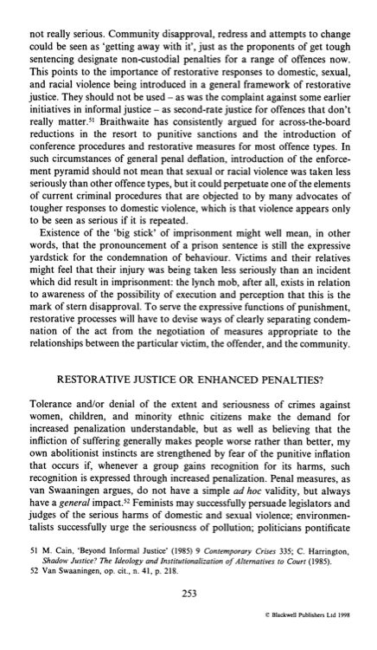

Gregory Capobianco, FN 72.1

FN 72.1: Expressions of remorse and requests for forgiveness occur in many restorative processes. See Strang, supra note 2, at 115;

Referring To: See, e.g., Heather Strang, Repair or Revenge: Victims and Restorative Justice (2002) (presenting findings from the Reintegrative Shaming Experiments [RISE] comparing cases randomly assigned to either court or conference in Canberra, Australia);

Comment: Even though this source is generally cited, I was not able to find enough of the opening pages of the book to complete the request. I did include the cover, copyright, and TOC pages below.

I also switched the order of this citation, putting the Sherman & Strang book first, followed by the Strang-only book. They both are books, and Rule 1.4(i)(2) says to alphabetize by the first author’s last name.

I have filed a library retrieval for this source.

Source Information:

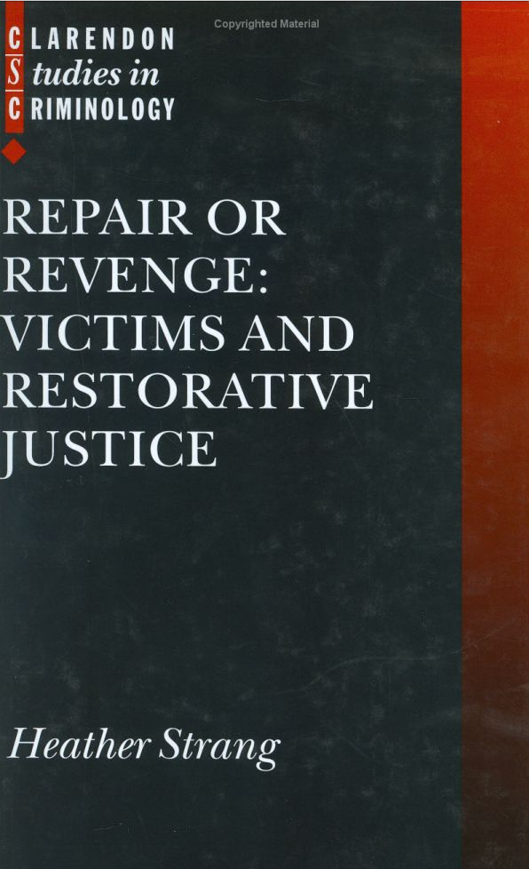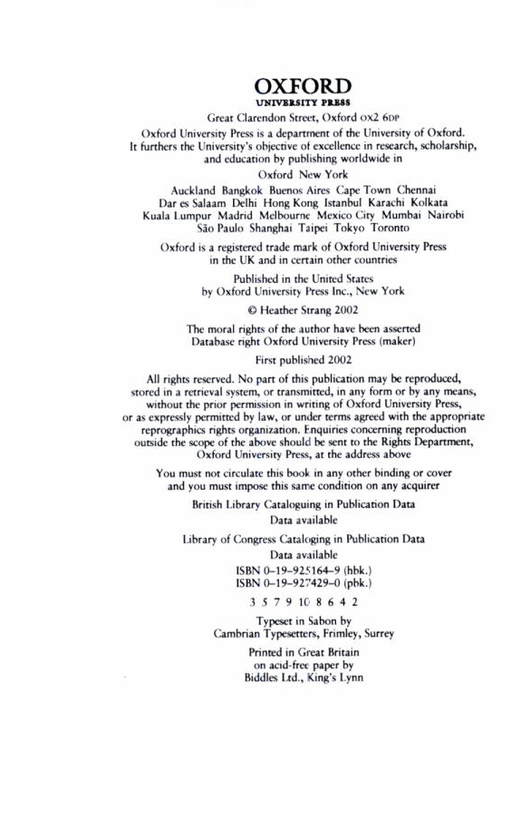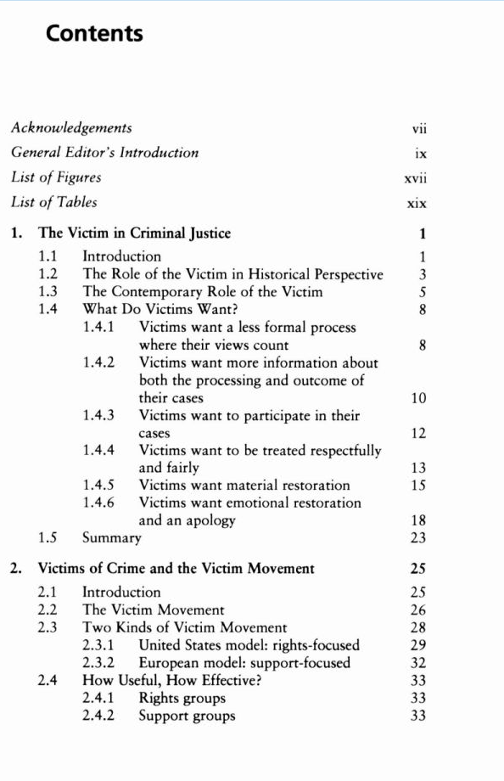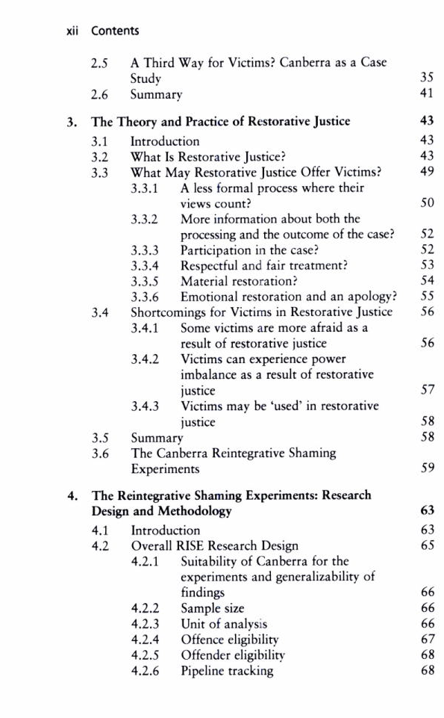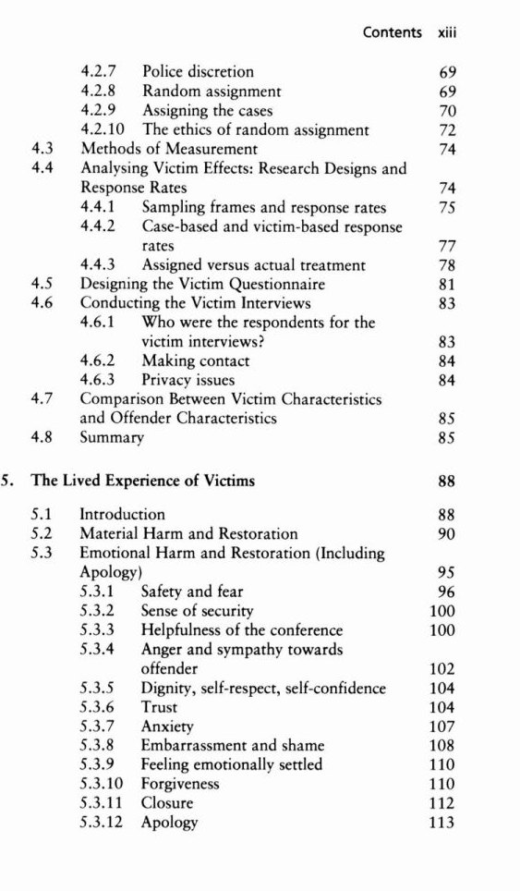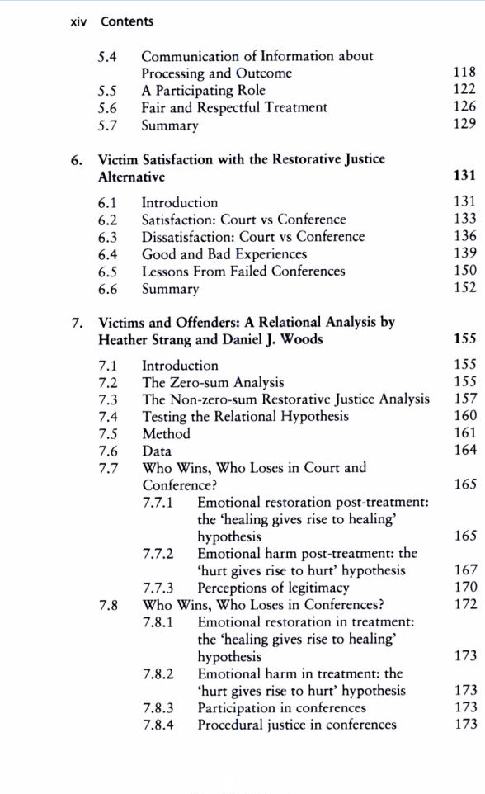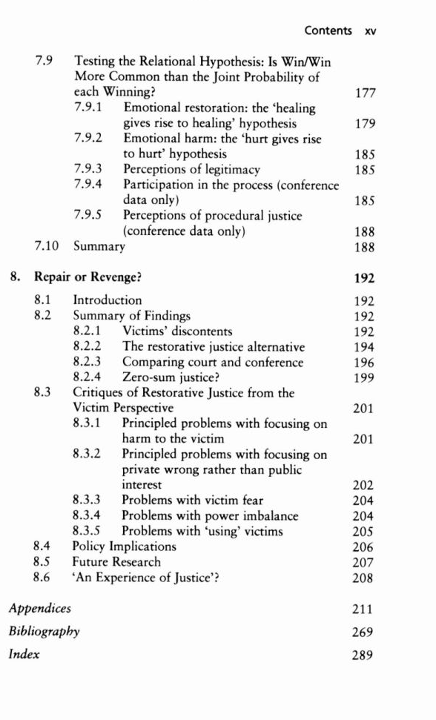

Gregory Capobianco, FN 72.2

FN 72.2: Sherman & Strang, supra note 2.

Referring To: Lawrence W. Sherman & Heather Strang, Restorative Justice: The Evidence (2007) (presenting a systematic review of evidence drawn from reasonably unbiased tests comparing restorative justice with conventional criminal justice. The review reveals that, with only one exception, rigorous tests of restorative justice showed significant reductions in recidivism rates. Restorative justice reduces crime more effectively in more serious crimes, in violence rather than in property crimes, and when there is a personal victim).

Source Information:

URL: http://www.sas.upenn.edu/jerrylee/RJ_full_report.pdf

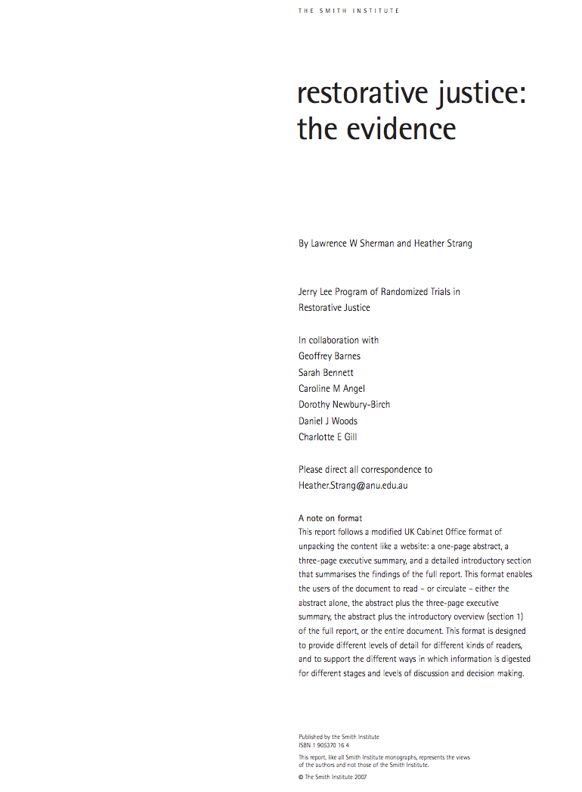

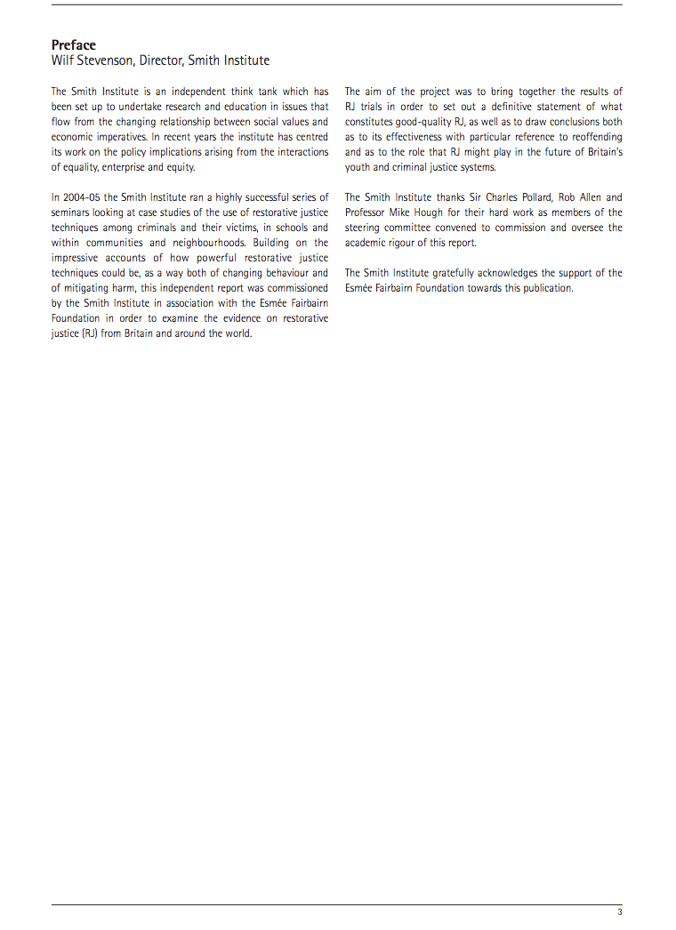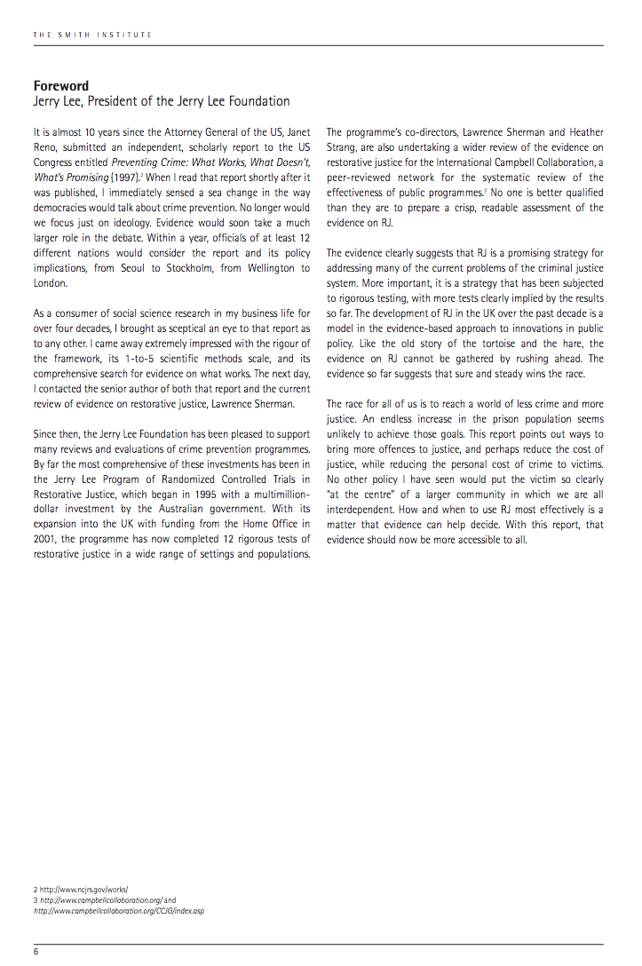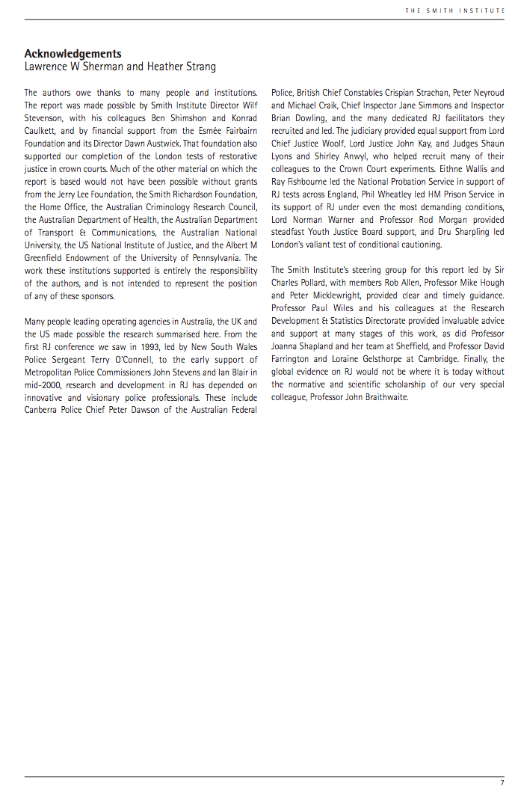
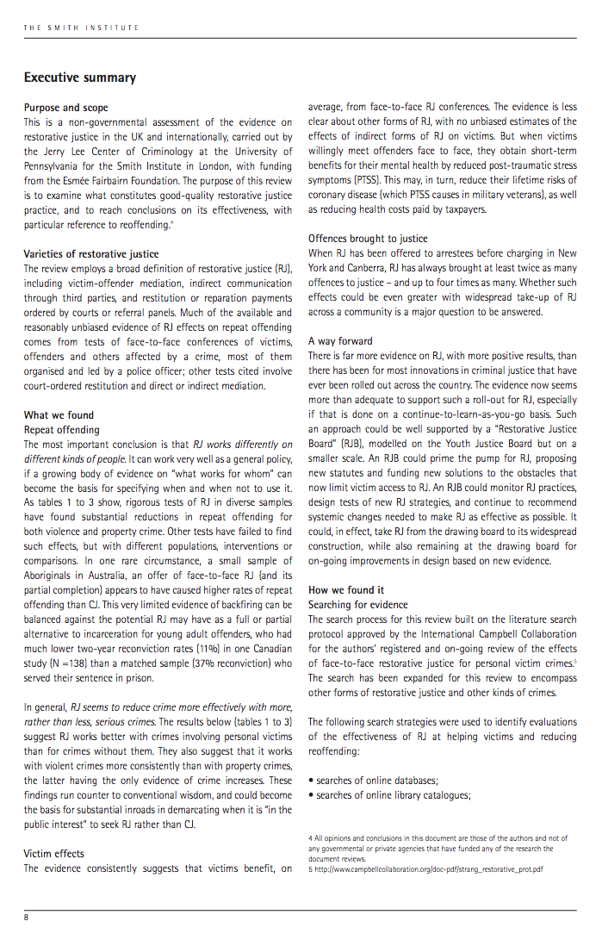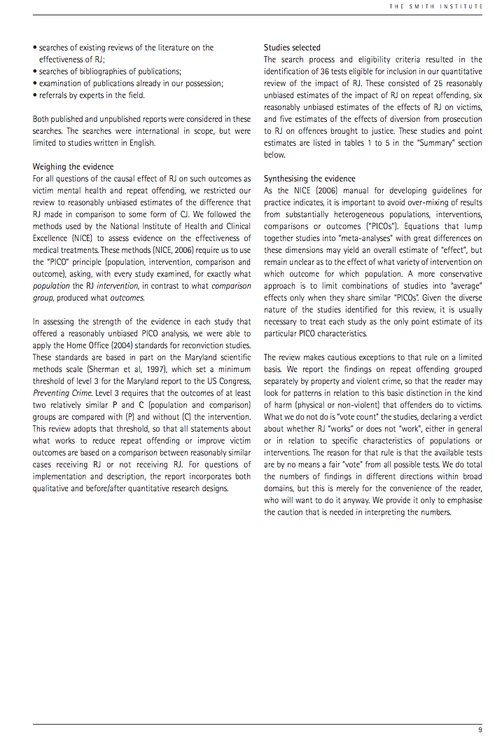

Gregory Capobianco, FN 73

FN 73: Braithwaite, supra note 56, at 37.

Referring To: John Braithwaite, Restorative Justice: Assessing Optimistic and Pessimistic Accounts, 25 Crime. Justice. 1, 60 (1999).

Comment:

Source Information:

URL:

25 Crime & Just. 1, *

Copyright (c) 1999 The University of Chicago
Crime and Justice
1999
25 Crime & Just. 1
LENGTH: 56203 words
ARTICLE: Restorative Justice: Assessing Optimistic and Pessimistic Accounts
NAME: John Braithwaite

[*36] single therapist cannot, by definition, do more than talk about healthy relationships."
The most sophisticated implementation of this ideal that has been well-evaluated is Burford and Pennell's (1998) Family Group Decision Making Project to confront violence and child neglect in families. Beyond the positive effects on the direct objective of reducing violence, the evaluation found a posttest increase in family support, concrete (e.g., babysitting) and emotional, and enhanced family unity, even in circumstances where some conference plans involved separation of parents from their children. The philosophy of this program was to look for strengths in families that were in very deep trouble and build on them.
Members of the community beyond the offender and the victim who attend restorative justice processes tend, like offenders, victims and the police, to come away with high levels of satisfaction. In Pennell and Burford's (1995) family group conferences for family violence, 94 percent of family members were "satisfied with the way it was run"; 92 percent felt they were "able to say what was important," and 92 percent "agreed with the plan decided on." Clairmont (1994, p. 28) also reports that among native peoples in Canada, the restorative justice initiatives he reviewed have "proven to be popular with offenders . . . and to have broad, general support within communities." The Ministry of Justice (1994), Western Australia, reports 93 percent parental satisfaction, 84 percent police satisfaction, and 67 percent judicial satisfaction, plus (and crucially) satisfaction of Aboriginal organizations with their restorative justice conference program (Juvenile Justice Teams). In Singapore, 95 percent of family members who attended family group conferences said that they benefited personally from the experience (Hsien 1996). For the Bethlehem police conferencing experiment, more parents of offenders were satisfied (97 percent) and likely to believe that justice had been fair (97 percent) than in cases that went to court (McCold and Wachtel, 1998, pp. 65-72).
A study by Schneider (1990) found that completing restitution and community service was associated with enhanced commitment to community and feelings of citizenship (and reduced recidivism). While the evidence is overwhelming that where communities show strong social support, criminality is less (Cullen 1994; Chamlin and Cochran 1997), it would be optimistic to expect that restorative justice could ever have sufficient impacts in restoring microcommunities to cause a shift in the macro impact of community on the crime rate (cf. Brown and Polk 1996).
But building the microcommunity of a school or restoring social [*37] bonds in a family can have important implications for crime in that school or that family. Moreover, the restoring of microcommunity has a value of its own, independent of the size of the impact on crime. In the last section I showed how whole-school approaches to bullying can halve bullying in schools. There is a more important point of deliberative programs to give all the citizens of the school community an opportunity to be involved in deciding how to make their school safer and more caring. It is that they make their schools more decent places to be in while one is being educated. There is Australian evidence suggesting that restorative sexual harassment programs in workplaces may reduce sexual harassment (Parker 1998). Again the more important value of these programs than the improved compliance with the law may be about more generalimprovements in the respect with which women are treated in workplaces as a result of the deliberation and social support integral to such programs when they are effective.
I have known restorative justice conferences where supporters of a boy offender and a girl victim of a sexual assault agreed to work together to confront a culture of exploitative masculinity in an Australian school that unjustly characterized the girl as "getting what she asked for" (Braithwaite and Daly 1994). Conversely, I have seen conferences that have missed the opportunity to confront homophobic cultures in schools revealed by graffiti humiliating allegedly gay men and boys (Retzinger and Scheff 1996). After one early New Zealand conference concerning breaking into and damaging the restaurant of a refugee Cambodian, the offender agreed to watch a video of The Killing Fields and "pass the word on the street" that the Cambodian restaurateur was struggling to survive and should not be harassed. A small victory for civil community life perhaps, but a large one for that Cambodian man.
One of the most stirring conferences I know of occurred in an outback town after four Aboriginal children manifested their antagonism toward the middle-class matriarchs of the town by ransacking the Country Women's Association Hall. The conference was so moving because it brought the Aboriginal and the white women together, shocked and upset by what the children had done, to talk to each other about why the women no longer spoke to one another across the racial divide in the way they had in earlier times. Did there have to be such an incivility as this to discover the loss of their shared communal life? Those black and white women and children rebuilt that communal life as they restored the devastated Country Women's Association Hall, working together, respectfully once more (for more details on this case, see the Real Justice website http://www.realjustice.org/).
[*38] One might summarize that the evidence of restorative justice restoring communities is of very small accomplishments of microcommunity building and of modest numbers of community members going away overwhelmingly satisfied with the justice in which they have participated. Maori critics of Pakeha restorative justice such as Monana Jackson (1987) and Juan Tauri (1998) point out that it falls far short of restoring Maori community control over justice. Neocolonial controls from Pakeha courts remain on top of restorative justice in Maori communities. This critique seems undeniable; nowhere in the world has restorative justice enabled major steps toward restoring precolonial forms of community among colonized peoples; nowhere have the courts of the colonial power given up their power to trump the decisions of the indigenous justice fora.
At the same time, there is a feminist critique of this indigenous critique of community restoration. I return later to at least one case where male indigenous elders in Canada used control over community justice as a resource in the oppression of women complaining of rape by dominant men. In this case the community was torn asunder to the point of a number of women leaving it.
With all the attention given to the microcommunity building of routine restorative justice conferences, we must not lose sight of historically rare moments of restorative justice that reframe macrocommunity. I refer, for example, to the release of IRA terrorists from prison so that they could participate in the IRA meetings of 1998 that voted for the renunciation of violent struggle. I refer to much more partially successful examples, such as the Camp David mediations of President Carter with the leaders of Egypt and Israel (more partially successful because it excluded the Palestinians themselves), and to more completely successful local peacemaking such as that of the Kulka Women's Club in the Highlands of New Guinea (Rumsey 1999).
D. Reintegrative Shaming Theory Predicts That Restorative Justice Practices Reduce Crime More than Existing Criminal Justice Practices
ma te whakama e patu!
"Leave him alone, he is punished by shame." (Maori saying)
Crime, Shame and Reintegration (Braithwaite 1989) gives an account of why restorative justice processes ought to prevent crime more effectively [*39]

Gregory Capobianco, FN 74.1

FN 74.1: See, e.g., Madelaine Adelman, Edna Erez & Nadira Shalhoub-Kevorkian, Israel: Policing Violence Against Minority Women in Multicultural Societies: ‘Community’ and the Politics of Exclusion, 7 Police & Society 105 (2003) (describing the complexity of policing domestic violence in Arab communities);

Comment: Aside from a few other articles citing to the same source, I would have no reason to believe that this source exists. Those other citations spell Nadera’s name differently, which is why I have changed it use an E. However, I have not been able to find the source itself.

I was unable to file a true library retrieval for this source. WorldCat reports no electronic or library availability of this source. http://yeshiva.worldcat.org/title/policing-violence-against-minority-women-in-multicultural-societies-community-and-the-politics-of-exclusion/oclc/4769517988&referer=brief_results



Gregory Capobianco, FN 74.2

FN 74.2: Julie Stubbs, Domestic Violence and Women’s Safety: Feminist Challenges to Restorative Justice, in Restorative Justice and Family Violence 42, 49 (Heather Strang & John Braithwaite eds., 2002) (discussing the problems in some restorative justice programs addressing family violence in indigenous communities where the safety of women was placed at the hands of local men, some of whom were themselves abusers).

Source Information:

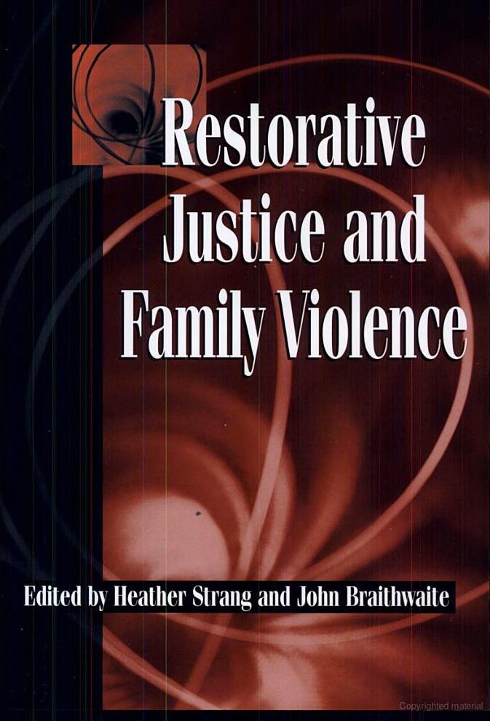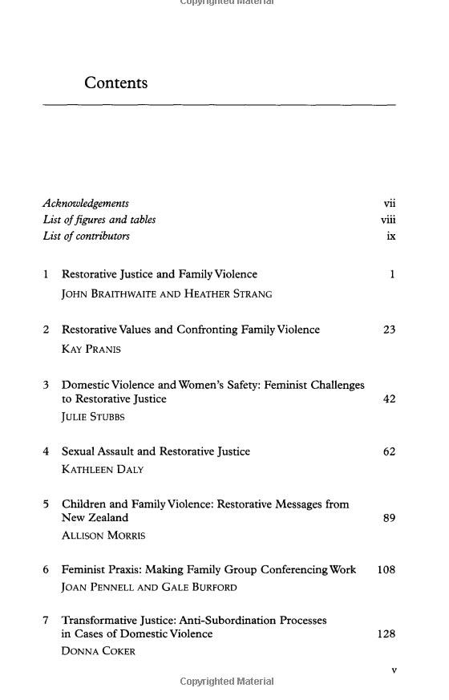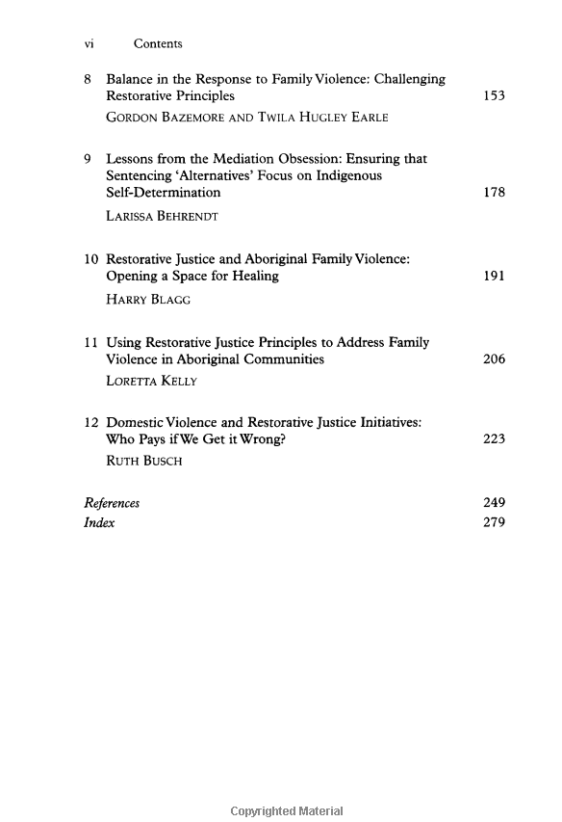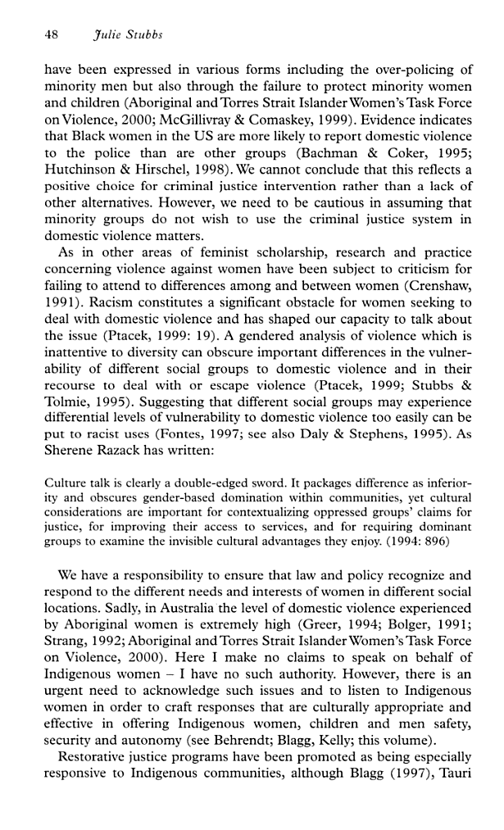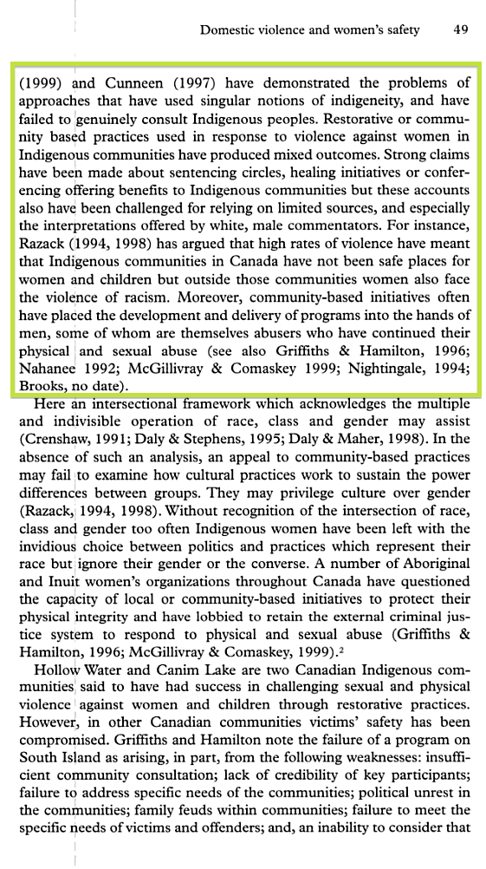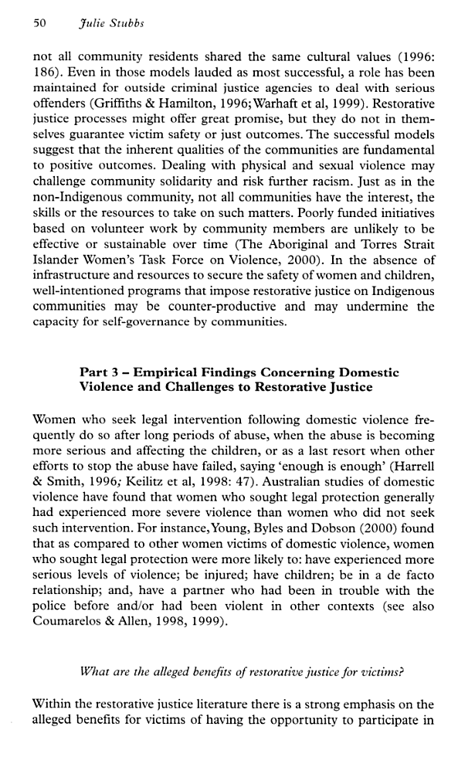

Gregory Capobianco, FN 75

FN 75: But see Braithwaite, supra note 19 at 564 (arguing that empirical evidence indicates that, in fact, women’s voices are heard more frequently than males’ in restorative justice processes, in contrast with the reality in formal courtrooms).

Referring To: John Braithwaite, Setting Standards for Restorative Justice, 42 Brit. J. Criminol. 563 (2002) (discussing state-imposed boundaries that proscribe any violent or coercive expressions);

Source Information:

URL: http://bjc.oxfordjournals.org/content/42/3/563.full.pdf+html

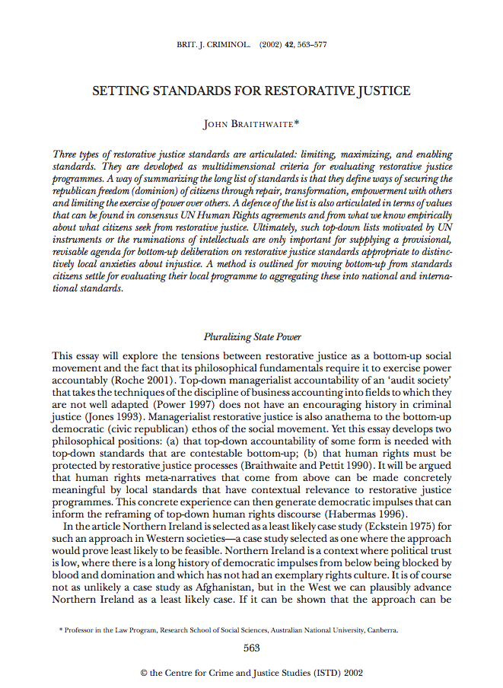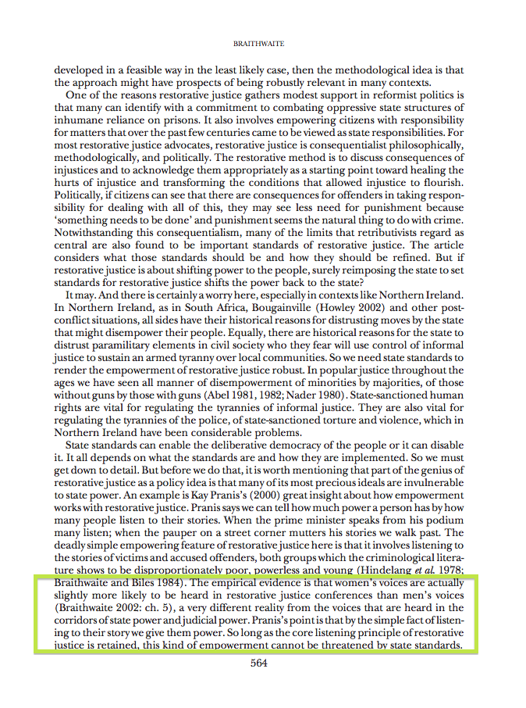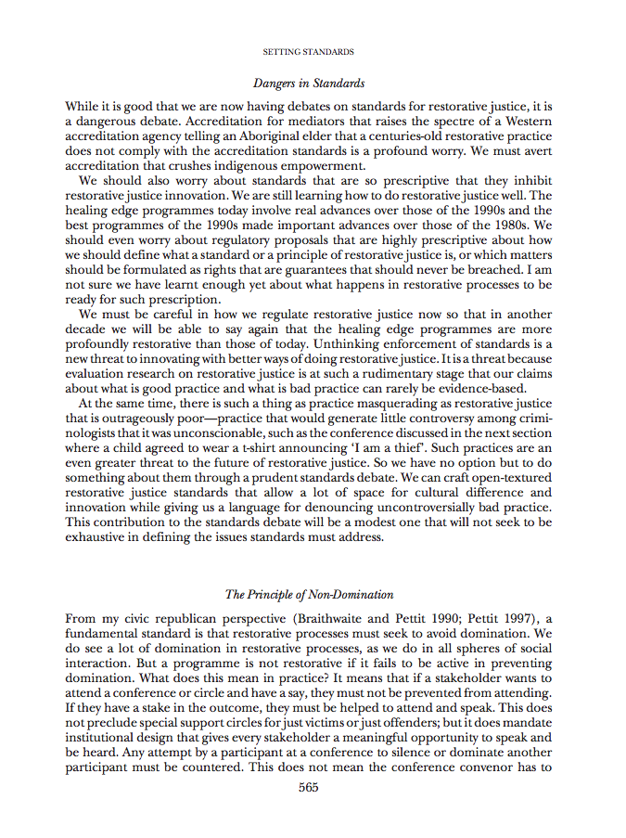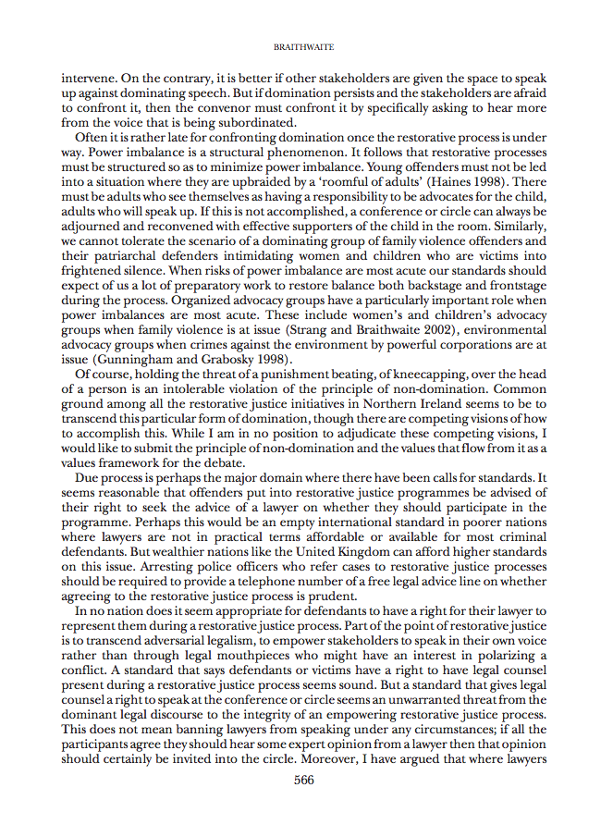

Gregory Capobianco, FN 76

FN 76: An example is the involvement of judges in sentencing circles in Canada and in the United States. The judge is passive during the circle but it is within his (or her) authority to decide whether or not to accept the outcome plan as a part of the sentence or as a replacement to it. See Goel, supra note 10.

Referring To: Rashmi Goel, Aboriginal Women and Political Pursuit in Canadian Sentencing Circles: At Cross Roads or Cross Purposes?, in Restorative Justice and Violence Against Women 60 (James Ptacek ed., 2010) (describing justice circles operated by native American communities in Canada).

Comment: I included the cover, copyright, and TOC pages below.

I have filed a library retrieval for this source.

Source Information:

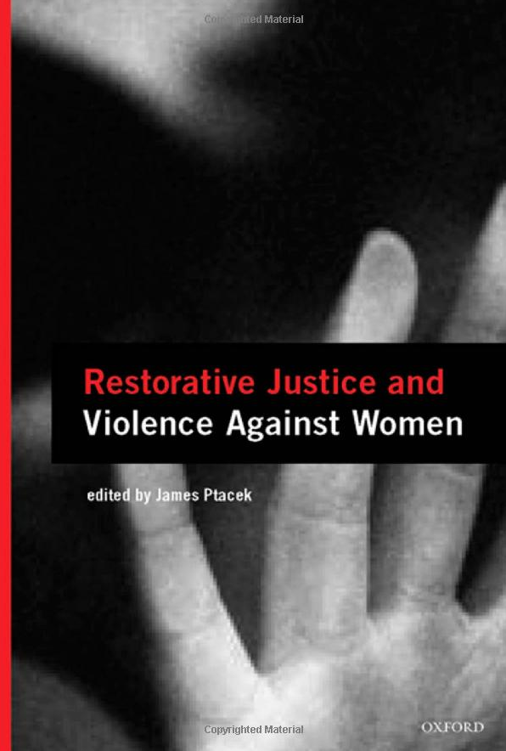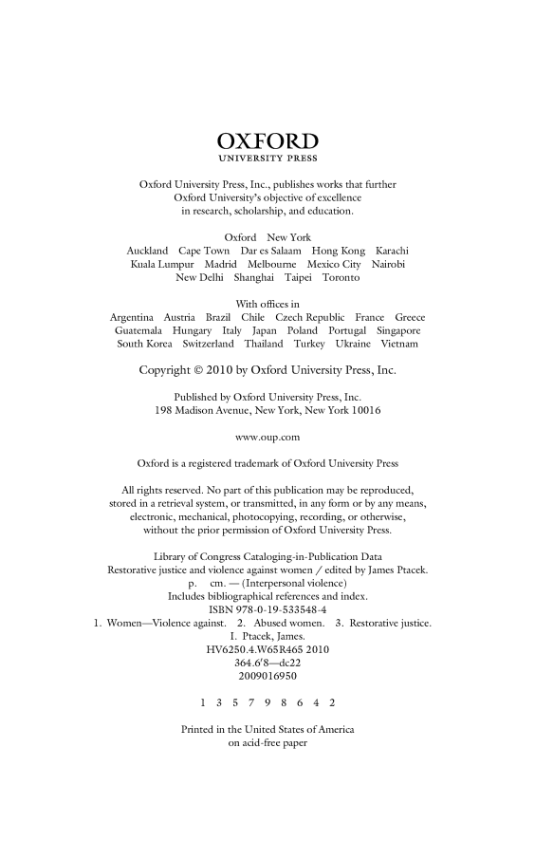
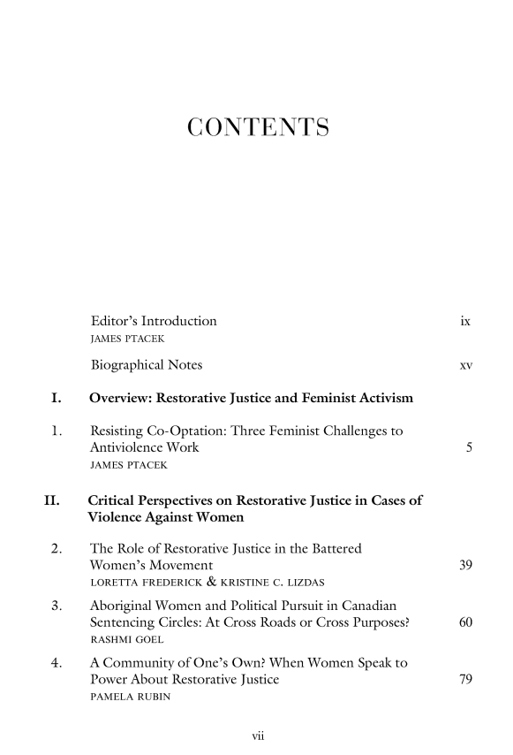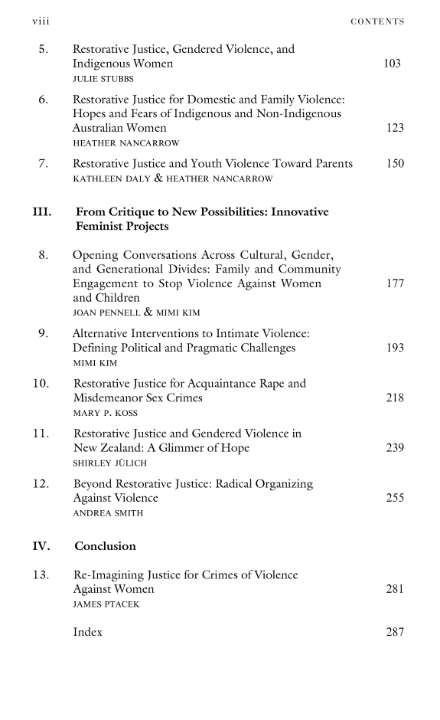

Gregory Capobianco, FN 77

FN 77: See Barbara Hudson, Beyond White Man’s Justice: Race, Gender and Justice in Late Modernity, 10 Theo. Crim. 29 (2006) (suggesting that restorative processes should meet the principles of discursiveness, relationalism and reflectiveness to address this concern).

Source Information:

URL: http://tcr.sagepub.com/content/10/1/29.short

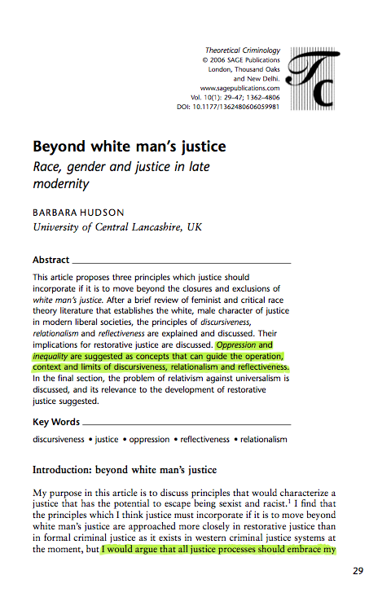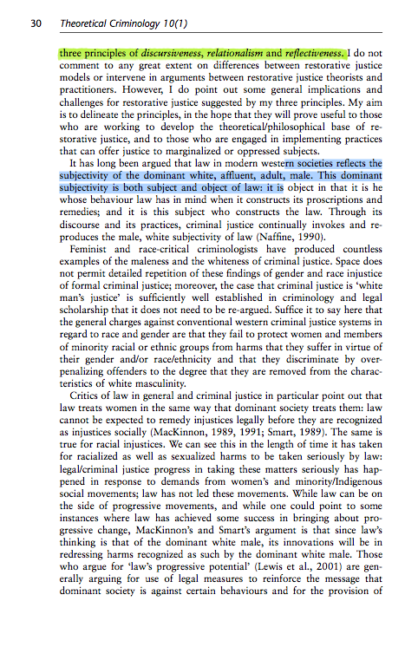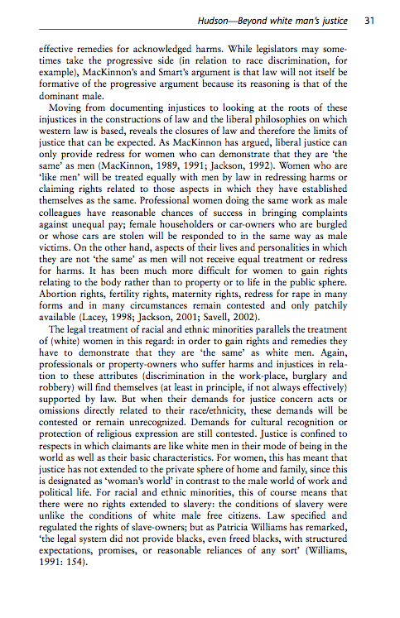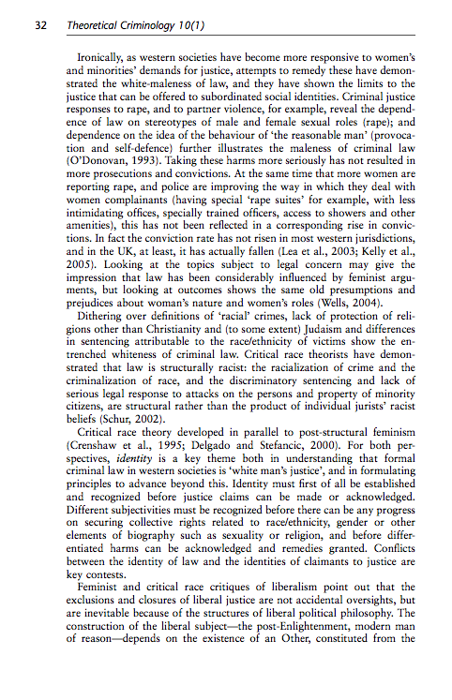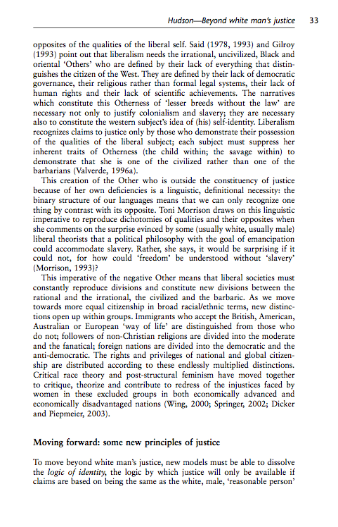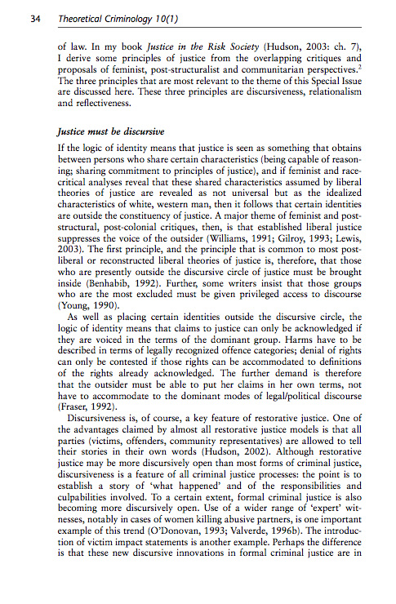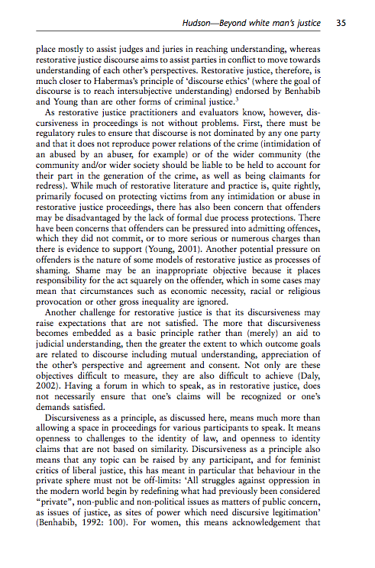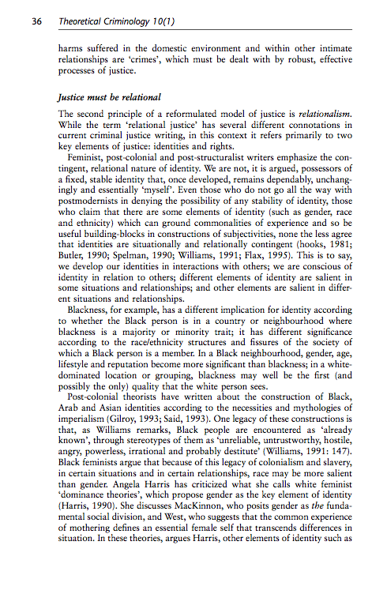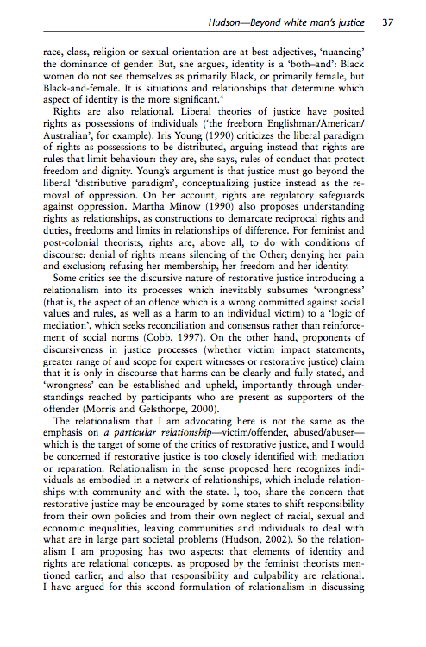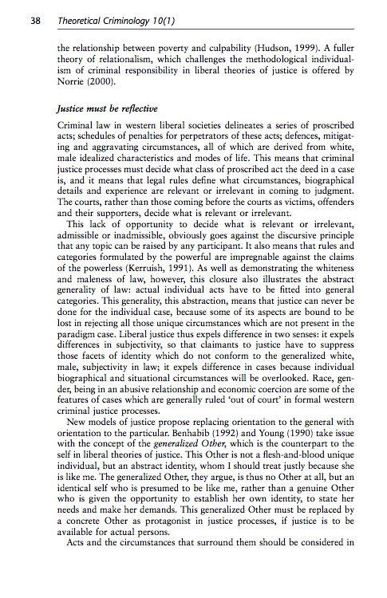

Gregory Capobianco, FN 78

FN 78: See Braithwaite & Pettit, supra note 17 (explaining why it is a consequential theory of justice).

Referring To: See John Braithwaite & Phillip Pettit, Not Just Deserts: A Republican Theory of Criminal Justice (1990).

Source Information:

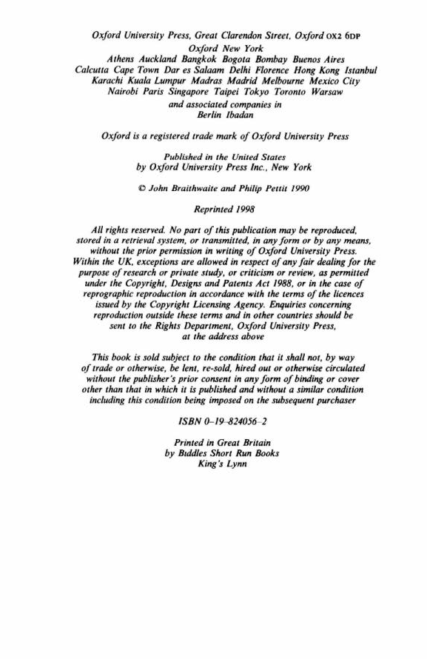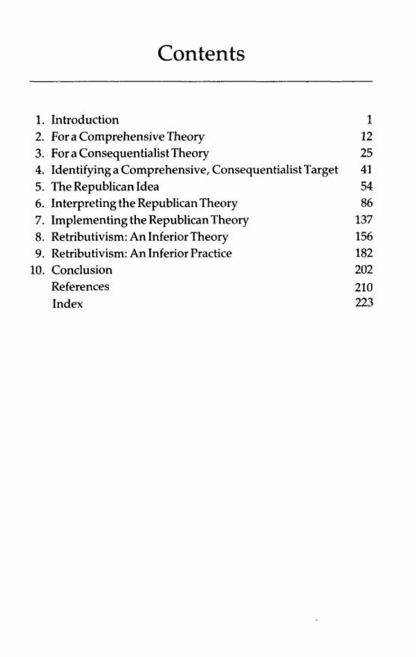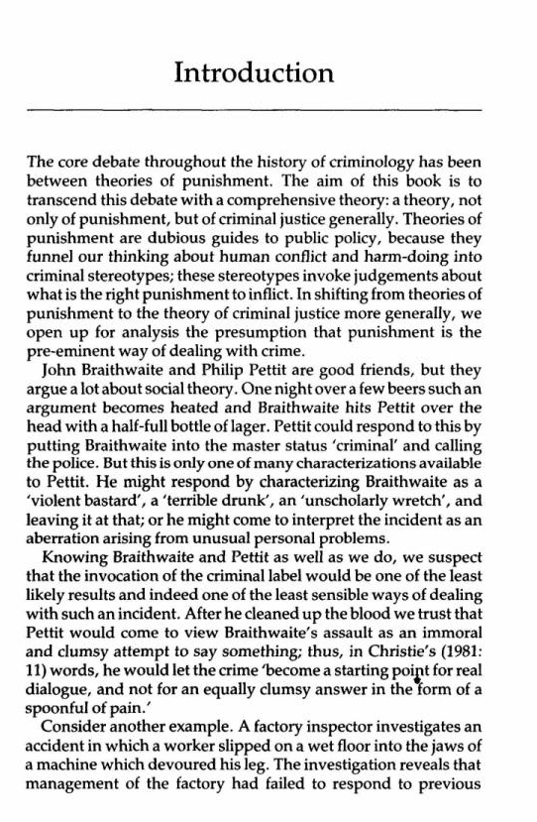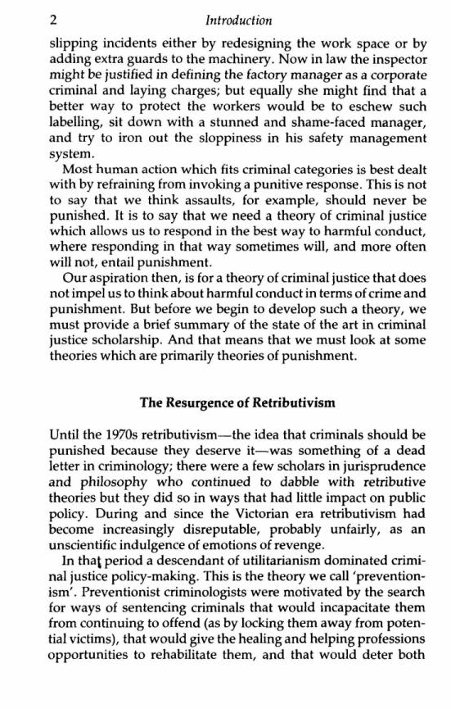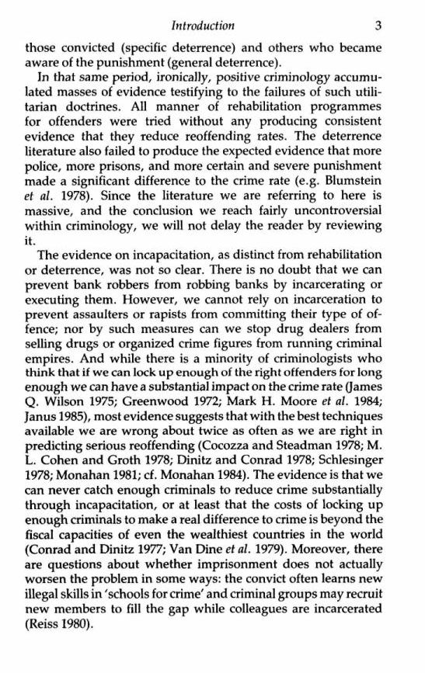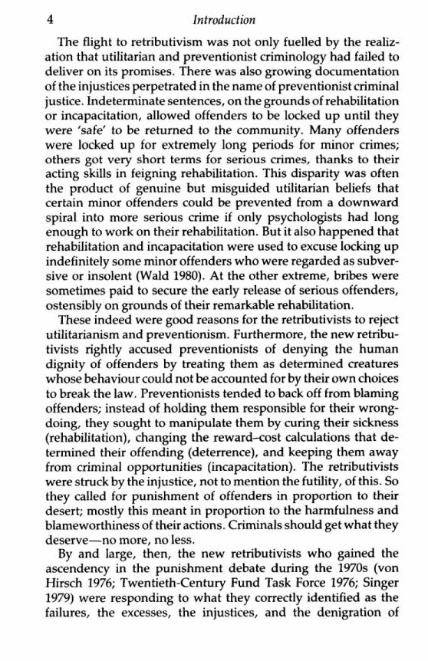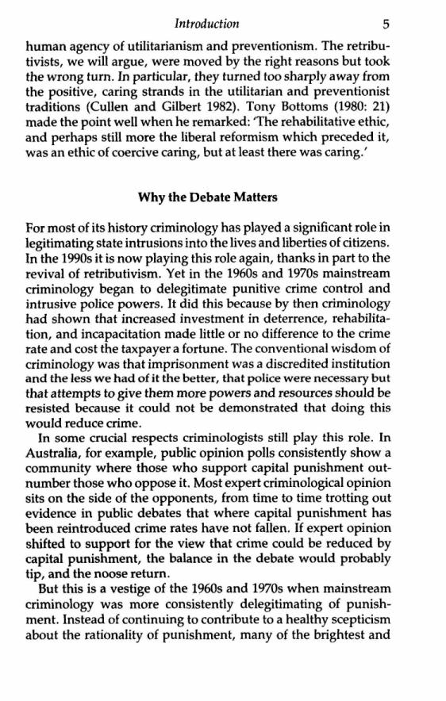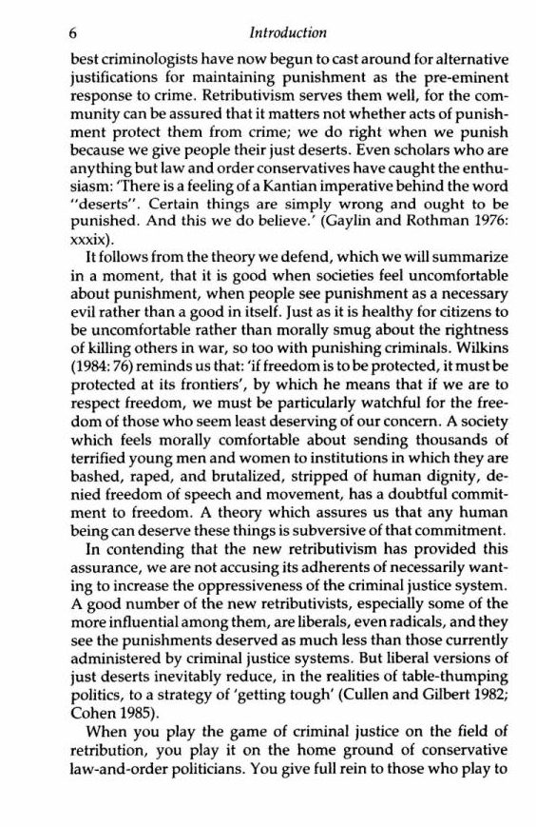

Gregory Capobianco, FN 79.1

FN 79.1: Martin Wright, The Court as Last Resort: Victim-Sensitive, Community-Based Responses to Crime, 42 Brit. J. Criminol. 654 (2002);

Comment: Table 13 says to abbreviate “Criminology” as “Criminology,” but the journal itself abbreviates it as “Criminol.” I have left it in the abbreviated form, following the convention used by the journal itself.

Source Information:

URL: http://bjc.oxfordjournals.org/content/42/3.toc

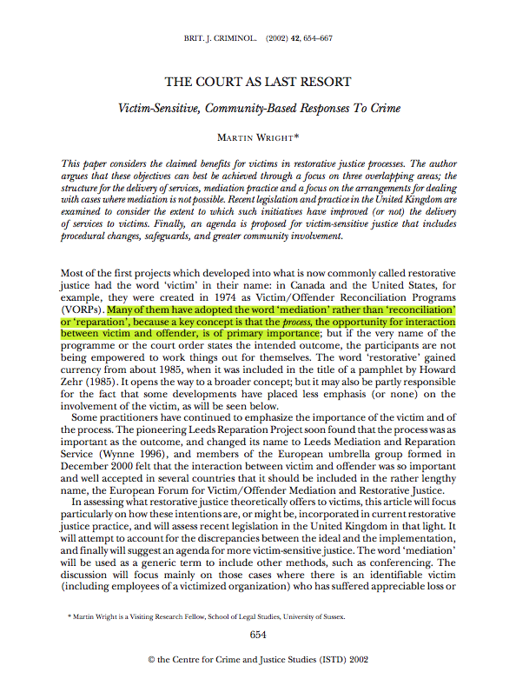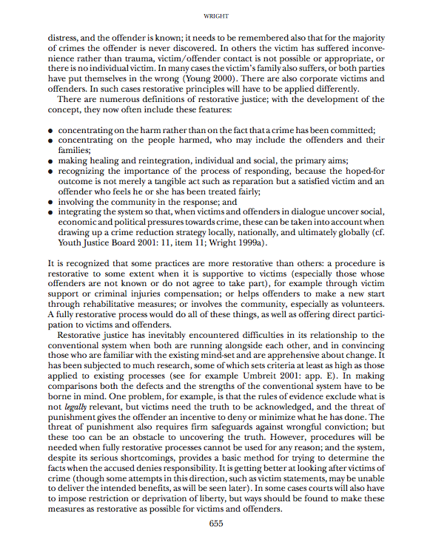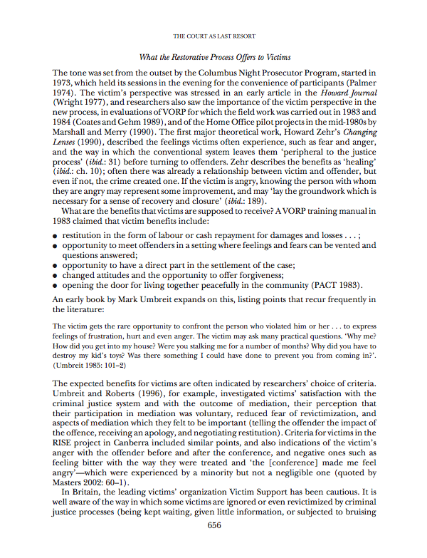

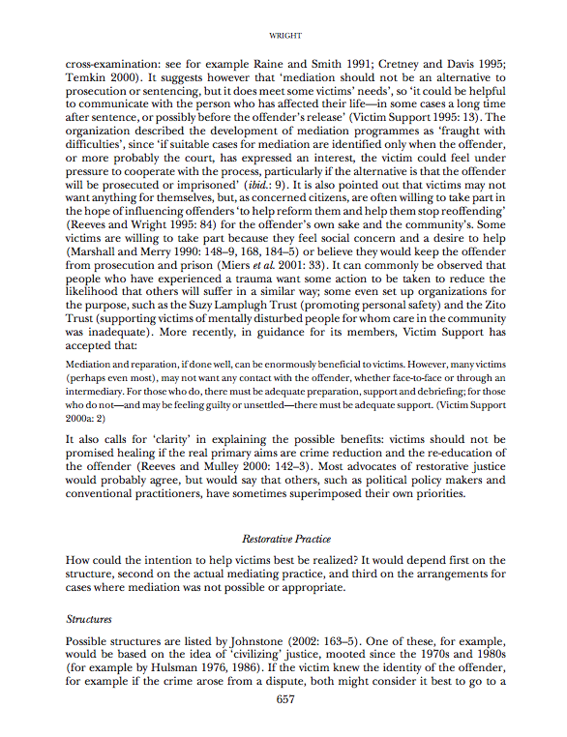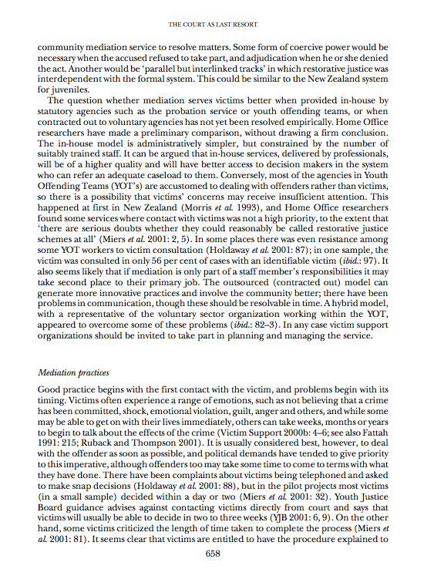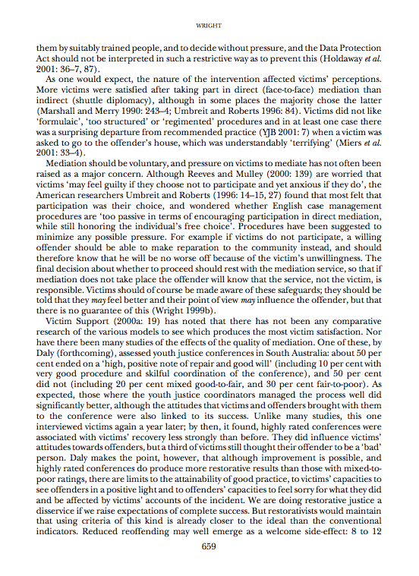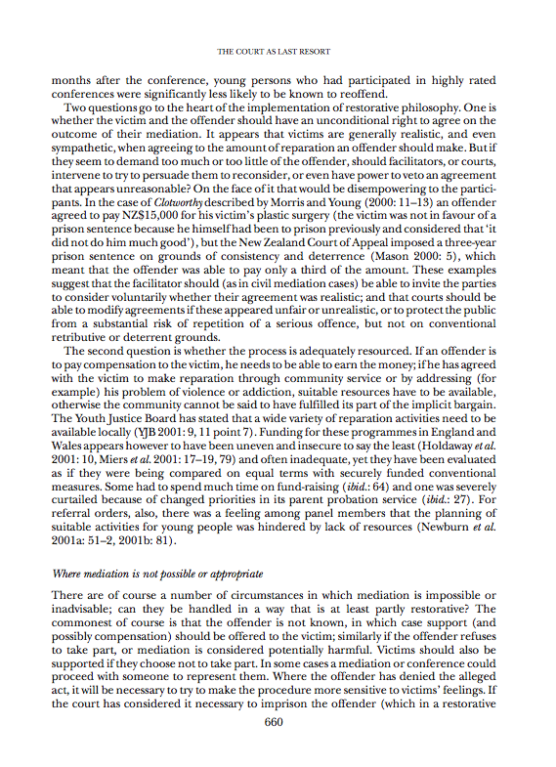

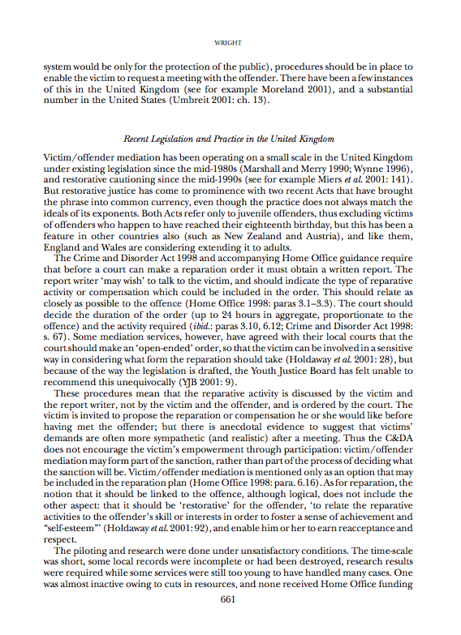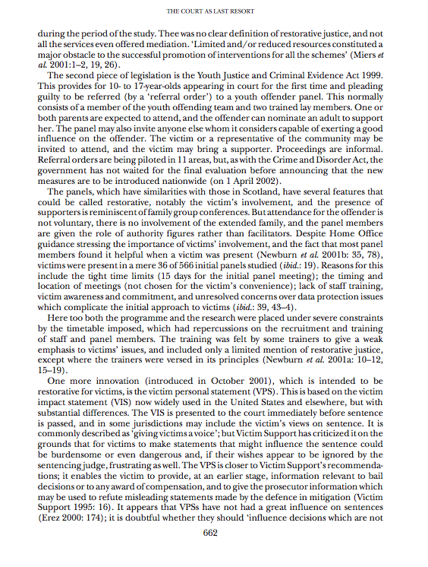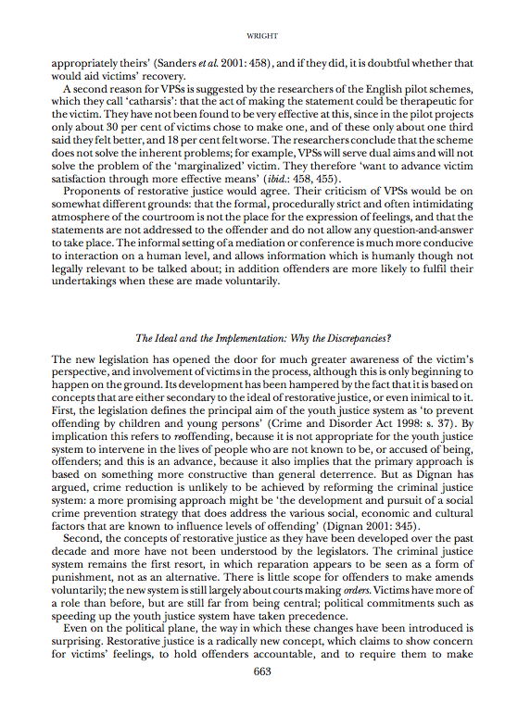

Gregory Capobianco, FN 79.2

FN 79.2: Fattah, supra note 62, at 257;

Referring To: Ezzat A. Fattah, A Critical Assessment of Two Justice Paradigms: Contrasting the Restorative and Retributive Justice Models, in Support for Crime Victims in a Comparative Perspective 99 (Ezzat A. Fattah & Tony Peters eds., 1998) (describing the detrimental implications of imprisonment)

Comment: I believe this pin cite is incorrect. Fattah’s essay begins on page 99 (as is correctly cited in footnote 62). The next essay 111 (one that is not written by Fattah) begins on page. The author pin cites to page 257, which is actually in a section called “Notes on the contributors.” It is hard to imagine that the proposition, which discusses restorative justice’s focus on victims, would be supported in a section about the contributors. But unfortunately, the specific page is unavailable, even after using multiple browsers and computers. I did include the cover, copyright, and TOC pages below.

I have filed a library retrieval for this source.

Source Information:

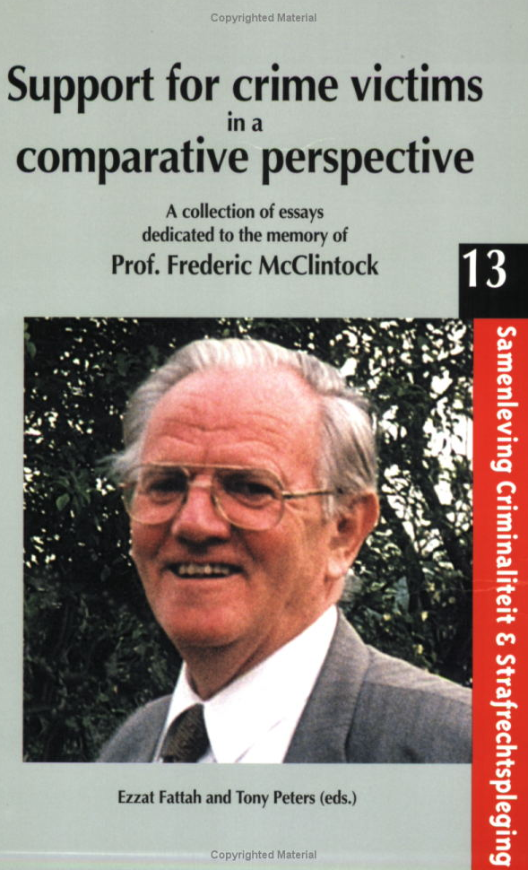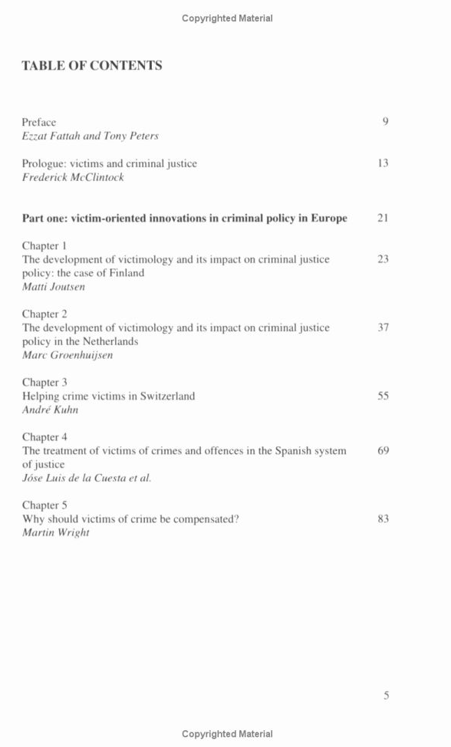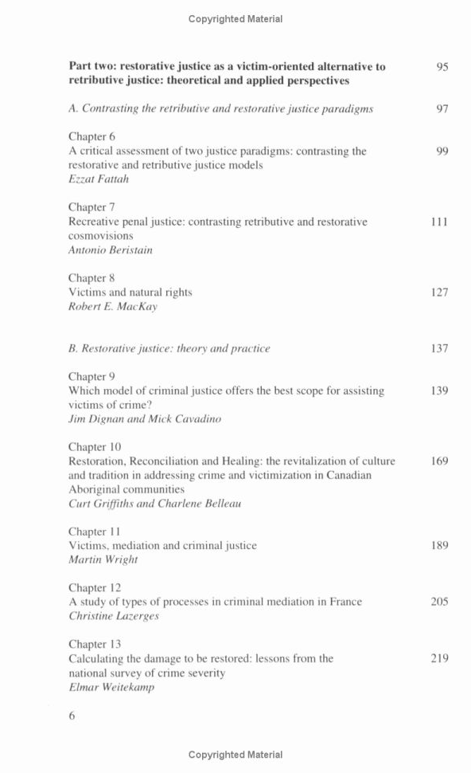

Gregory Capobianco, FN 79.3

FN 79.3: Zehr, supra note 11.

Referring To: See, e.g., Howard Zehr, Changing Lenses: A New Focus for Criminal Justice (1990) (defining restorative justice as a “third lens”);

Comment: While the 2005 edition is available online, the 1990 edition is not. I have filed a library retrieval for this source.

Gregory Capobianco, FN 80

FN 80: See Barton, supra note 11 (explaining the notion of empowerment in restorative processes as therapeutic).

Referring To: Charles K.B. Barton, Restorative Justice: The Empowerment Model 15 (2003) (arguing that the punitive approach inherently disempowers the primary stakeholders in the conflict while restorative justice empowers them);

Comment: The copyright page does not list the date of publication. The best I could find was that the author’s introductory note is signed as of September 2003.

Source Information:

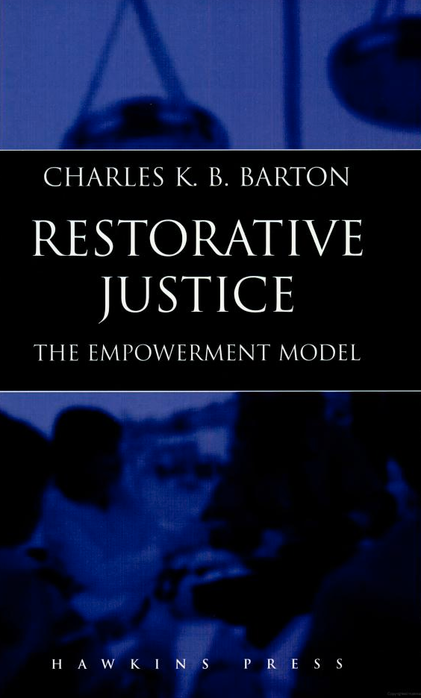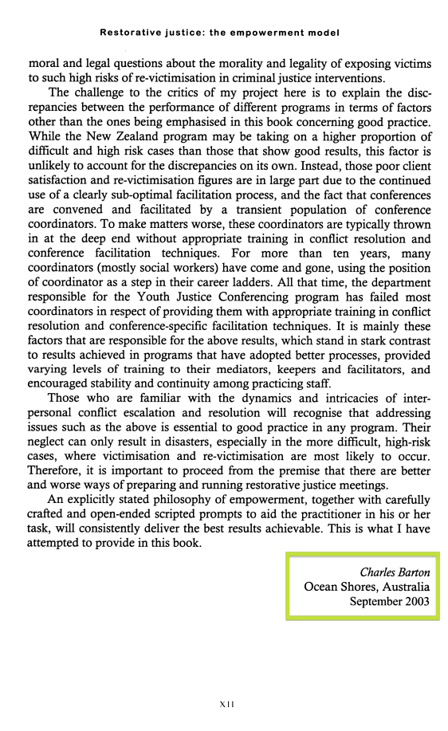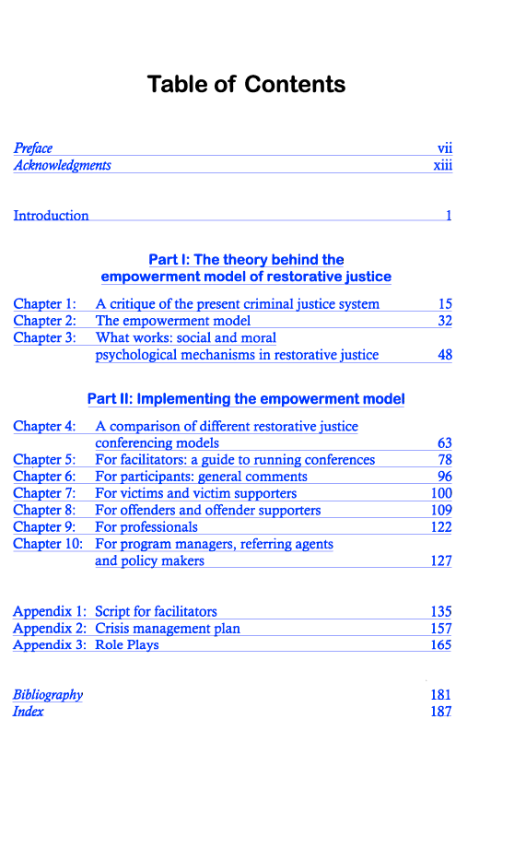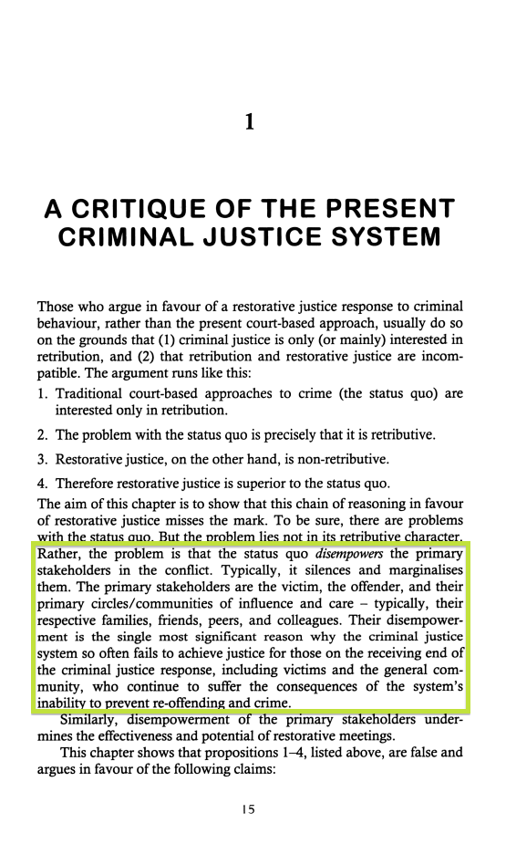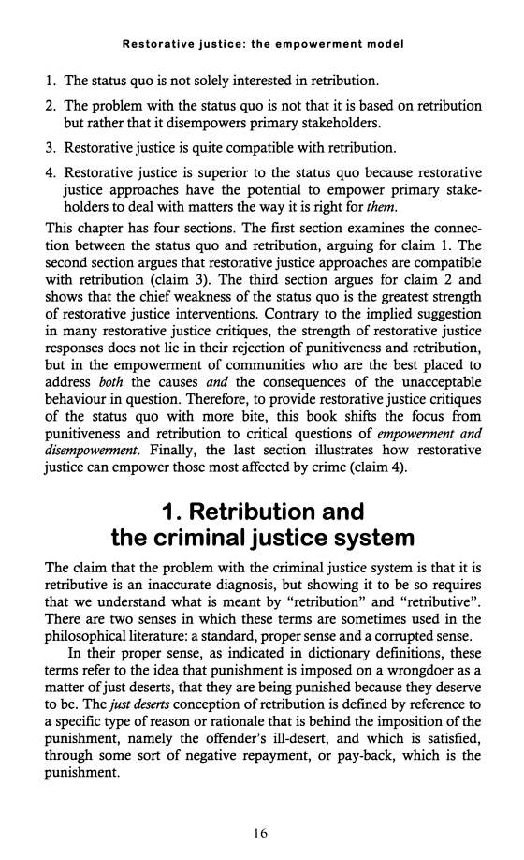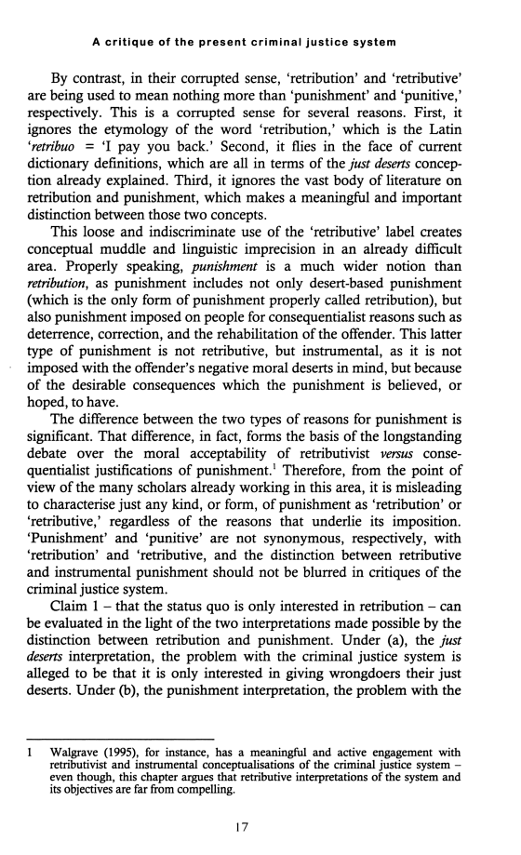

Gregory Capobianco, FN 81

FN 81: Angel, supra note 41.

Referring To: Caroline M. Angel, Crime Victims Meet Their Offenders: Testing the Impact of Restorative Justice, Conference on Victims Post-Traumatic Stress Symptoms (Jan. 1, 2005) (unpublished dissertation, University of Pennsylvania), available at http://repository.‌upenn.edu/‌dissertations/‌AAI3165634 (presenting findings regarding reduced post-trauma symptoms among robbery and burglary victims whose cases were randomly referred to conferences) .

Source Information:
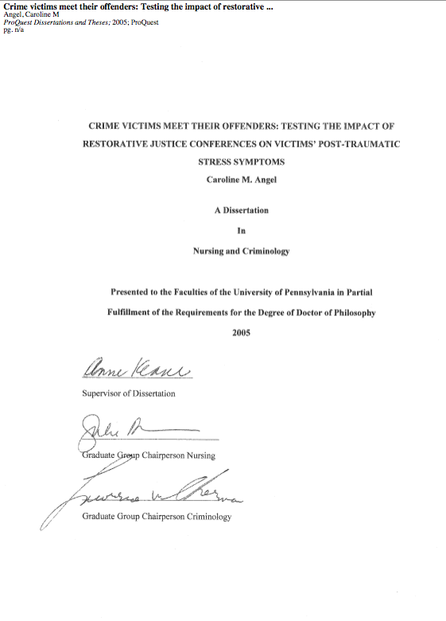



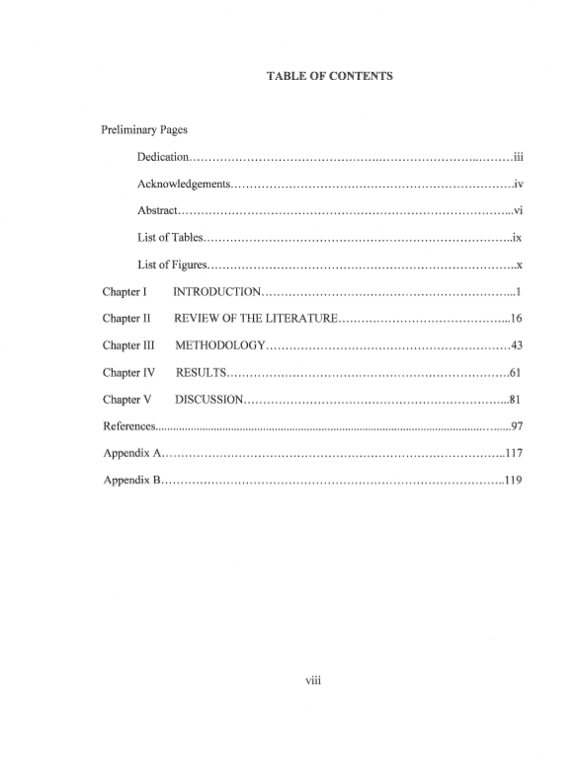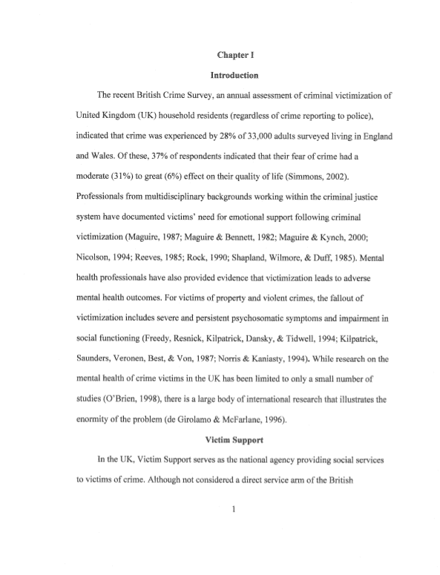
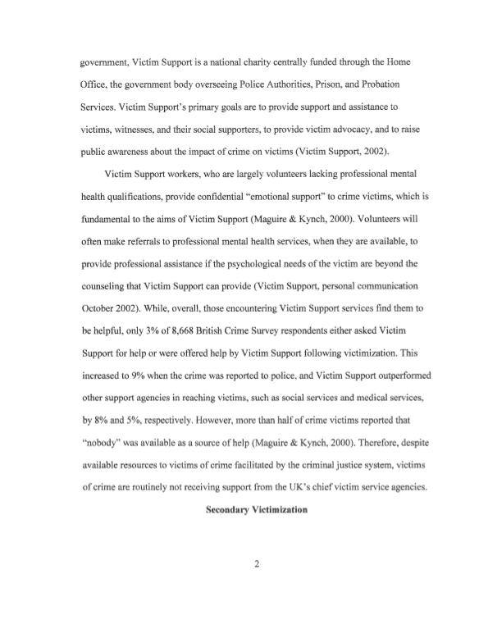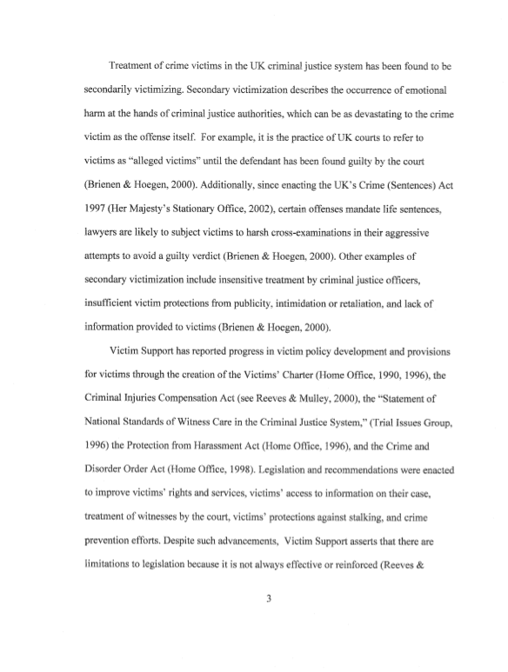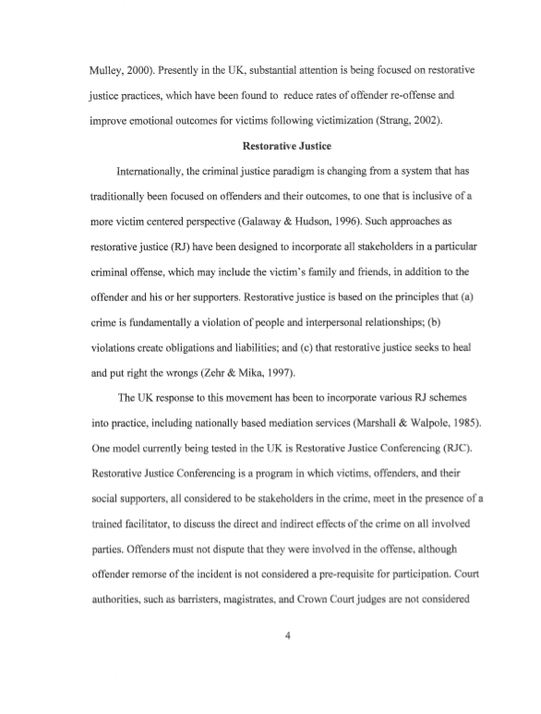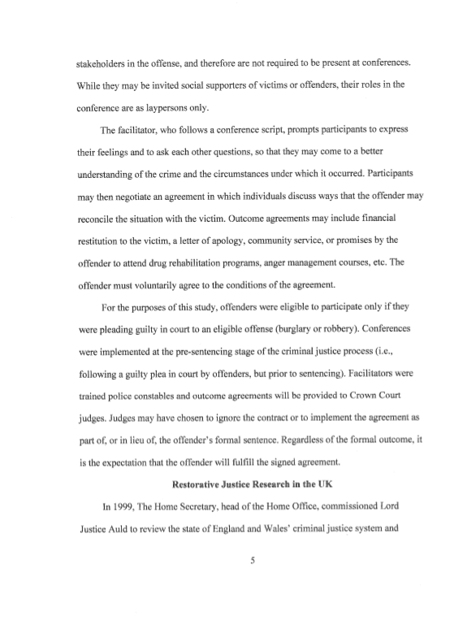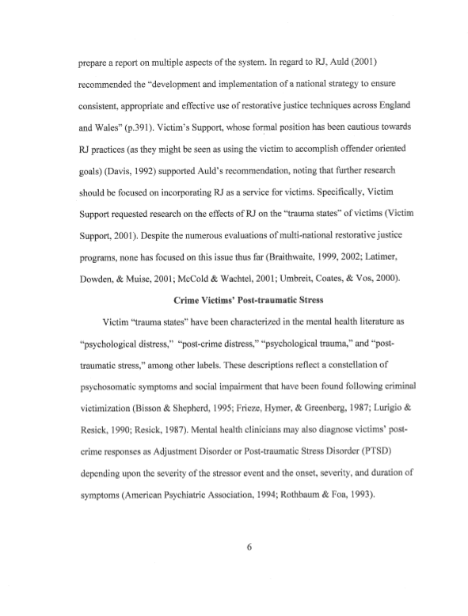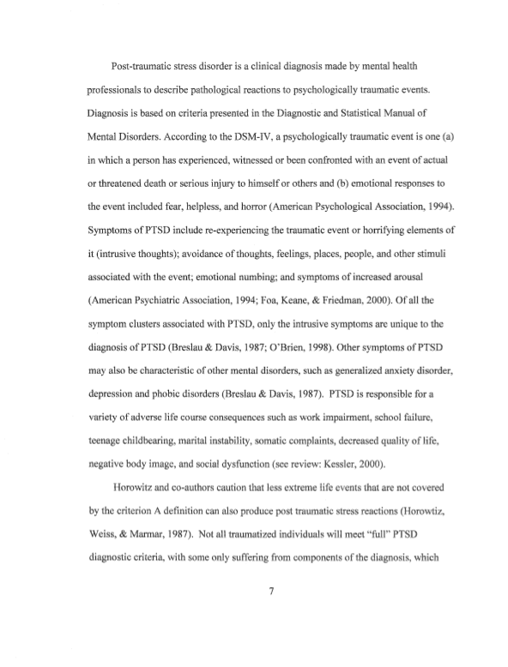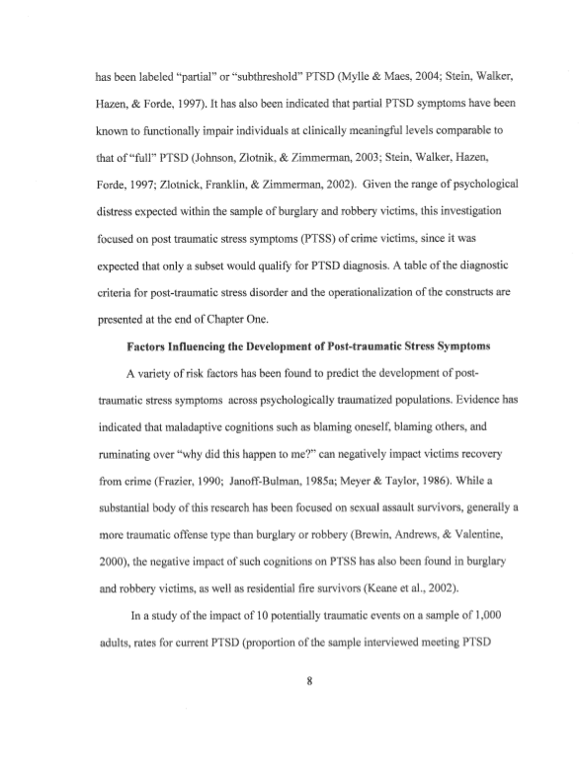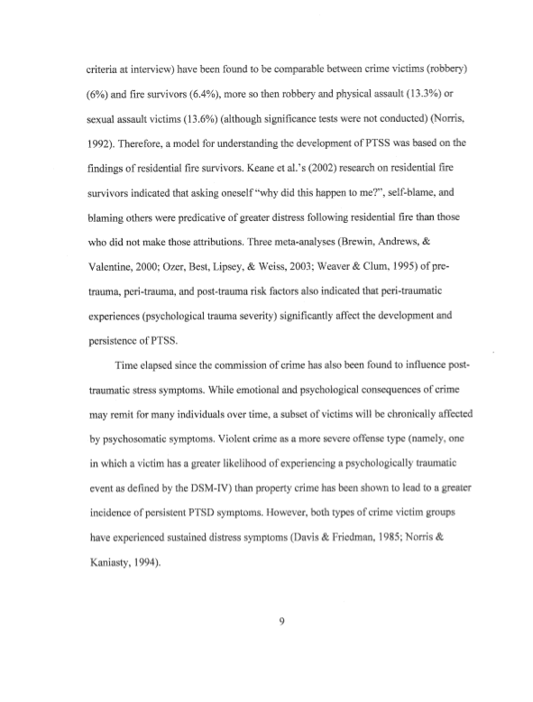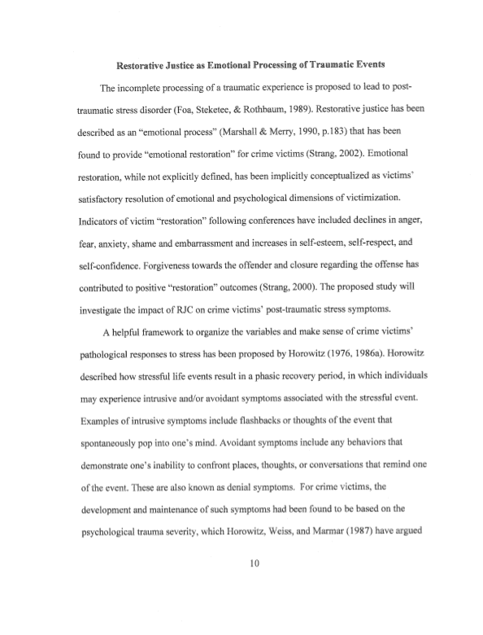

Gregory Capobianco, FN 82

FN 82: Hadar Dancig-Rosenberg & Dana Pugach, Pain, Love, and Voice: The Role of Domestic Violence Victims in Sentencing, 18 Mich. J. Gender & L. 423 (2012).

Source Information:

URL: https://a.next.westlaw.com/Document/Idea40f7b508d11e18b05fdf15589d8e8/View/FullText.html?transitionType=UniqueDocItem&contextData=(sc.Default)

18 Mich. J. Gender & L. 423
Michigan Journal of Gender & Law
2012
Article
PAIN, LOVE, AND VOICE: THE ROLE OF DOMESTIC VIOLENCE VICTIMS IN SENTENCING
Hadar Dancig-Rosenberg^{a1} Dana Pugach^{a2}
Copyright (c) 2012 The University of Michigan (Michigan Journal of Gender & Law); Hadar Dancig-Rosenberg; Dana Pugach

*424 Introduction
Criminal law systems throughout the world have evolved to a stage where they no longer ask, “What is the appropriate role of the victim in a criminal trial?” The questions now relate to the scope of the victim's rights, in which procedures she has independent standing, and at what stage she should be heard.¹ The process of the “prosecution stepping into the victim's shoes,” whereby the state controls the entire criminal process, seemingly on behalf of the victim, has been replaced by the recognition that the interests of the prosecution (the State) are not always consistent with those of the victim.² The view that will be developed here as the main thesis of this Article, that victims should be heard at the sentencing stage, irrespective of their views, is far from common. This Article will first establish the theoretical basis for this view by drawing on an expressive theory, discussed in Part I, and will take this theory a step further, into the sphere of the particular victim who asks for leniency.
The friction between the various interests represented in the criminal process frequently comes to the fore at the sentencing stage and is reflected in the sentence itself. The sentencing stage is not just the culmination of a criminal process; it may be viewed as the distillation of the entire criminal process. The harm to the victim is weighed against the assailant's personal profile as well as the public interest, and the outcome may be a call for retribution, prevention, deterrence or even *425 rehabilitation.³ Further, the sentencing process is usually not subject to the evidentiary rules that govern the entire criminal process in different criminal justice systems.⁴ At the sentencing stage, evidence may be introduced that would otherwise be excluded under statutory evidence law, including an impact statement by the victim.⁵ Moreover, even in those states that have adopted sentencing guidelines, the sentencing stage is often still a function of judicial discretion.⁶ Thus, it is important to consider restrictions that may apply to the victim's statement, following from procedural safeguards, even where strict evidentiary rules do not apply. Can the victim independently initiate a statement of her position, and to what extent may the court take her concerns or status into account as distinct from “damage” that characterizes victims of this nature? Should the victim be restricted to merely describing her damages, or should she also be entitled to express her view regarding the appropriate sentence?
*426 Traditionally, the victim's point of view is regarded only in the context of pushing for severity in sentencing.⁷ We are accustomed to hearing the protests of crime victims against the lenient punishments of “their” defendants and against plea bargains that appear to be acts of kindness to the defendants.⁸ Different legal systems took one step towards recognition of the relevance of pleadings relating to concrete damage by expanding the avenues for compensation based either upon the criminal proceeding or the criminal injury itself.⁹ The standing of a victim as a proponent for harsher sentencing is a matter which is far from simple, yet we shall focus on a matter which is even tougher: the standing of a victim who requests leniency.¹⁰ Thus, how should the court *427 act when those belonging to a defined group deemed worthy of special protection, namely, victims of intimate partner violence, seek leniency for their partners?¹¹ The problem highlighted here is the relationship between the public interest and victims' private interest. How should the tension which may result from the conflict between the interests of the individual victim who advocates leniency be reconciled with the interests of the “collective” victims--the sector of women suffering from domestic violence?
Part I establishes a general theoretical framework that supports granting a voice to every victim at the sentencing stage as an obligation of the legal system. We derive this obligation to the victim and society from a sentencing theory that attributes importance to the message transmitted by the criminal trial, the feelings evoked by the injury, and the ensuing punishment. We imbue this expressive theory with a new interpretation and argue that the only feasible conclusion is that any subjective victim's view should be heard and taken into account. We shall also briefly consider alternative proceedings in criminal law that prima facie provide a worthy solution that respects the female victim.
Proceeding to the specific offense of spousal violence,¹² Part II presents a synopsis of the psycho-social background required for an understanding of the unique character of crimes of domestic violence. This discussion will offer the background to our proposed comprehensive solution, informed by a feminist analysis of dilemmas posed by domestic violence. These dilemmas arise from a tension between paternalism and the desire to protect women on the one hand, and the recognition of women's autonomy and free choice on the other hand. This tension gives rise to a number of fundamental questions which will be discussed.¹³
*428 In Part III we present our own approach, a complex feminist view, which rejects the adoption of a dichotomous perspective found in current literature that recognizes only two diametrically opposed positions for describing a woman's autonomy and her freedom of choice. That perspective fails to explain the complex reality that characterizes life in the shadow of violence; instead, we propose the adoption of a resolution-sensitive model that recognizes a scale of situations that reflect the actions of women functioning in situations of partial autonomy. We argue that in each case there must be an examination of the subjective position of the woman and the underlying motives of her request for leniency in sentencing, having consideration for the nature of the spousal relationship and the woman's inner world. Based on this approach we attempt to derive a solution appropriate for a multi-dimensional model that takes a pluralistic approach to female typology. We propose a practical tool for examining the question--a modus operandi for receiving the report on the victim (Victim Report). Familiarity with the woman's inner world through a comprehensive victim report is likely to facilitate an understanding of the motivation behind her request for leniency. Thus, a comprehensive victim report will help the victim herself (a goal in itself, particularly according to principles of therapeutic jurisprudence), improve the criminal justice system, and contribute to socio-legal research.
The importance of this Article's thesis is twofold. First, it will contribute to the developing body of theoretical writing in the area of victims' rights and the idea of therapeutic jurisprudence. Second, this Article will contribute to the practical aspect of victims' rights as it recommends a tool, the Victim Report, to solve the truly difficult dilemma of how best to present the victim's view to the court (once it has been determined that this step is crucial). The proposed solution demonstrates the advantages to be gained by integrating therapeutic tools into the fabric of the legal system.
I. The Role of the Victim in the Sentencing Process
A. The Victim's Views Among Other Sentencing Considerations
Initially, we shall present what we believe to be the appropriate theoretical framework both for justifying punishment and for determining the level of punishment and the victim's role in this determination. This discussion is vital because even those in favor of giving victims standing at the sentencing stage are not united in their approach; significant differences *429 exist among the various theories and models designed to safeguard this standing.
In the classical model, criminal law represented the public interest whereas tort law was seen as the appropriate way to recover private damages.¹⁴ Classical theories focused on the conceptual need to punish the wrongdoer for his wrongdoings.¹⁵Accordingly, it is almost impossible to find separate references to the views of the victim in the voluminous literature dealing with the justification for particular sentences in criminal law; in this context there is no distinction among models offering a theoretical justification for sentences, such as retribution or utilitarianism. In general, no attention is paid to the past or future condition of the specific victim.¹⁶ Another factor routinely rejected by authors writing about sentencing is emotion; they focus on cognition instead.¹⁷ After *430 many years of searching for the justification for punishment, emotion is treated with contempt and is seen as something to be disregarded unless it can be wrapped under the mantle of “moral concepts,” as in Bentham's use of the concept of retribution which may include anger.¹⁸ Accordingly, literature dealing with punishment theory often sweepingly dismisses the negative feelings of victims towards their abusers as “vindictiveness” or “vengefulness.” The desire for revenge is portrayed as an ignoble, immoral emotion that should not be included among sentencing considerations.¹⁹
One relevant sentencing theory--the expressive theory--emphasizes the messages conveyed by actions and legal processes. This concept recognizes the offense as conveying a negative message for the victim and society, and the sentence as a means of reflecting the condemnation of the wrongdoer. The sentence also serves as an outlet for feelings such as jealousy, resentment, and anger harbored by society and *431 the victim.²⁰ Nonetheless, even the supporters of this theory have generally failed to discuss the voice of the specific victim or the spectrum of possible emotions potentially stirred up by a crime. Instead, they have seen it as a public catharsis,²¹ a condemnation on behalf of those in whose name the sentence is imposed and the social consequence of the crime.²² As William DeFord notes, importance attaches to the fact that these writers speak of expressivism and not of communication--one aspect of communication is that it entails the transmission of messages between all involved parties, while expressivism is restricted to a one-way message being sent.²³
The lack of reference to the individual victim in the expressive theory is surprising, considering the changing perceptions regarding victims' roles. The increasing acknowledgement of the victim as a person who can no longer be ignored in the criminal process and whose role is not purely that of a witness has given rise to the concomitant question: how much weight should be given to the victim's views, emotions, and wishes in sentencing considerations in the criminal trial?²⁴ Avoiding the question by referring the victim to civil proceedings or even to alternative processes is seen as an improper way of getting rid of the victim without according her the justice she deserves through the criminal process, and perhaps even causing harm to the public, which may expect *432 consideration to be given to the victim.²⁵ Indeed, in recent years there has been a developing debate as to whether it is appropriate to give the victim an independent voice during the sentencing stage, and if so, how best to define her status: whether as a witness to the damage (the “soft version”) only, or as one entitled to express her opinion as to the appropriate sentence (the “extreme version”).²⁶As noted, prevailing sentencing theories that ignore the victim are incompatible with the latter view and a different theory that will allow the victim's voice to be heard is required.
Diane Whiteley's scholarship provides a theoretical foundation for this Article. Whiteley's theory draws on concepts from expressivist literature such as the centrality of communication in the writings of Dan M. Kahan, while also considering the subjective dimension of a particular victim.²⁷ Thus, it is possible to view Whiteley's position as supplementing existing sentencing theories and not as replacing them. Whiteley bases the need to listen to the victim and consider her views among other sentencing considerations on the “moral sentiments” which the recognized victim and community feel as a result of the crime.²⁸ According to Whiteley, erasing emotion from theoretical thinking about criminal law action and justifications discounts very significant factors.²⁹ *433

Gregory Capobianco, FN 83

FN 83: Albert Dzur & Susan Olson, The Value of Community Participation in Restorative Justice, 35 J. of Soc. Phil. 91 (2004).

Source Information:

URL: http://onlinelibrary.wiley.com/doi/10.1111/j.1467-9833.2004.00218.x/abstract

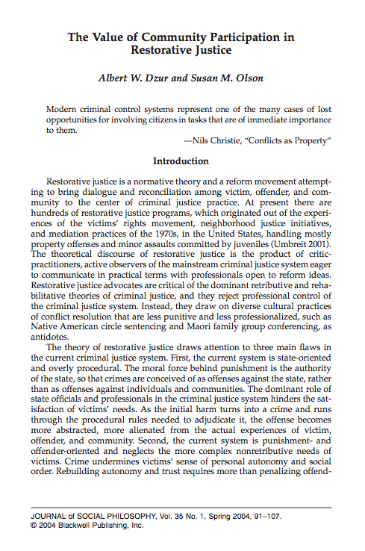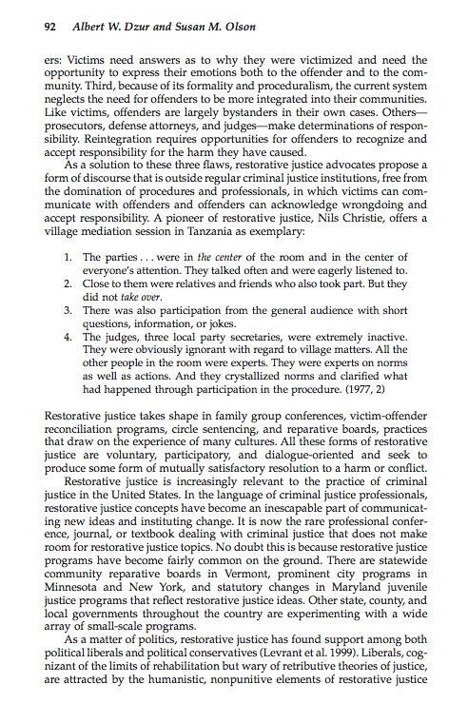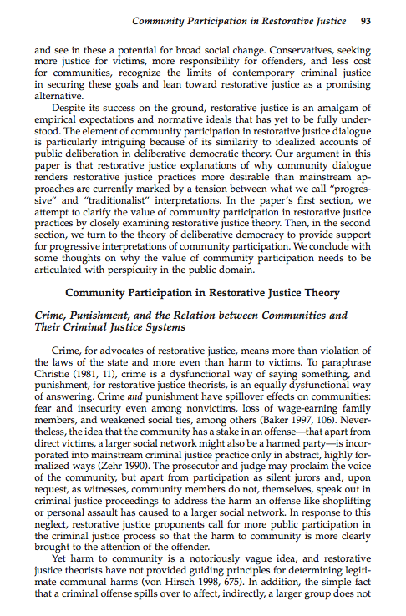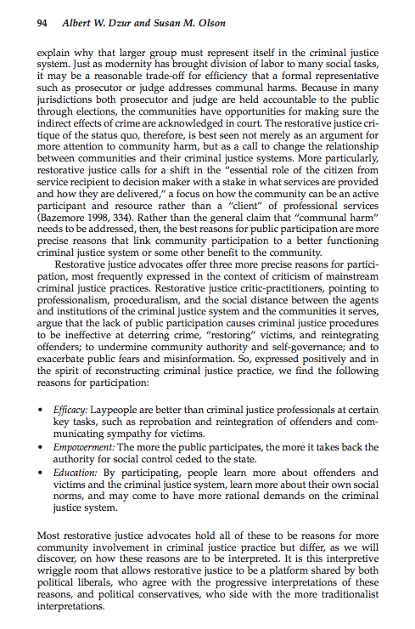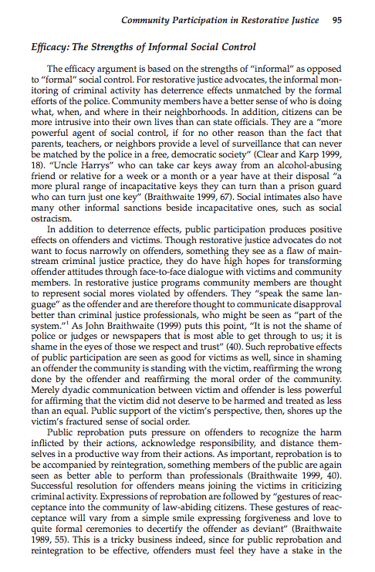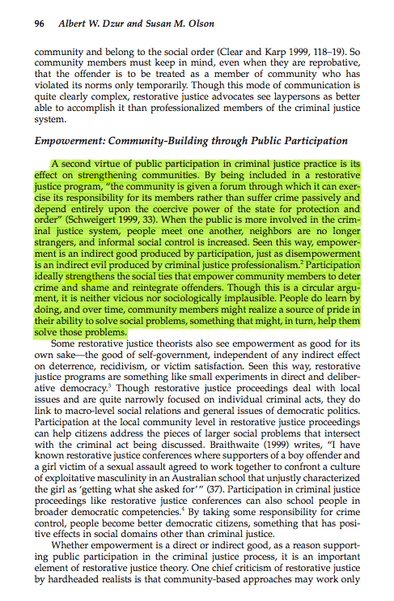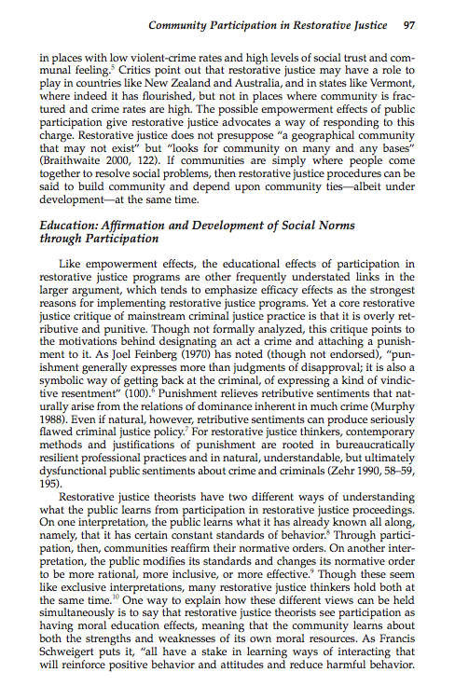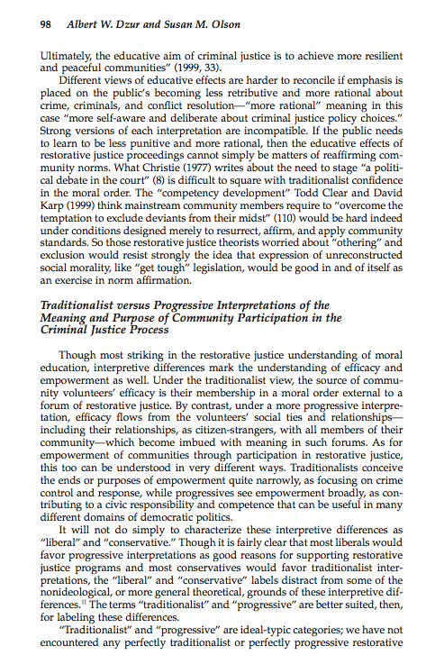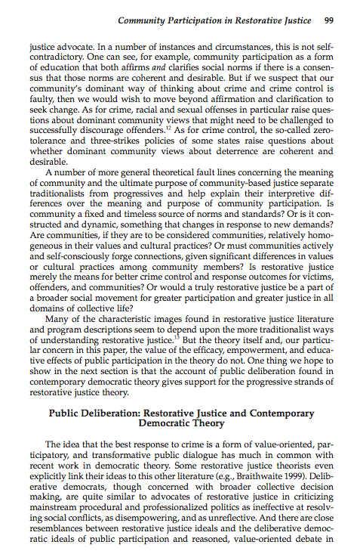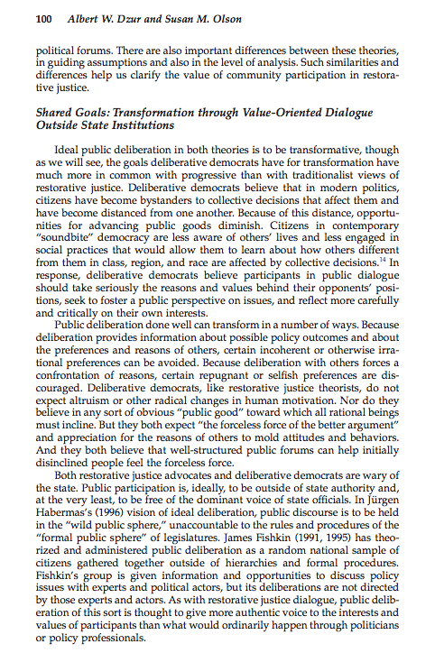

Gregory Capobianco, FN 84

FN 84: Mimi Kim, Alternative Interventions to Intimate Violence: Defining Political and Pragmatic Challenges, in Restorative Justice and Violence Against Women 196 (James Ptacek ed., 2010).

Comment: Even though I could not find the pin cited pages for this source, I included the cover, copyright, and TOC pages.

I have filed a library retrieval for this source.

Source Information:

URL: http://books.google.com/books?id=KYCOBFb8GO4C&printsec=frontcover&source=gbs_ge_summary_r&cad=0#v=onepage&q&f=false

Gregory Capobianco, FN 85

FN 85: See Randall Collins, Interaction Ritual Chains (2004) (describing restorative justice processes as a “social ritual”. Collins explains how such rituals reinforce a sense of belonging among their participants, strengthen social norms, create “group energy” and reduce anger among the participants).

Source Information:

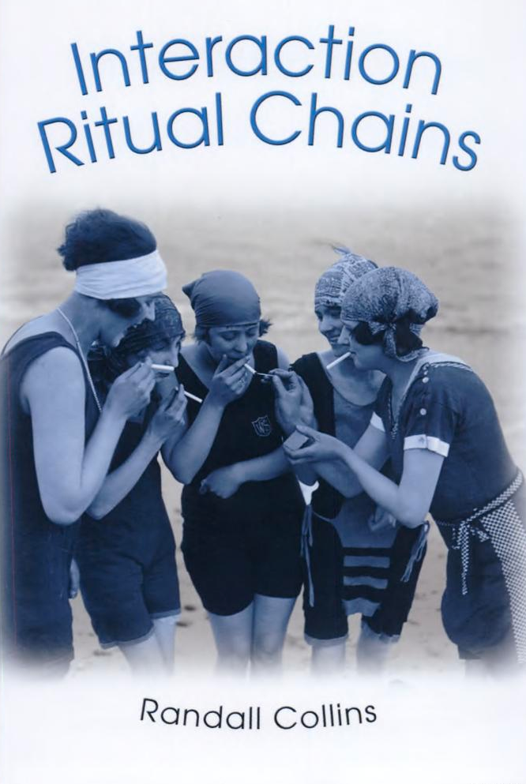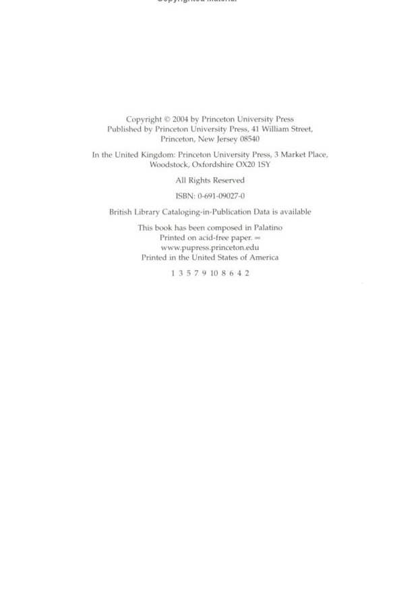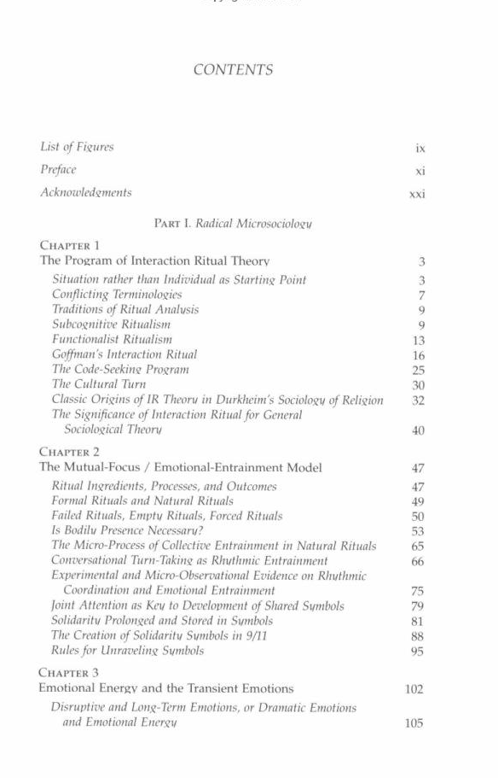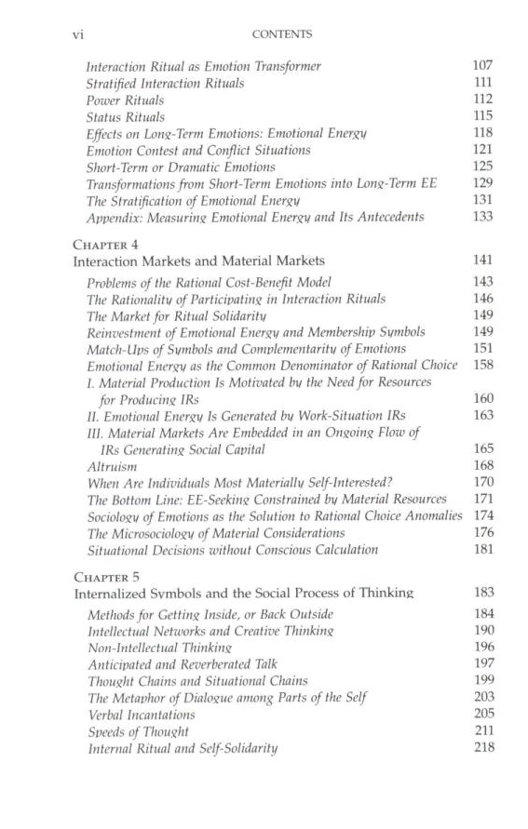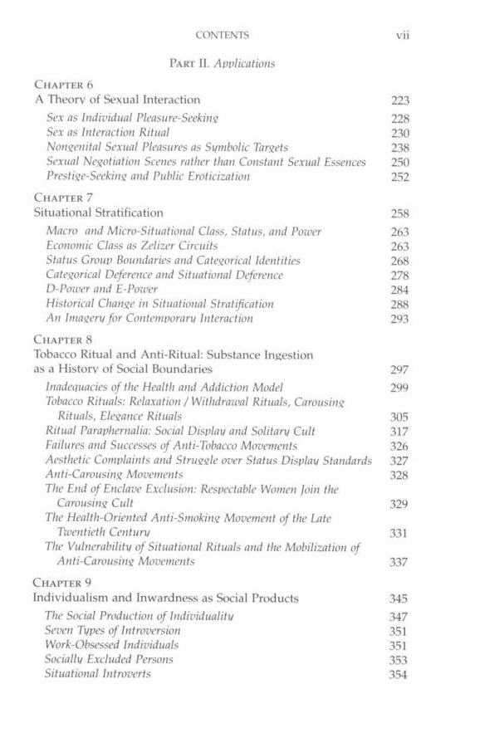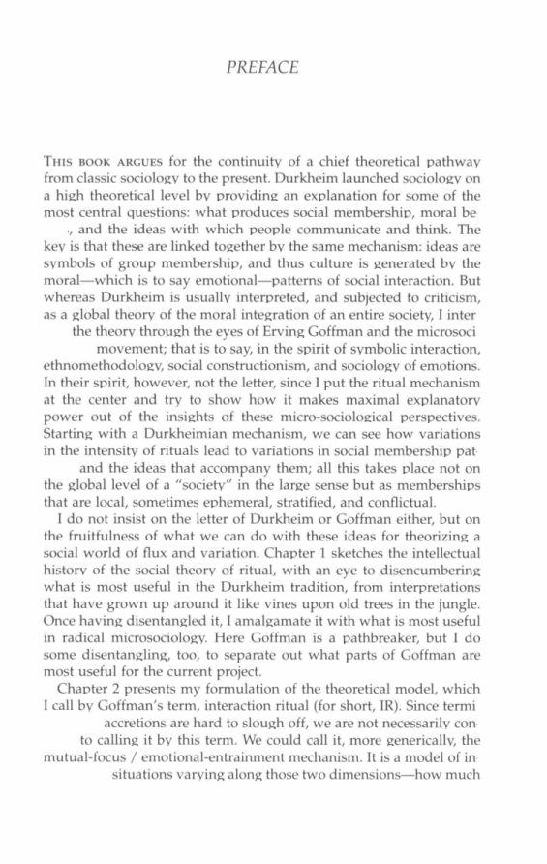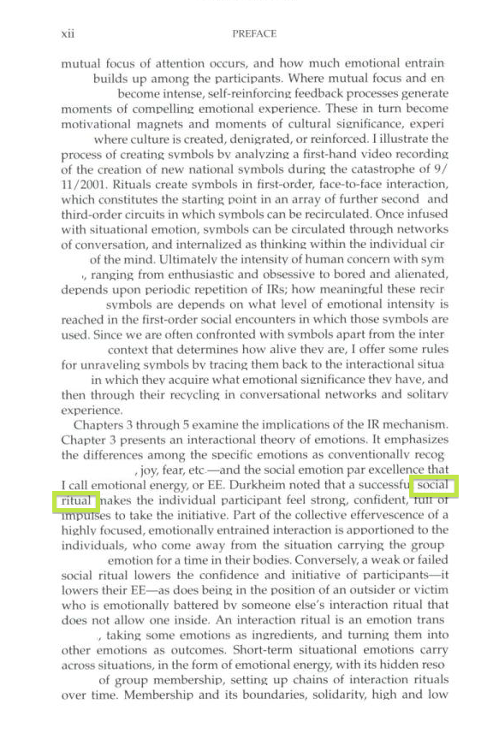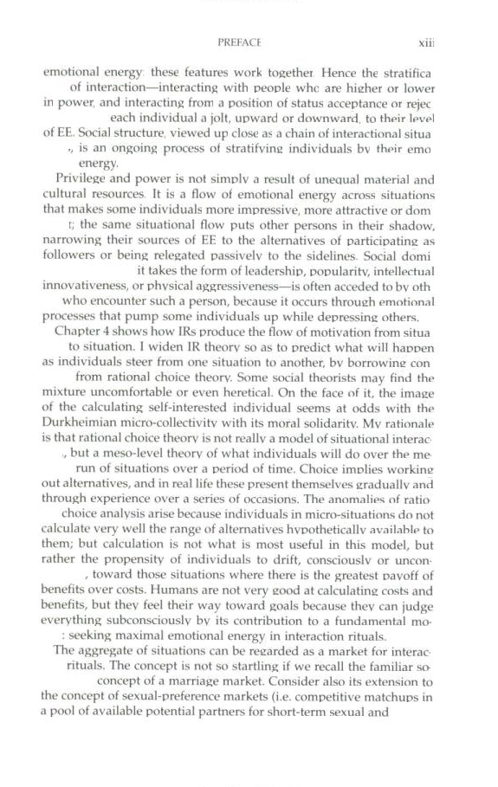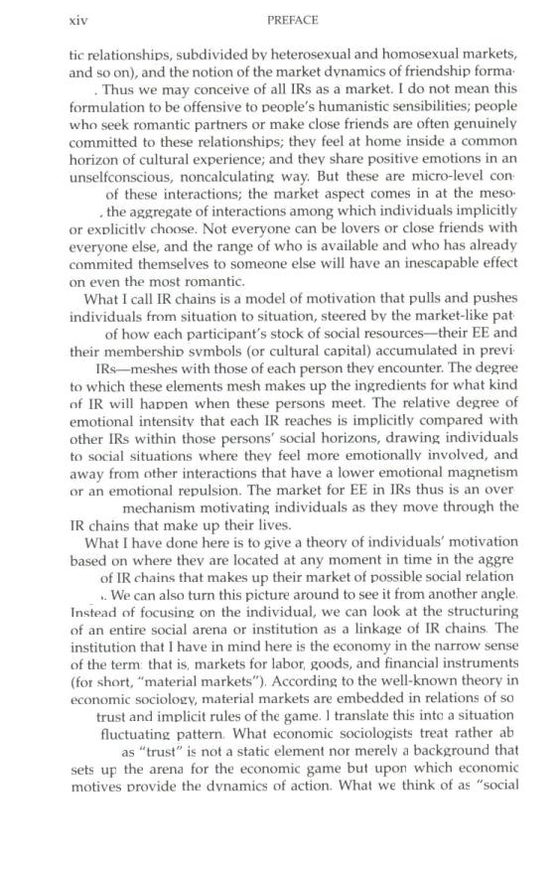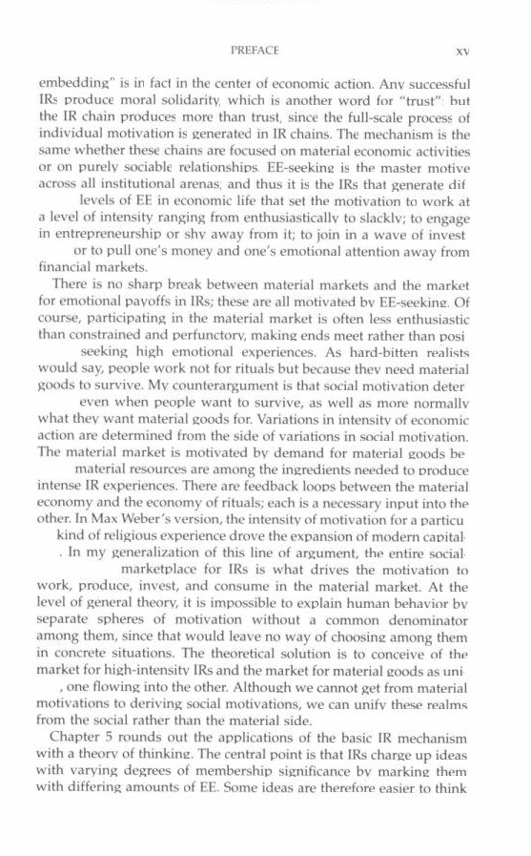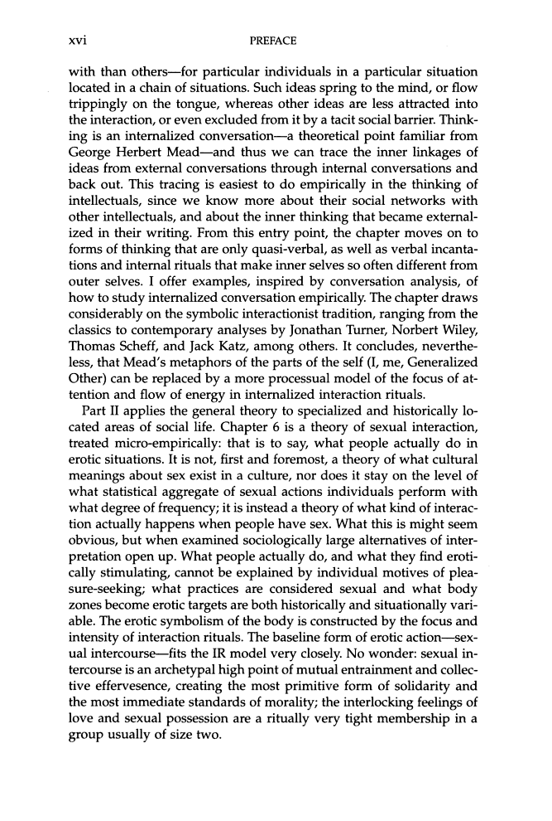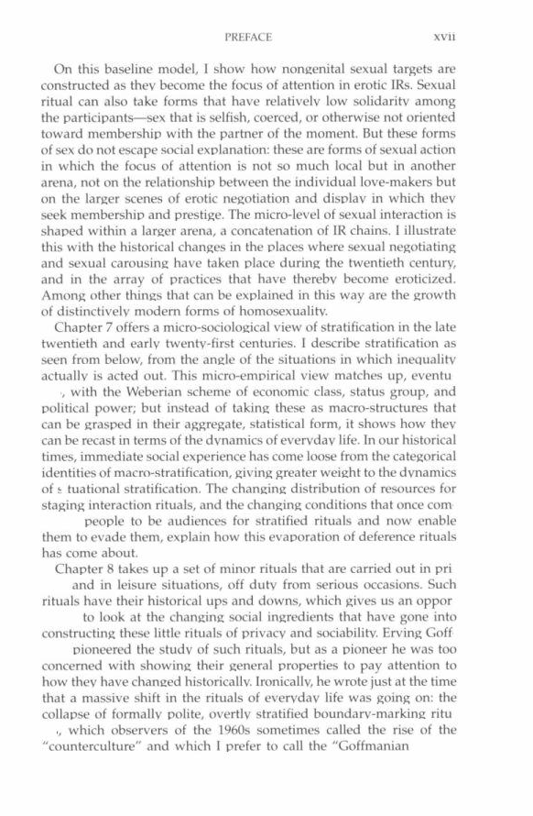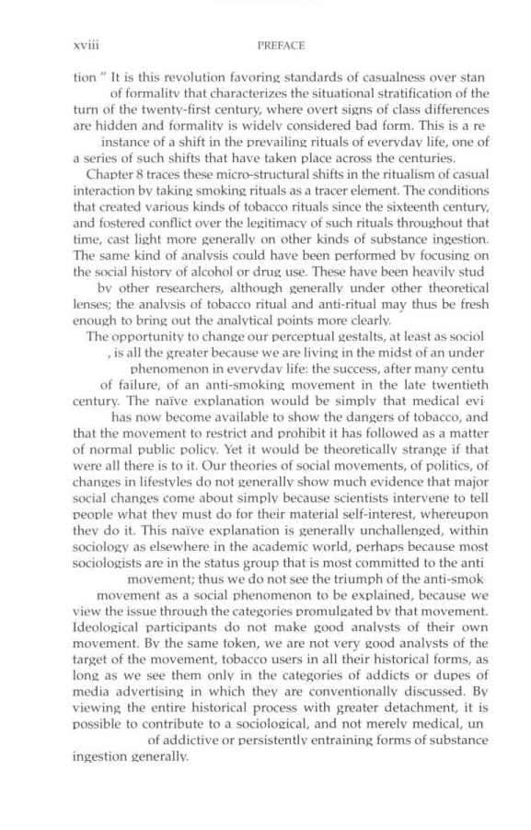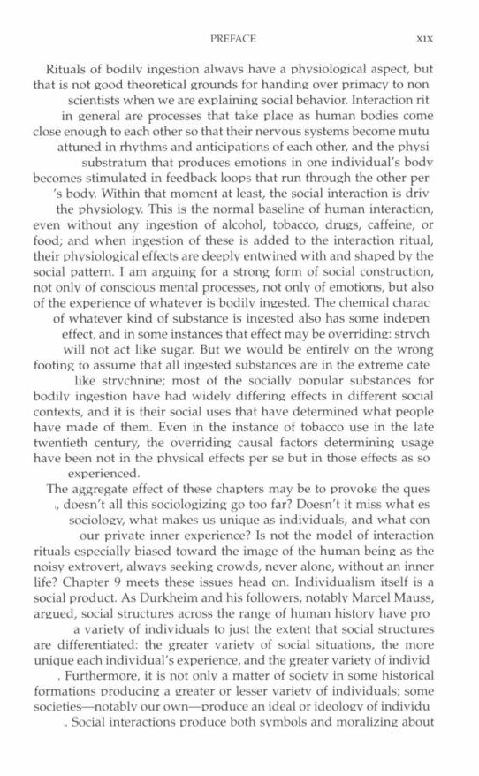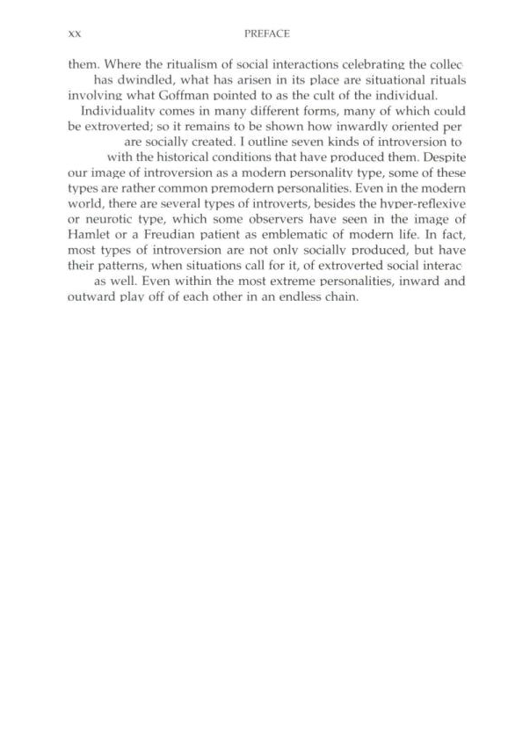

Gregory Capobianco, FN 86

FN 86: Bazemore, supra note 1.

Referring To: See, e.g., Gordon Bazemore, Restorative Justice and Earned Redemption, 41 Am. Behav. Sci. 768 (1998);

Source Information:

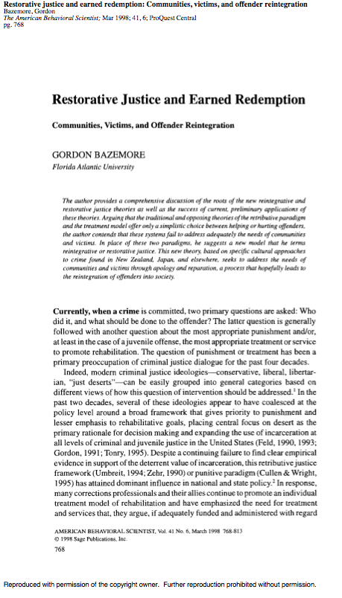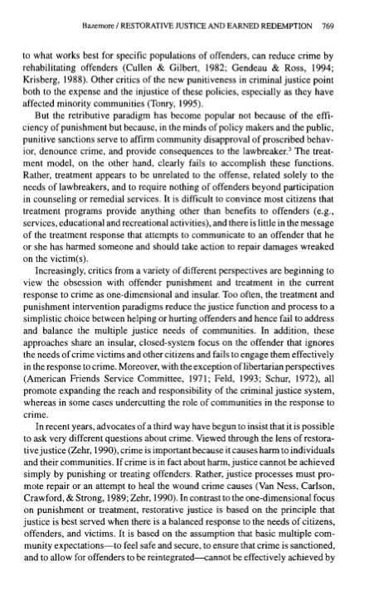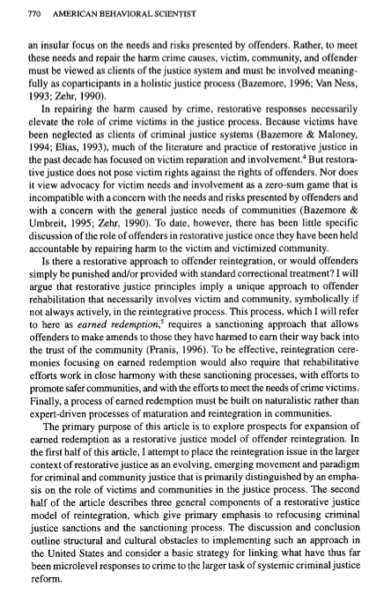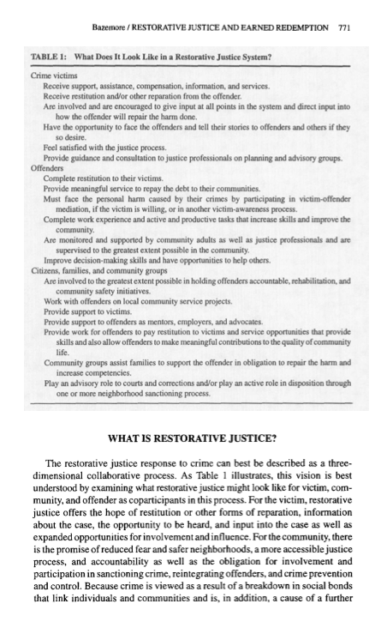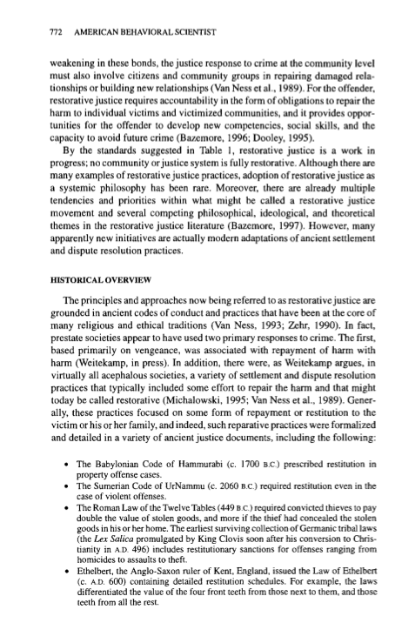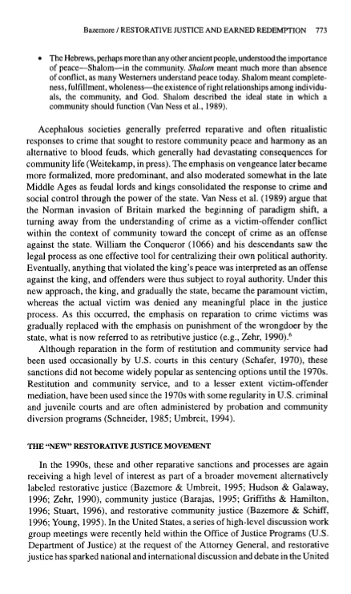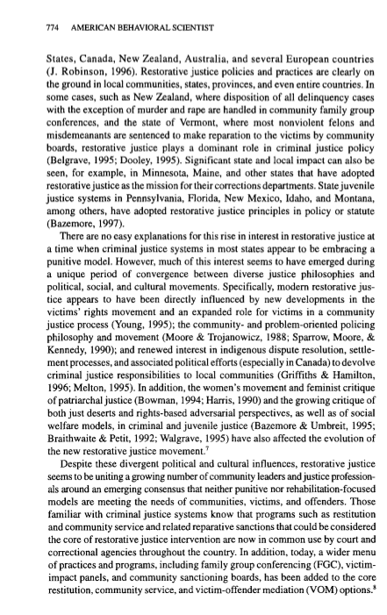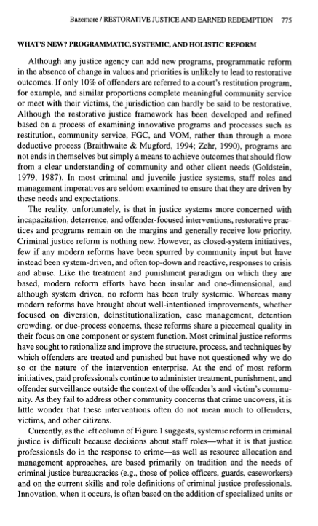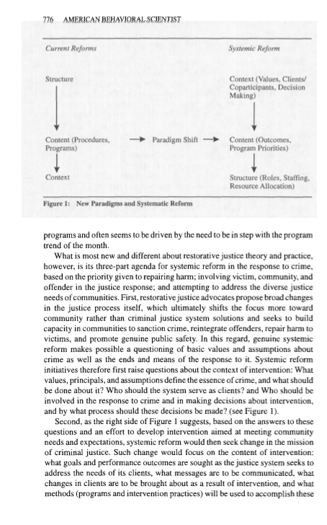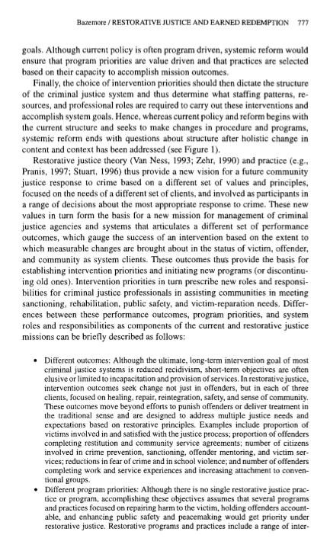

Gregory Capobianco, FN 87

FN 87: Lode Walgrave, Restorative Justice, Self-Interest and Responsible Citizenship 76 (2008) (portraying the community as both a means and an end).

Comment: I have filed a library retrieval for this source.

Source Information:

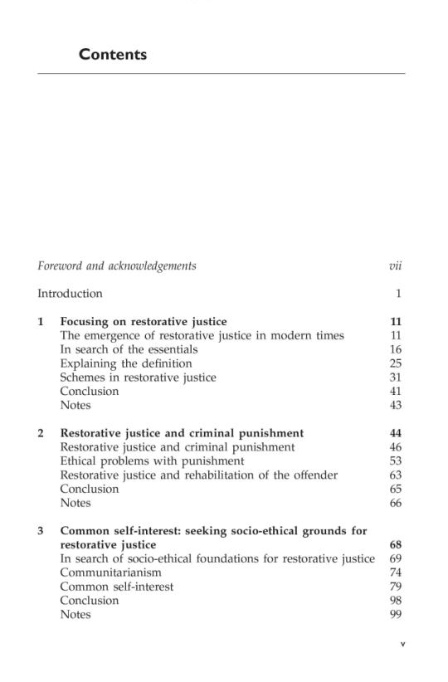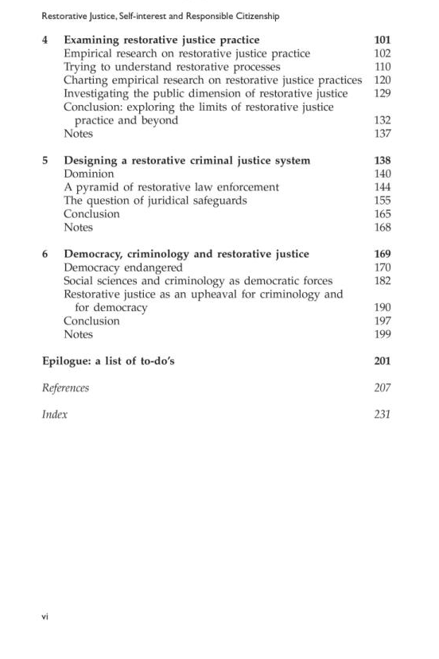

Gregory Capobianco, FN 88

FN 88: Robert White, Social Justice, Community Building and Restorative Strategies, 3 Contemp. Justice Rev. 55 (2000).

Comment: According to Table 13, “Justice” should be abbreviated to “Just.”

I was unable to file a true library retrieval for this source. I cannot find the Article on HeinOnline, JSTOR, Proquest, EBSCO, or WorldCat more generally. The journal is available at http://www.tandfonline.com/loi/gcjr20, but only back until Volume 5, in 2002.

Gregory Capobianco, FN 89

FN 89: By “requital” we mean both the goal of achieving proportionality in punishment (“just deserts”), and the goal of “making offenders pay” for their deeds (retribution).

Comment: Proposition does not require citation.

Gregory Capobianco, FN 90

FN 90: Deontological moral theories highlight the intrinsic value of actions and norms. See George P. Fletcher, The Grammar of Criminal Law: Foundations, at ch. 5.3 (2007).

Comment: I have filed a library retrieval for this source.

Source Information:

URL: http://books.google.com/books?id=aahu4OAab8wC&printsec=frontcover&source=gbs_ge_summary_r&cad=0#v=onepage&q&f=false

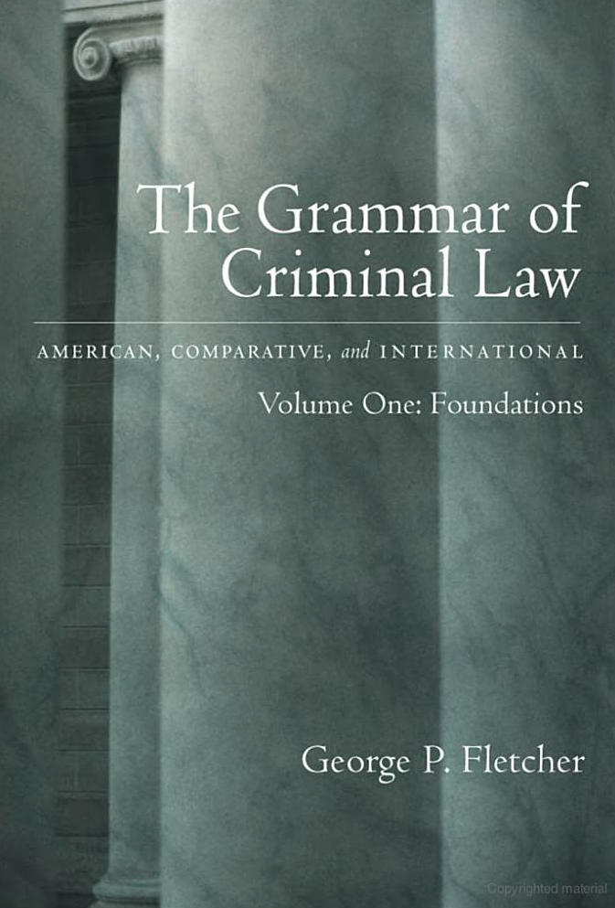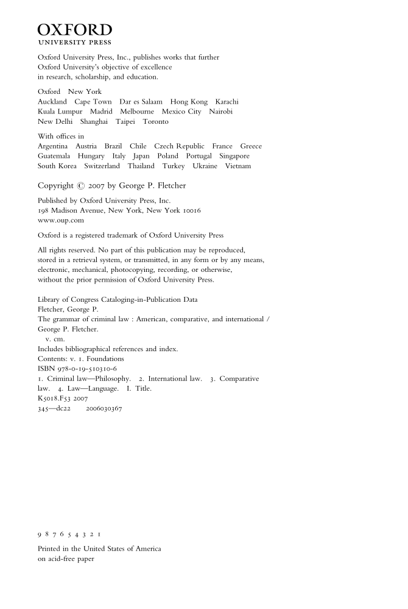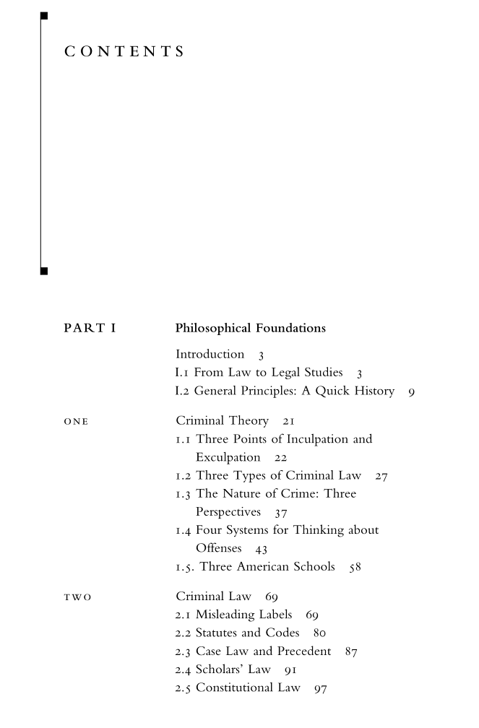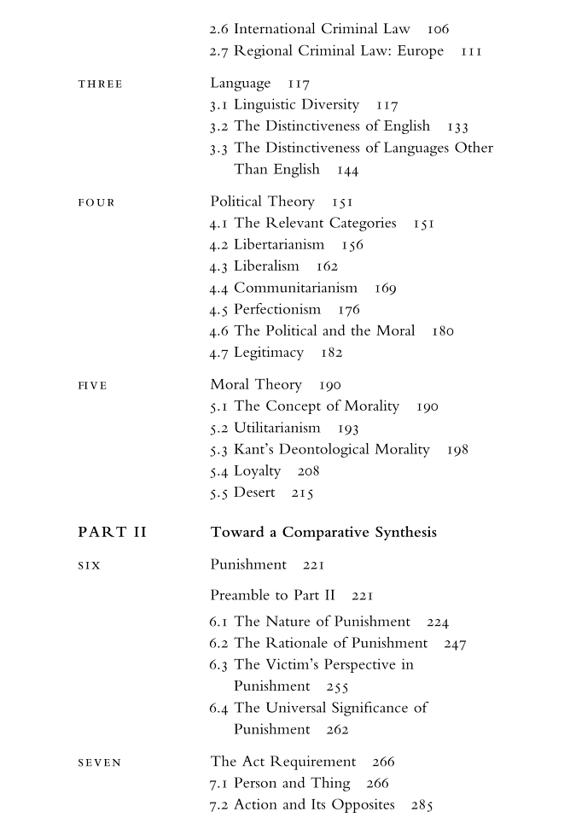

Gregory Capobianco, FN 91

FN 91: See John Rawls, Two Concepts of Rules, 64 Philos. Rev. 3, 5 (1955) (explaining that according to the retributivist approach, “The state of affairs where a wrongdoer suffers punishment is morally better than the state of affairs where he does not).”

Comment:

Source Information:

URL: http://philosophyfaculty.ucsd.edu/faculty/rarneson/Courses/RAWLStwoconceptsrules.pdf


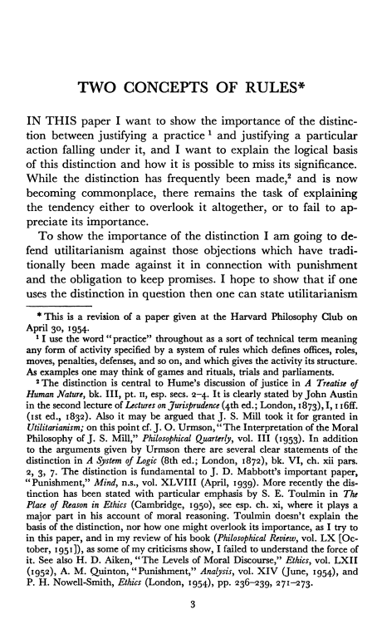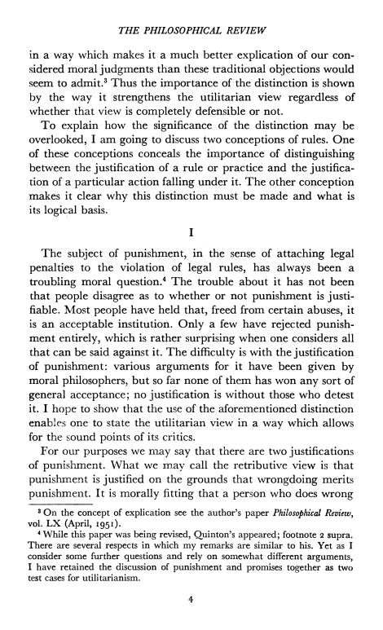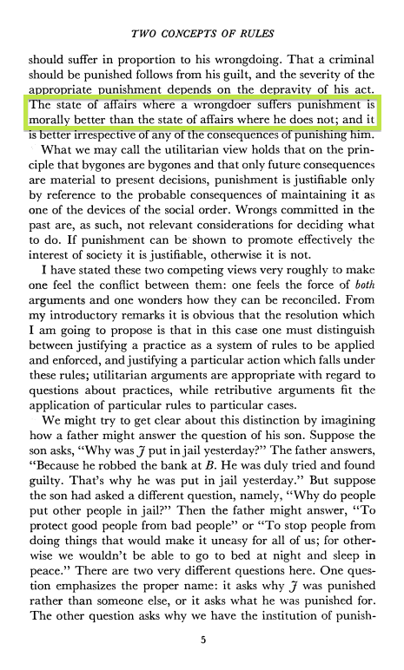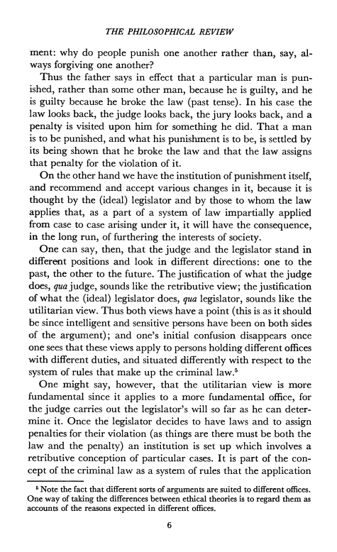

Gregory Capobianco, FN 92

FN 92: For a review of the various positions regarding retribution within restorative justice see Michael King, Arie Freiberg, Becky Batagol, & Ross Hyams, Non-Adversarial Justice 44-45 (2009).

Source Information:

URL: http://books.google.com/books?id=QN5ZJuddf-wC&printsec=frontcover

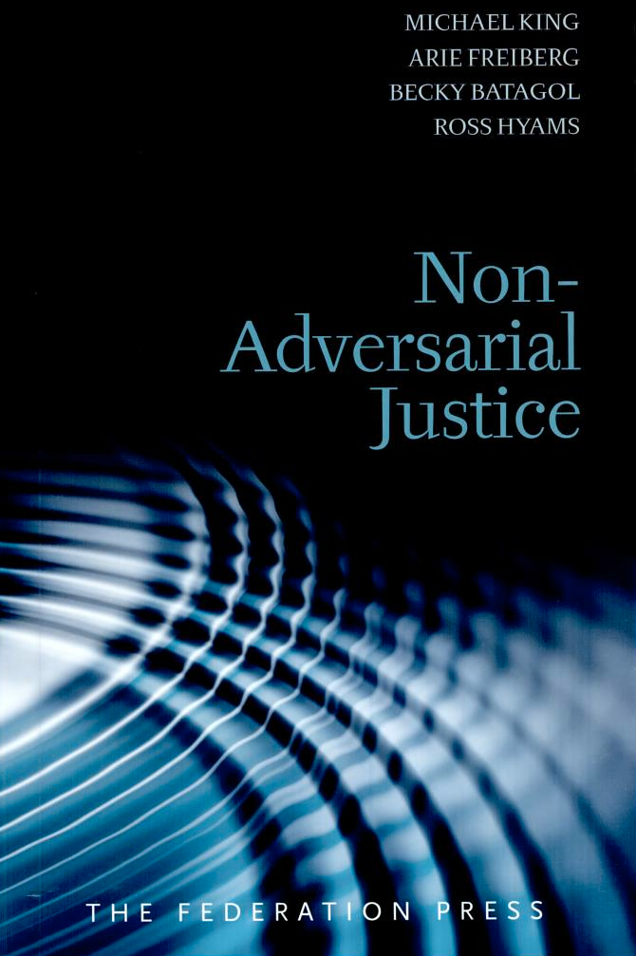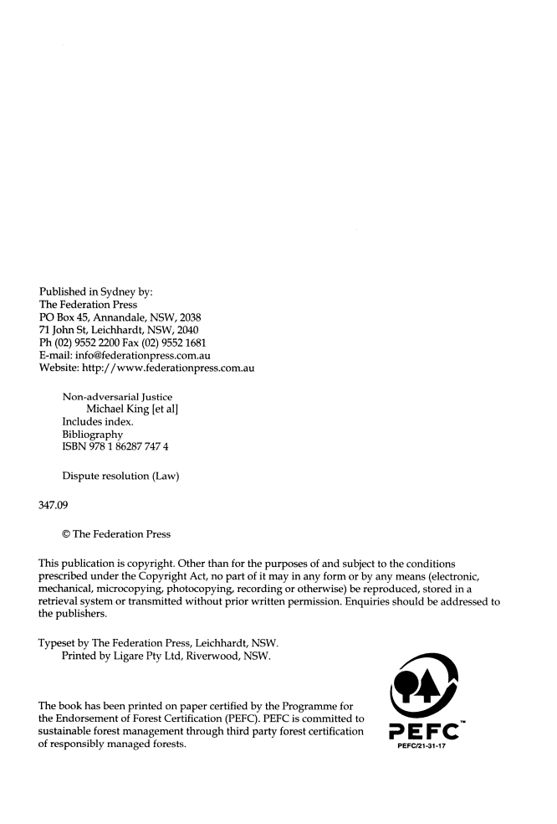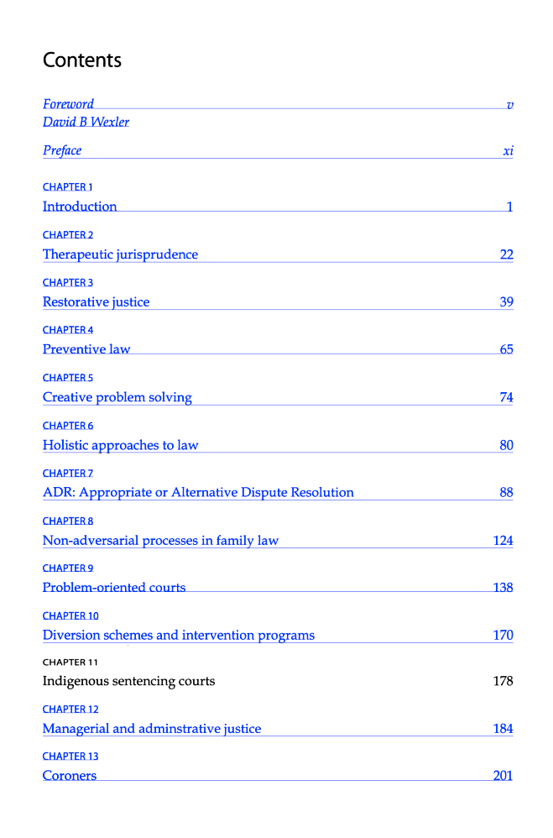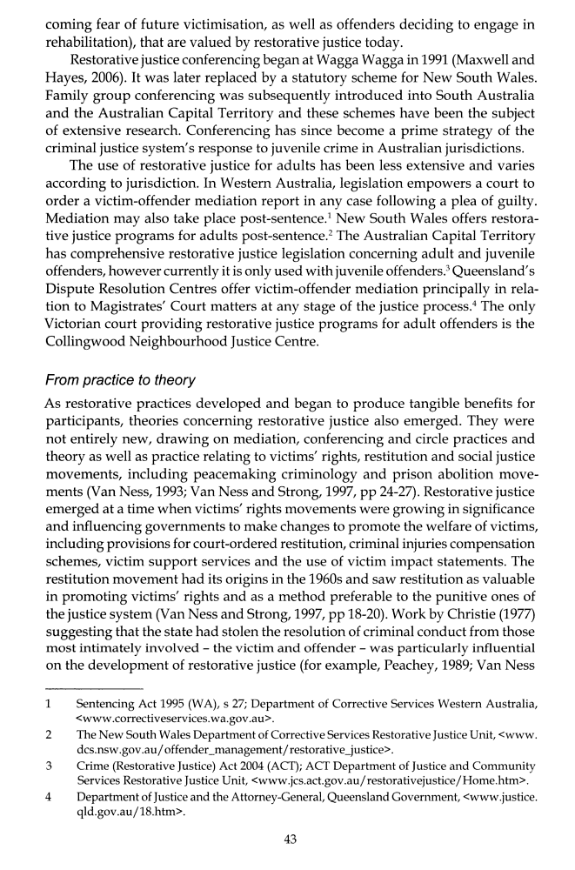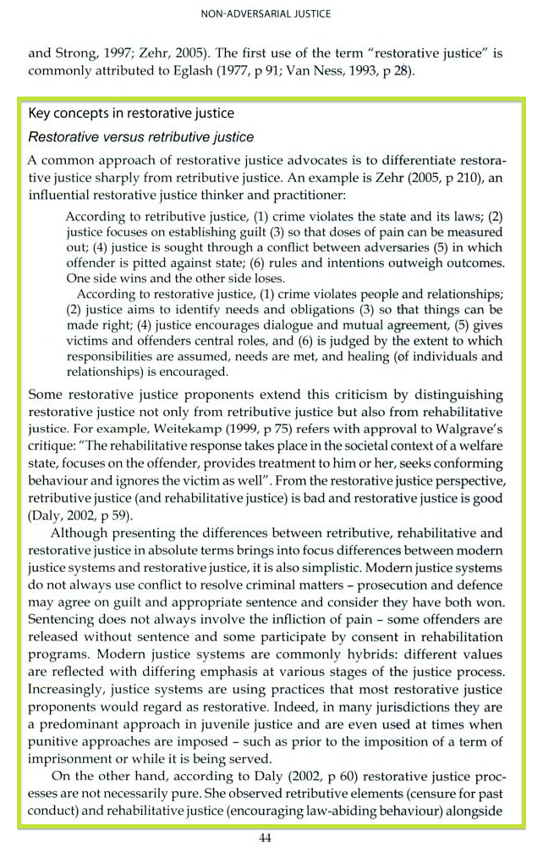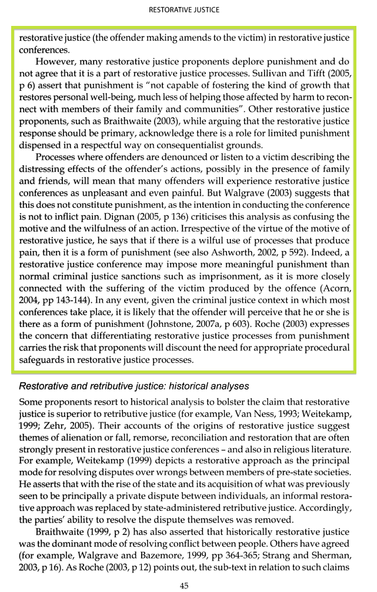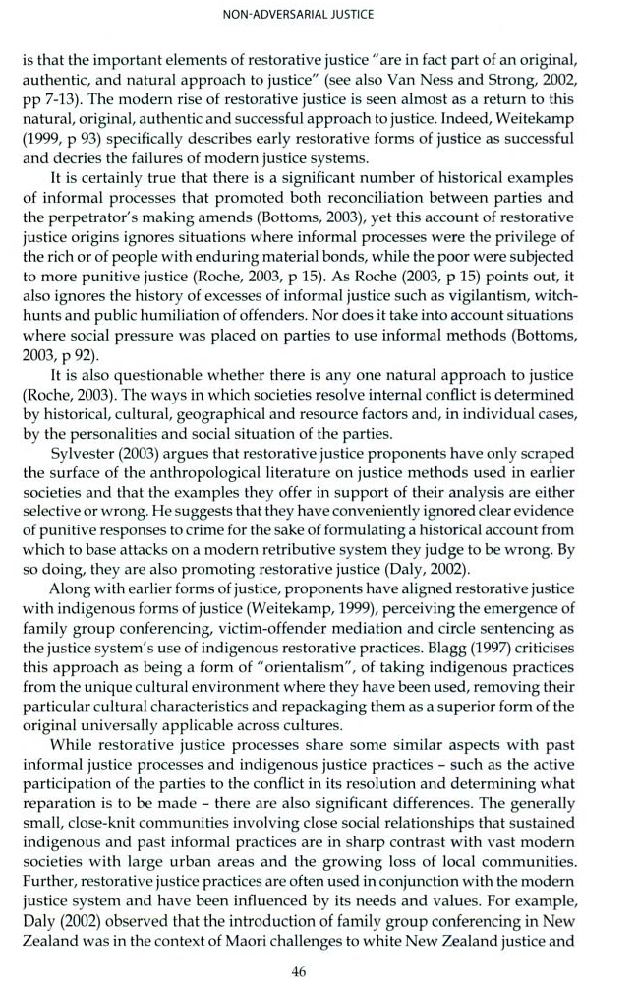

Gregory Capobianco, FN 93.1

FN 93.1: See Martin Wright, Justice for Victims and Offenders: A Restorative Response to Crime, 133-135 (2d ed., 1996);

Comment: While I was not unable to find the pin cited pages, I did include the cover, copyright, and TOC pages below.

I have filed a library retrieval for this source.

Source Information:

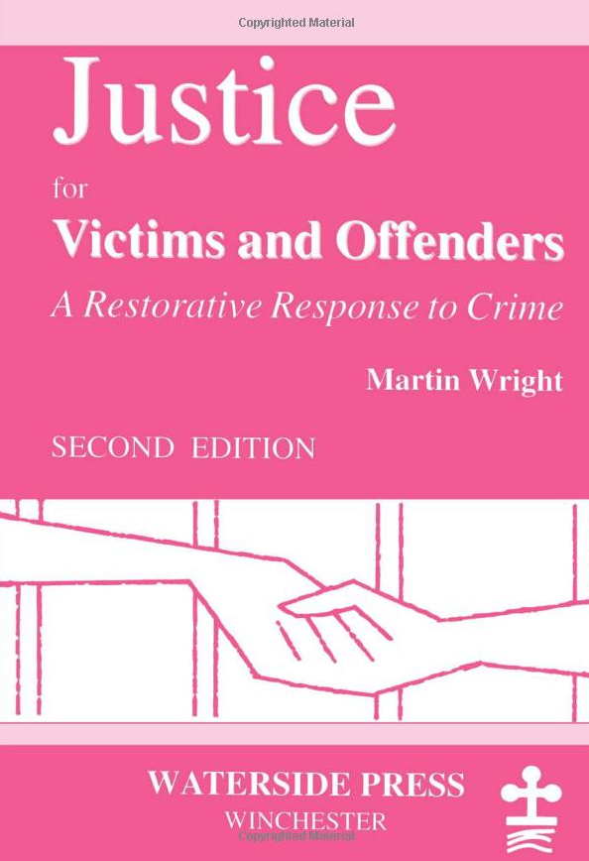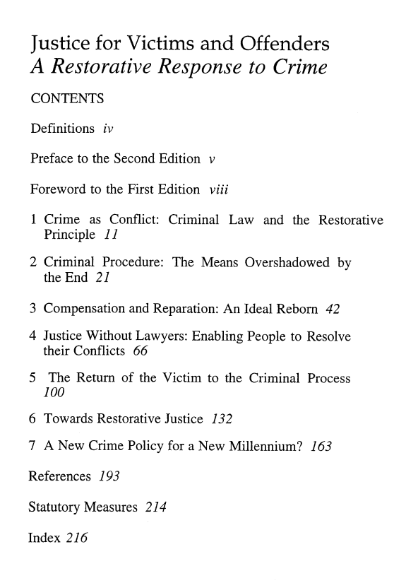

Gregory Capobianco, FN 93.2

FN 93.2: Daniel. Van Ness, supra note 1, at 251-52, 258-59.

Referring To: Daniel Van Ness, New Wine and Old Wineskins: Four Challenges of Restorative Justice, 4 Crim. L. F. 251 (1993).

Source Information:

URL: https://a.next.westlaw.com/Document/I8adb45315a2411dbbe1cf2d29fe2afe6/View/FullText.html?navigationPath=Search%2Fv3%2Fsearch%2Fresults%2Fnavigation%2Fi0ad705250000013d2dd216d7de1bcac3%3FNav%3DANALYTICAL%26fragmentIdentifier%3DI8adb45315a2411dbbe1cf2d29fe2afe6%26startIndex%3D1%26contextData%3D%2528sc.Search%2529%26transitionType%3DSearchItem&listSource=Search&listPageSource=74149503428f611b299f8f4cb7dcd9c4&list=ANALYTICAL&rank=3&grading=na&sessionScopeId=4fe0fcaa580bf6033cb1012528a2ea6f&originationContext=Search%20Result&transitionType=SearchItem&contextData=%28sc.Search%29#co_tempAnchor

4 Crim. L.F. 251
Criminal Law Forum
1993
NEW WINE AND OLD WINESKINS: FOUR CHALLENGES OF RESTORATIVE JUSTICEª
Daniel W. Van Ness ^{aa}
Copyright (c) 1993 by Prison Fellowship

[*251]
And nobody puts new wine into old wineskins; if he does, the wine will burst the skins, and the wine is lost and the skins too. No! New wine, fresh skins.
Mark 2:22
At the 1987 London conference on criminal law reform that led to the formation of the Society for the Reform of Criminal Law, Justice John Kelly of Australia delivered a remarkable address on the purpose of law.¹ Speaking to two hundred judges, legal scholars, and law reformers from common law countries, he laid aside his prepared comments and spoke with great feeling about the need for criminal law practitioners to see themselves as healers. A purpose of criminal law, he *252 said, should be to heal the wounds caused by crime. Since “healing” is not a word frequently heard in legal gatherings, it was helpful that he illustrated what he meant.
Justice Kelly told of a case in which he had made a special effort to ensure that a rape victim felt vindicated. He had just sentenced the defendant to prison, but before calling the next case he asked the victim to approach the bench. Justice Kelly had watched the complainant throughout the proceedings, and it was clear that she was very distraught, even after the offender's conviction and sentencing. The justice spoke with her briefly and concluded with these words: “You understand that what I have done here demonstrates conclusively that what happened was not your fault.” The young woman began to weep as she left the courtroom. When Justice Kelly called the family several days later, he learned that his words had marked the beginning of psychological healing for the victim. Her tears had been tears of healing.
The view that justice should bring about healing is, in fact, an ancient concept, one that a growing number of commentators are developing for contemporary application under the rubric of “restorative justice.” Advocates of restorative justice face legal and jurisprudential challenges, among these the challenge to abolish criminal law, the challenge to rank multiple goals, the challenge to determine harm rationally, and the challenge to structure community-government cooperation. This article will consider these fourchallenges in turn and suggest ways in which they might be addressed.
ROOTS
We are used to thinking of criminal law as the means through which government prohibits criminal behavior and punishes criminals.² We take for granted the distinction between private and public wrongs, which separates the law of torts from criminal law, a distinction *253 ingrained in our common law tradition.³ But there is another, older understanding of law that resists this duality, affirming that no matter how we administer the law, one of the primary goals of justice should be to restore the parties injured by crime.⁴
Early legal systems that form the foundation of Western law emphasized the need for offenders and their families to settle with victims and their families. Although crime breached the common welfare, so that the community had an interest in, and a responsibility for, addressing the wrong and punishing the offender, the offense was not considered primarily a crime against the state, as it is today. Instead, a crime was viewed principally as an offense against the victim and the victim's family.⁵ This understanding was reflected in ancient legal codes from the Middle East, the Roman empire, and later European polities.⁶ Each of these diverse cultures responded to what we now call *254 crime by requiring offenders and their families to make amends to victims and their families—not simply to insure that injured persons received restitution but also to restore community peace.⁷
This can be seen as well in the language of the Old Testament, where the word shalom is used to describe the ideal state in which the community should function.⁸ This term signifies completeness, fulfillment, wholeness—the existence of right relationships between individuals, the community, and God.⁹ Crime was understood to break shalom, destroying right relationships within the community and creating harmful ones. Ancient Hebrew justice, then, aimed to restore wholeness.¹⁰ Restitution formed an essential part of this process, but restitution was not an end in itself. This is suggested by the Hebrew word for “restitution,” shillum, which comes from the same root as shalom and likewise implies the reestablishment of community peace. Along with restitution came the notion of vindication of the victim and of the law itself. This concept was embodied in another word derived from the same root as both shalom and shillum—shillem. Shillem can be translated as “retribution” or “recompense,” not in the sense of revenge (that word in Hebrew comes from an entirely different root) but in the sense of *255 satisfaction or vindication.¹¹ In short, the purpose of the justice process was, through restitution and vindication, to restore a community that had been sundered by crime.
This view of justice is not confined to the far distant past. Many precolonial African societies aimed not so much at punishing criminal offenders as at resolving the consequences to their victims. Sanctions were compensatory rather than punitive, intended to restore victims to their previous position.¹² Current Japanese experience demonstrates a similar emphasis on compensation to the victim and restoration of community peace.¹³ The approach (as we will see later) emphasizes a process that has been referred to as “confession, repentance and absolution.”¹⁴
For all of its tradition, the restorative approach to criminal justice is unfamiliar to most of us today. For common law jurisdictions, the Norman invasion of Britain marked a turning point away from this understanding of crime. William the Conqueror and his successors*256 found the legal process an effective tool for establishing the preeminence of the king over the church in secular matters, and in replacing local systems of dispute resolution.¹⁵ The Leges Henrici, written early in the twelfth century, asserted exclusive royal jurisdiction over offenses such as theft punishable by death, counterfeiting, arson, premeditated assault, robbery, rape, abduction, and “breach of the king's peace given by his hand or writ.”¹⁶ Breach of the king's peace gave the royal house an extensive claim to jurisdiction:
[N]owadays we do not easily conceive how the peace which lawful men ought to keep can be any other than the queen's or the commonwealth's. But the king's justice ... was at first not ordinary but exceptional, and his power was called to aid only when other means had failed.... Gradually the privileges of the king's house were extended to the precinct of his court, to the army, to the regular meetings of the shire and hundred, and to the great roads. Also the king might grant special personal protection to his officers and followers; and these two kinds of privilege spread until they coalesced and covered the whole ground.¹⁷
Thus, the king became the paramount victim, sustaining legally acknowledged, although symbolic, damages.
Over time, the actual victim was ousted from any meaningful place in the justice process, illustrated by the redirection of reparation from the victim to the king in the form of fines.¹⁸ A new model of *257 crime was emerging, with the government and the offender as the sole parties.
RESTORATION INTO SAFE COMMUNITIES OF VICTIMS AND OFFENDERS WHO HAVE RESOLVED THEIR CONFLICTS
Criminal justice policy today is preoccupied with maintaining security—public order—while trying to balance the offender's rights and the government's power. These are, of course, vital concerns, but a restorative perspective on justice suggests that fairness and order should be only part of society's response to crime.
And, in fact, other emphases have emerged. These include restitution,¹⁹ victim's rights,²⁰ rehabilitation,²¹ victim-offender reconciliation,²² community crime prevention,²³ and volunteer-based services for offenders and victims.²⁴ Some of these movements incorporate proposals *258 for systemic change, but for others the criminal justice system is basically irrelevant other than to provide a framework in which (or around which) the programs can function. In any event, the current system's limitations of vision and of participants have begun to be addressed at least in piece-meal fashion.
Some writers have suggested a more comprehensive approach that combines many of these alternatives and that not only recognizes the wisdom of the ancient model but also seeks to apply that wisdom to the present realities of criminal justice. This effort has been championed by legal scholars and criminologists,²⁵ victim-offender reconciliation practitioners,²⁶ and adherents of various philosophical, political, and religious perspectives.²⁷ Several have called this approach “restorative justice”²⁸—the overall purpose of which is the restoration into safe communities of victims and offenders who have resolved their conflicts.²⁹ *259 The restorative model seeks to respond to crime at both the macro and the micro level—addressing the need for building safe communities as well as the need for resolving specific crimes.
How might a system of restorative justice achieve its goals? In what ways would such a system differ from current criminal justice practice? While this article is not intended to explore these questions exhaustively, several general comments can be made. First, restorative justice advocates view crime as more than simply lawbreaking, an offense against governmental authority; crime is understood also to cause multiple injuries to victims, the community, and even the offender.³⁰ Second, proponents argue that the overarching purpose of the criminal justice process should be to repair those injuries.³¹ Third, restorative justice advocates protest the civil government's apparent monopoly over society's response to crime. Victims, offenders, and their communities also must be involved at the earliest point and to the fullest extent possible. This suggests a collaborative effort, with civil government responsible for maintaining a basic framework of order, and the other parties responsible for restoring community peace and harmony. The work of civil government must be done in such a way that community *260

Gregory Capobianco, FN 94

FN 94: Lode Walgrave, Restorative Justice for Juveniles: Just a Technique or a Fully Fledged Alternative? 34 Howard Journal 228 (1995).

Comment: I have filed a library retrieval for this source.

Gregory Capobianco, FN 95

FN 95: Id.

Referring To: Lode Walgrave, Restorative Justice for Juveniles: Just a Technique or a Fully Fledged Alternative? 34 Howard Journal 228 (1995).

Comment: I have filed a library retrieval for this source.

Gregory Capobianco, FN 96.1

FN 96.1: Strang, supra note 2;

Referring To: See, e.g., Heather Strang, Repair or Revenge: Victims and Restorative Justice (2002) (presenting findings from the Reintegrative Shaming Experiments [RISE] comparing cases randomly assigned to either court or conference in Canberra, Australia);

Comment:

Source Information:

URL: http://lawpac.lawnet.fordham.edu/search/o50919816

Gregory Capobianco, FN 96.2

FN 96.2: Jo-Anne Wemmers, The Meaning of Justice for Victims, in The International Handbook of Victimology 27 (Martin Kett, Paul Knepper & Shlomo G. Shoham eds., 2009).

Source Information:

URL: http://books.google.com/books?id=8UkUlVY0YZEC&printsec=frontcover

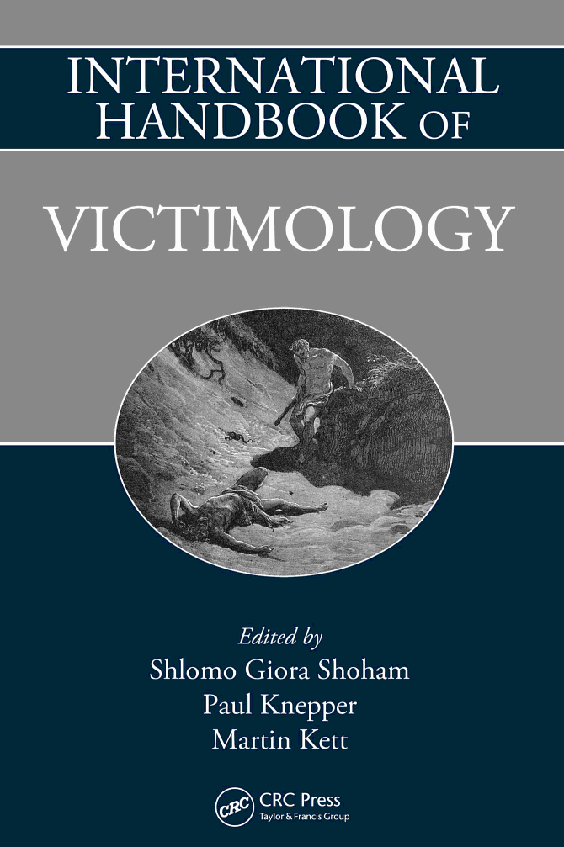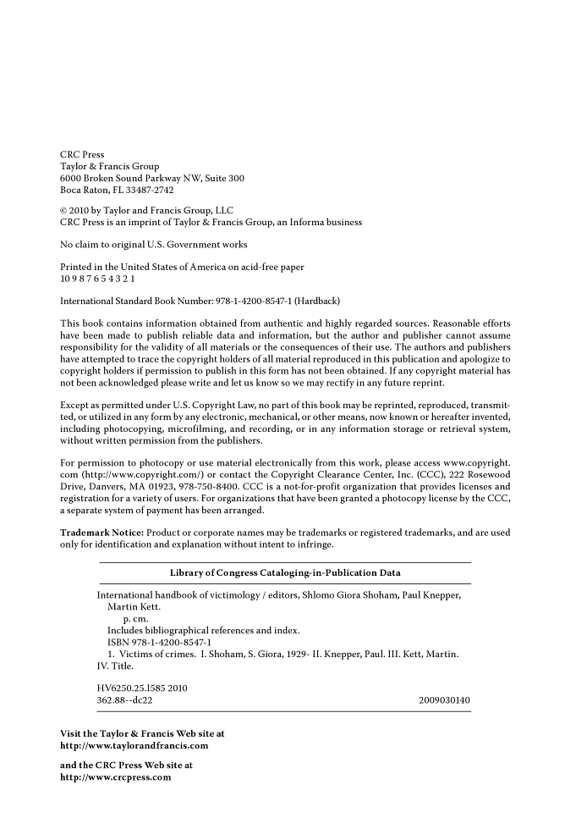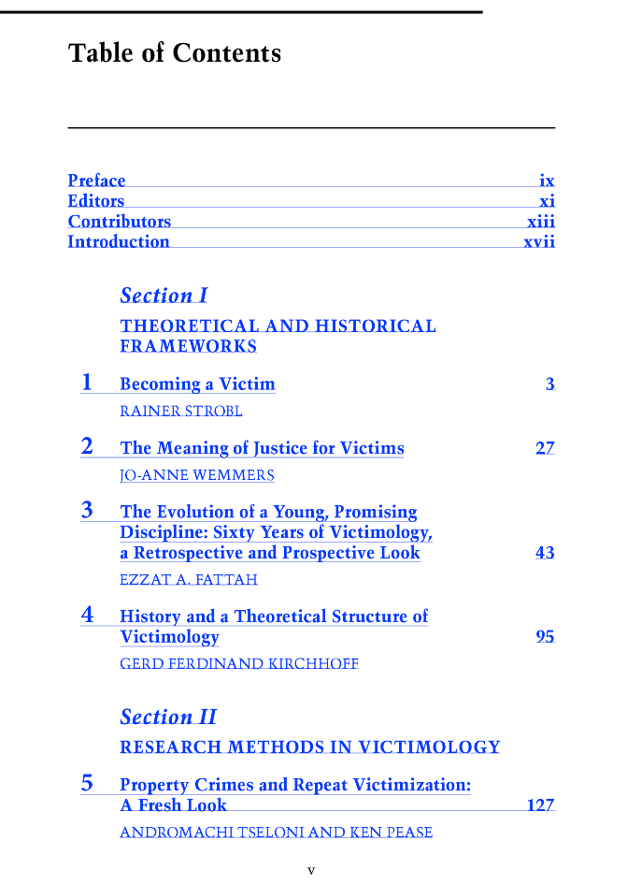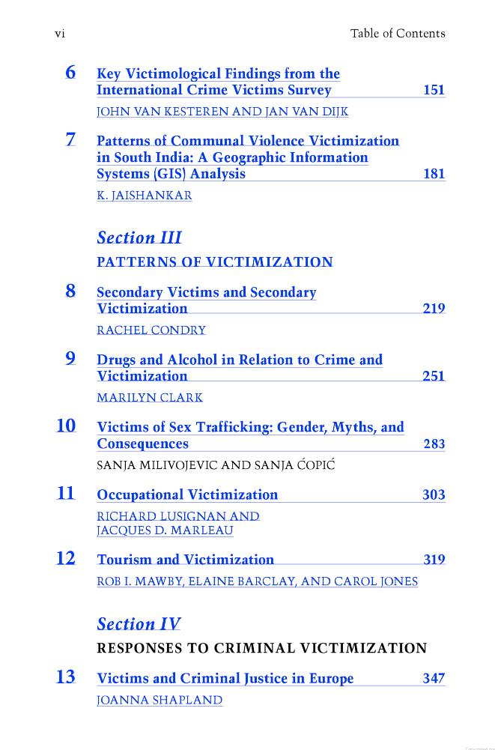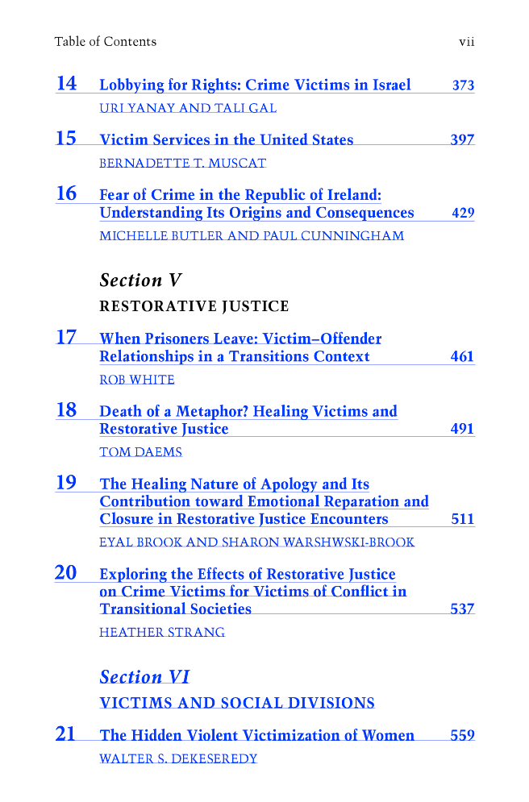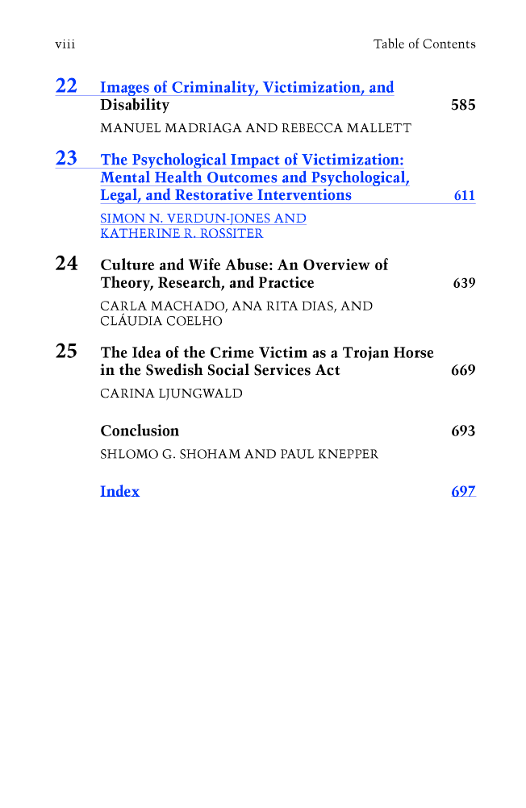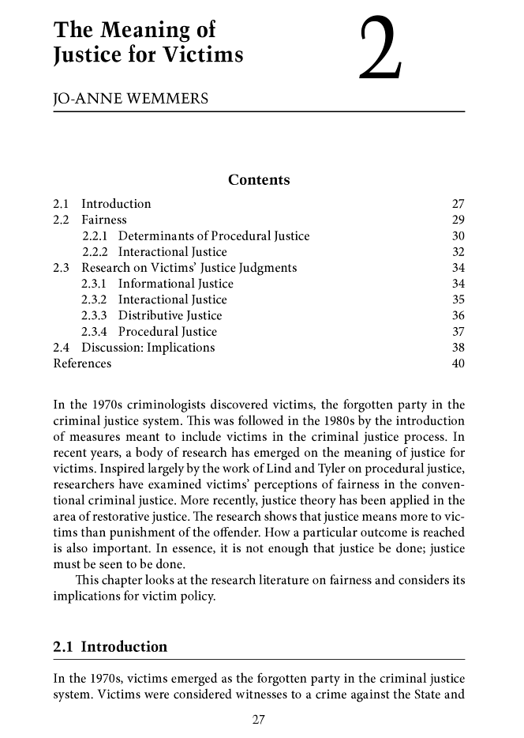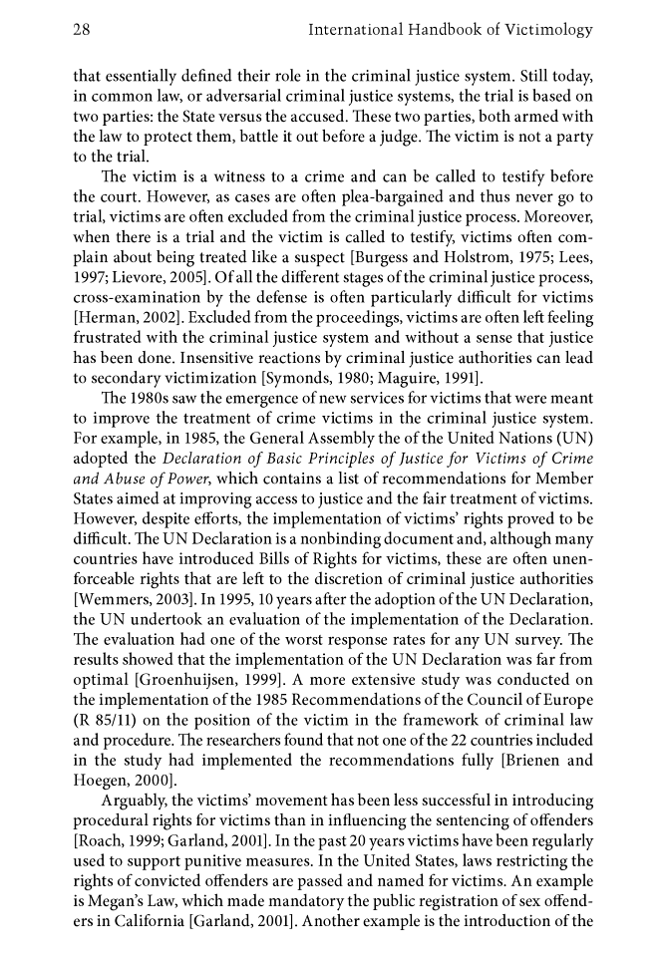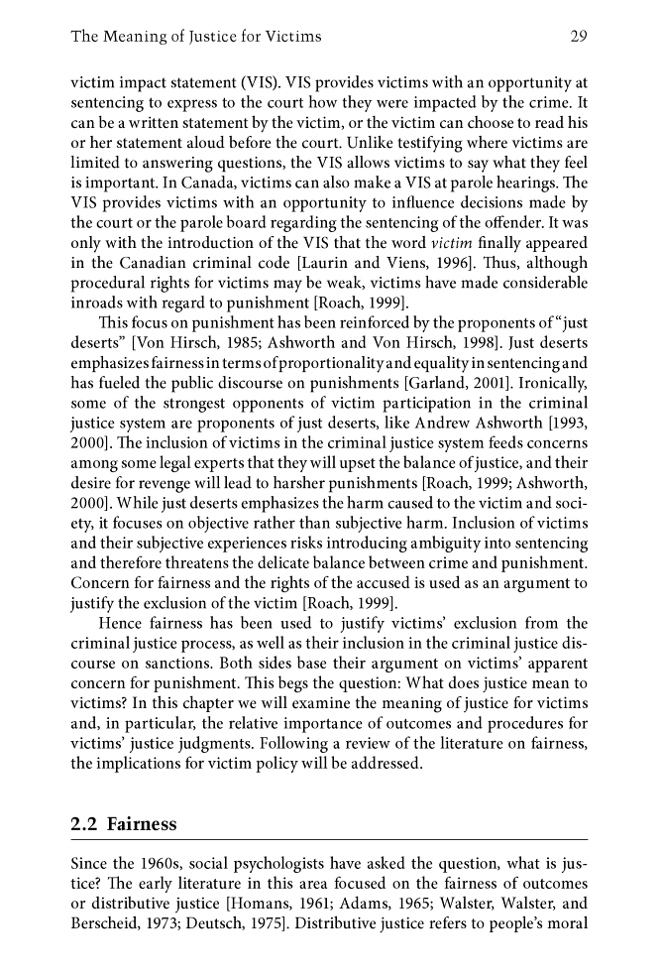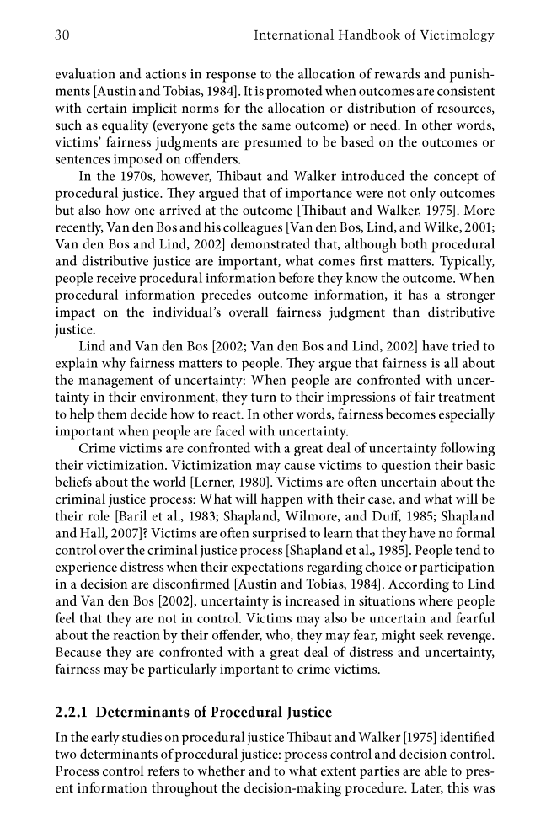

Gregory Capobianco, FN 97.1

FN 97.1: See R. A. Duff, Alternatives to Punishment - or Alternative Punishment?, in Retributivism and its Critics 44 (Wesley Cragg ed., 1992) (arguing that restorative justice processes do not offer alternatives to punishment but rather alternative forms of punishments);

Comment: This Article begins on page 43, not page 44. There is nothing particularly unique on page 44 to make me think that the Author meant for this to be a pin cite, especially considering the title of the essay itself directly supports the parenthetical.

Source Information:

URL: http://books.google.com/books?id=ucDoaXqO5vMC&printsec=frontcover

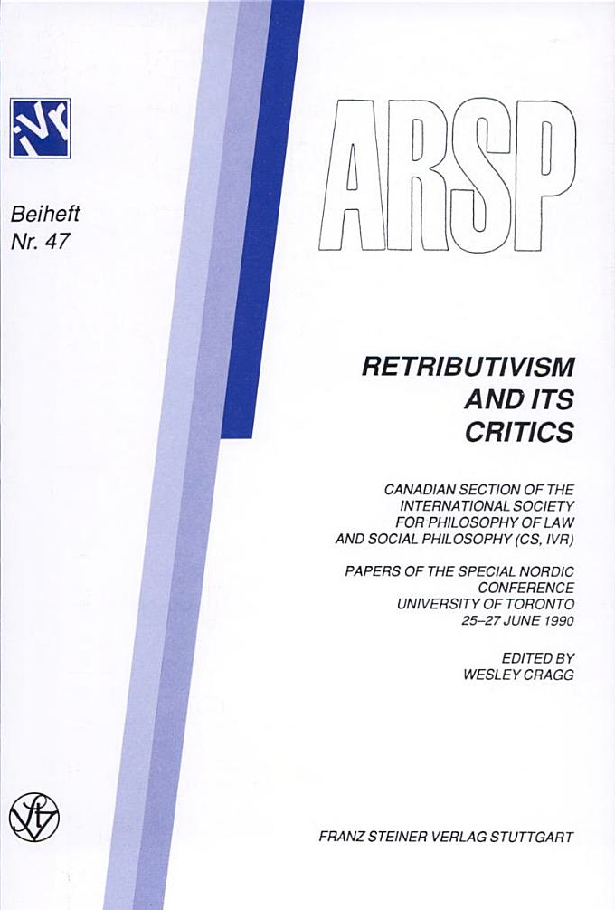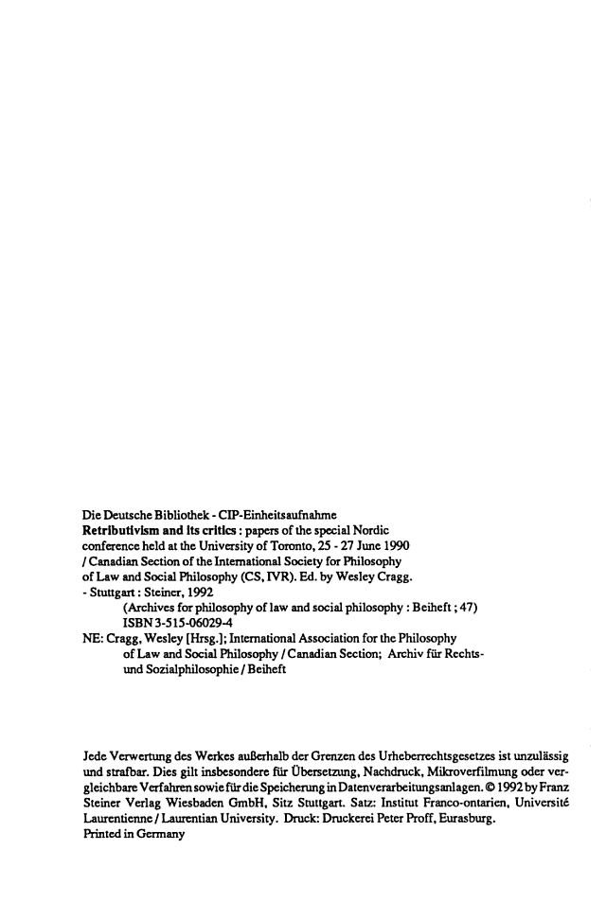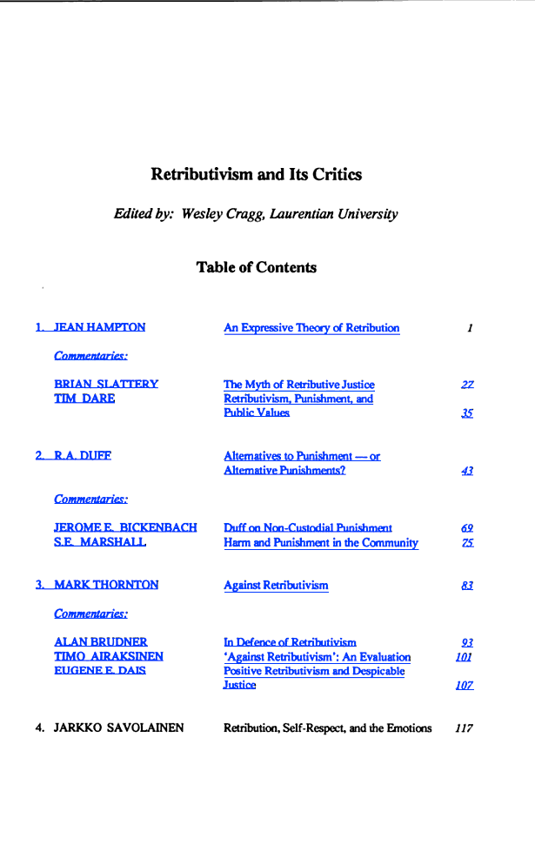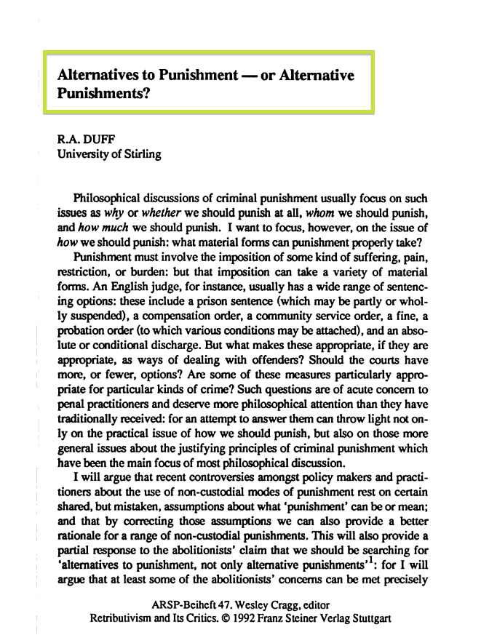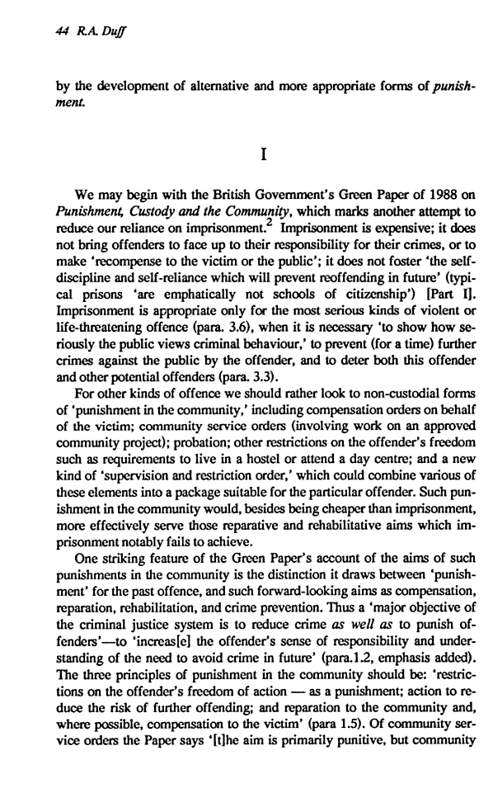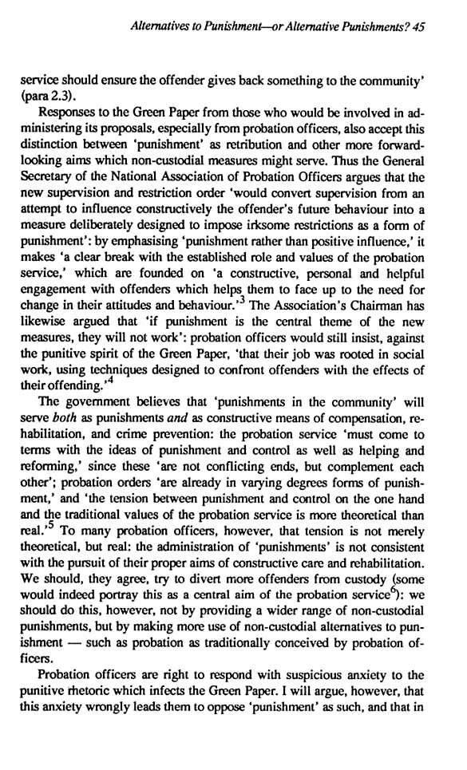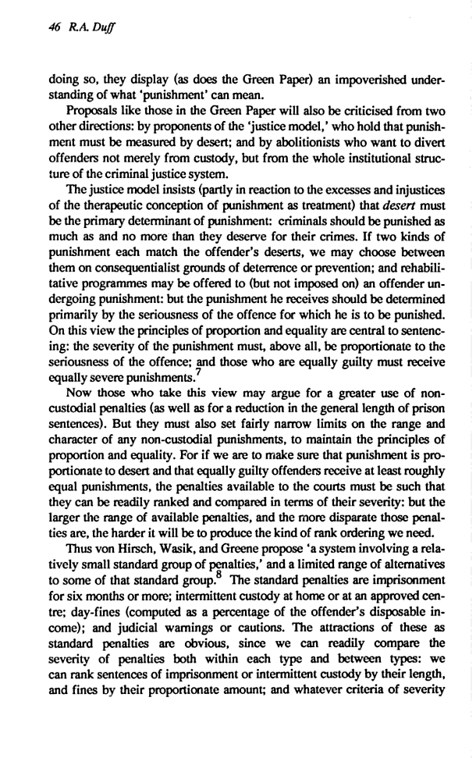

Gregory Capobianco, FN 97.2

FN 97.2: Luna, supra note 18, at 295, 299 (arguing that successful restorative justice processes may lead to agreed-upon resolutions that represent the participants’ varying interests and punishment ideologies).

Referring To: Erik Luna, Punishment Theory, Holism, and the Procedural Conception of Restorative Justice, 2003 Utah L. Rev. 205, 231 (explaining the differences between restorative justice, which is based on republicanism, and punitive justice, which is based on liberalism).

Source Information:

URL: https://a.next.westlaw.com/Document/I2de8ec314b0911db99a18fc28eb0d9ae/View/FullText.html?transitionType=UniqueDocItem&contextData=(sc.Default)

2003 Utah L. Rev. 205
Utah Law Review
2003
The Theory and Jurisprudence of Restorative Justice
PUNISHMENT THEORY, HOLISM, AND THE PROCEDURAL CONCEPTION OF RESTORATIVE JUSTICE
Erik Luna^{a1}
Copyright (c) 2002 Utah Law Review Society; Erik Luna

*294 that genuine remorse must be felt not imposed, occurring as a result of moral reasoning rather than brute force. “An intention to shame is not respectful,” one expert notes, while “[a]n intention to help a person understand the harm they caused and to support them in taking full responsibility for that harm is respectful.”³⁷⁸
By accepting responsibility for the offense and acknowledging the harm he has caused, the offender shows respect for the victim and his right not to be victimized.³⁷⁹ Genuine remorse also signals the offender's affirmation of the legal norms of a community and his desire to be part of legitimate society. It thereby provides the first step toward incorporating the offender into the community. Finally, genuine remorse is a prerequisite to the moral development of the offender. Without understanding the impropriety of his conduct, he may retain a deviant identity and connection to an antisocial subculture. In contrast, an offender who recognizes the wrongfulness of his behavior and feels sorrow for having violated both the legal norm and the victim is, as an empirical matter, less likely to recidivate.³⁸⁰
Acceptance. A desired response of participants to the offender's remorse is their acceptance of that expression as genuine and meaningful. It is, in fact, the typical reply when an individual demonstrates a state of “perfect defenselessness”³⁸¹ by admitting his wrongdoing and communicating sincere, sorrowful regret.³⁸² The acceptance of his genuine remorse demonstrates respect for the offender by validating his emotions and recognizing him as an individual capable of taking responsibility for misconduct. But acceptance also serves the victim's emotional well-being.³⁸³ It empowers the victim by placing him in a position of control, even for a split-second, and allows him to release some of the pent-up anger and pain resulting from the crime.
Planning. After the “core sequence”³⁸⁴ of remorse and acceptance, participants in a successful process will create a plan that meets the needs of all *295 involved--for instance, providing the offender his “just deserts,” making amends to the victim, satisfying the community's desire for security and value affirmation, and addressing the factors that contributed to the crime and the obstacles the offender will face in becoming a law-abiding citizen. When achieved through open input and group deliberation, the planning stage gives participants an ownership interest in the end result. To the extent that offenders feel that they participated in the process and that the outcome was appropriate, they are more likely to follow through with the plan. And to the extent that victims believe that the plan embodies a just outcome, they are more likely to feel better about themselves, the offender, and the sanctioning process. In sum, an appropriate plan will be respected by all participants and will harmonize their various interests and punishment ideologies.
Facilitation. The final stage holds the key to attaining the process goals of the procedural conception of restorative justice. Success at all previous stages will be for naught unless the offender receives the necessary support to fulfill the charted plan. Many offenders will lack the means to satisfy their sanctioning obligations without the assistance of family members, supporters, and welfare professionals. If a contributing factor to criminal behavior was a dysfunctional family life, psychological disorders, or substance abuse, the offender may need relevant treatment and counseling. If the core issue is a lack of self-worth or job opportunities, the offender may require skills training and gainful employment.³⁸⁵ And to the extent that deviant conduct is related to peer pressure or insufficient role modeling, the offender may need positive mentoring and opportunities to become involved with prosocial peer groups. In addition to providing the means to achieve the sanctioning plan, facilitation will require supporters to follow-up on the offender's progress and to help him in overcoming unforeseen obstacles.
2. An Example of the Procedural Conception
Given this framework, it seems only natural to ask whether any currently existing approach to punishment might be consistent with the procedural conception of restorative justice. One possibility is New Zealand's Family Group Conference (FGC).³⁸⁶ The FGC is at the heart of a revolutionary piece of legislation, the Children, Young Persons and Their Families Act of 1989. This statute was a response to a number of serious complaints about the treatment of juvenile offenders in the New Zealand justice system. Experts, politicians, and the public had become disillusioned with six decades of paternalistic welfare *296 legislation that was seen as unjust, expensive, and largely ineffective at preventing youth crime.
In particular, there was a widely held notion that state paternalism had done more harm than good for the families and support networks that are vital to child development. The heavy emphasis on institutionalizing juvenile offenders had two negative results: removing children from their families (and the accompanying emotional bonds) and exacerbating juvenile crime by placing offenders in a custodial setting conducive to the criminogenic influence of delinquent peer pressure. The process also precluded involvement or input from the victims of youth crime and community members affected by criminal activity, while the Maori community³⁸⁷expressed concerns that the existing approach was wholly foreign to its traditional values and destructive of kinship networks essential to its culture. Finally, there was a perception that offenders received more or less than the deserved punishment for their crime, often correlating with troublesome factors such as race and socioeconomic status.
In attempting to address these concerns, the Children, Young Persons and Their Families Act incorporated six principles into the new approach to youth justice:
(1) Under the Act, juvenile offenders were to be held accountable by giving them the opportunity to take personal responsibility for their conduct and make amends for the resulting harm.
(2) The Act recognized that entanglement in the criminal justice system was intrinsically harmful to the juvenile, while institutionalization tended to increase the chances of recidivism. The legislation therefore emphasized the use of diversionary tactics before employing the formal machinery of the court system.
(3) The Act placed family and kinship networks at the center of the process. Toward this end, family participation was emphasized in deciding the appropriate course for addressing criminal behavior as well as providing social services to assist the juvenile and his family in reaching positive goals.
(4) The Act expressly integrated the victim into the decisionmaking process, making him a central participant in any deliberations and ensuring that his needs are sufficiently considered.
(5) The Act acknowledged the reality of New Zealand as a highly diverse society grounded in different ethnic and racial traditions. Cultural appropriateness and sensitivity were important goals, ensuring that Maori values and kinship structures could be incorporated into the sanctioning process.
*297 (6) The Act recognized that the previous approach, like the adult criminal justice system, was adversarial in nature and guaranteed that any outcomes would have both winners and losers. It therefore sought consensus decisionmaking as the primary procedure, where juveniles, family members, victims, and law enforcement would arrive at suitable resolutions through mediated discourse.
Given these guiding principles, the Act created three tracks for dealing with a juvenile once his crime was uncovered. Under the first track, the police officer may issue a warning to the juvenile or use some other type of informal diversionary strategy. Typically, this means an immediate warning on the street or an admonition in the presence of the juvenile's parents. The officer might also require an apology to the victim or some type of community service. The second track applies when law enforcement expresses an intent to charge the juvenile for his offense but, in consultation with a “youth justice coordinator,” agrees to convene a family group conference in lieu of bringing formal charges. The final track is where the police are satisfied that the requirements for arrest have been met and the juvenile is, in fact, arrested. The offender will be brought before a youth court judge and, if the charge is not denied, a family group conference will be held. A conference will also be ordered prior to the pronouncement of sentence if the charge is substantiated in a court hearing. So except for informal police warnings or diversion, an acquittal by court hearing, or charges of certain serious crimes such as murder and manslaughter, the family group conference is the prescribed means of addressing youth crime in New Zealand.
The chief organizer and facilitator of the FGC is the aforementioned youth justice coordinator. This individual is responsible for consulting with the juvenile, his family, the victim, the police, and other relevant stakeholders to determine the desirability of a family group conference, who should be invited to the FGC, whether the parties and invitees plan to attend, and a suitable time and place to hold the conference. It is also incumbent on the coordinator to ensure that all parties are adequately informed about the necessary background of the offense, how the FGC is likely to proceed, and other information relevant to both voluntary attendance and informed participation.
Although the FGC is an inherently flexible process that can be adjusted to the needs of the parties, it tends to follow a fairly standard pattern. Two leading experts on family group conferencing, Gabrielle Maxwell and Allison Morris, suggest that the process generally involves the following:
• introductions of the parties and participants
• an explanation of the procedure by the youth justice coordinator
• the presentation of a factual summary of the offense by the police
• an opportunity for the offender to comment on the accuracy of the police statement
*298 • an opportunity for the victim or his representative to express his view if the offender admits the offense
• a general discussion of possible outcomes
• a discussion of options among the offender's family
• the formulation of a plan, response, or outcome by the offender's family
• general negotiation among the parties and participants
• agreement from the enforcement agency and victim
• recording the agreed plan and closure of the meeting³⁸⁸
This general FGC process is necessarily subject to variation and, as noted by researchers and youth justice coordinators, no two conferences are alike. Nonetheless, there are two mandatory ingredients to successful completion of a conference: The juvenile must not deny responsibility for the offense, and all parties must consent to the FGC plan. If either of these conditions are not met, the juvenile's case typically will be referred to the youth court. Although not a statutory requirement, the success of a conference agreement is also dependent on the youth justice coordinator's follow-up, ensuring that the agreed restitution is being made, that the necessary services are provided the juvenile, and that all other details in the plan are being met.
In theory, at least, family group conferencing adopts a more holistic process than the traditional approaches to juvenile justice and seems roughly compatible with the procedural conception of restorative justice. Consistent with holism, the FGC recognizes that crime is not an atomized event existing within a vacuum but instead an interconnected whole that occurs against a specific background and with consequences that extend into the future. The process thus emphasizes the concrete over the abstract, allowing the stakeholders to discuss the field of causation preceding the offense and its rippling impact on particular persons and collectives. Moreover, each stakeholder is allowed to voice his opinion on the causes of crime and the justification for punishment, thereby explicitly providing for individual perspective in the process.
The FGC structure also incorporates the elements of a successful resolution under the procedural conception of restorative justice, beginning with an environment of respect for the participants. The FGC is an inclusive process, offering victims and other stakeholders a forum to express the harms caused by the crime, the concerns they have with the offender, and their ideas for an appropriate resolution. The process also allows the participation of family members and supporters of the most vulnerable parties--the juvenile offender and the victim. Moreover, the participation of all parties is strictly voluntary; even the offender has the option of refusing to attend the FGC. Although juveniles almost *299 invariably do attend their conferences, the mere fact that the option exists is a sign of respect toward the offender.
Unlike the procedural rigidity of traditional approaches to youth crime, the FGC vests substantial latitude in the participants to shape the process into a form most amenable to their needs and the problem at hand. A conference need not occur in a government facility, for instance, or during business hours; instead, the conference can be held in a private home, at a marae³⁸⁹ or church, and at a time and date most convenient to all parties involved. Process control is also vested in the key participants--the victim and the offender--by permitting them to choose supporters to join them during the conference. Likewise, the FGC is premised on free discourse among participants, allowing an opportunity to air their thoughts and emotions. Most importantly, each participant can express his own vision of justice, whether it be retributive, utilitarian, or restorative (conceived substantively). Through the flow of undominated dialogue, the participants tend to gain respect and understanding for one another as well as a sense of ownership in the process. Although each stakeholder may maintain allegiance to a particular punishment theory, the mere act of respectful dialogue and deliberation can result in an overlapping consensus on an appropriate resolution in a given case despite philosophical disagreements. In other words, each party can exit the process satisfied that their perspective on punishment has been vindicated without requiring a collective agreement on the superiority of one theory or another.
In addition to incorporating the basic elements of the procedural conception of restorative justice, the FGC presents a process that would seem to inspire the aforementioned stages of successful sanctioning. The inclusive, informal, and dialogic nature of a conference tends to produce constructive censuring of the offense rather than destructive condemnation or disintegrative shaming of the offender. The focus of censure is the wrongfulness of the crime and the harm to the victim and community, with the offense, rather than the offender, placed in the symbolic center of discussion. The presence of the juvenile's family and supporters gives the process credence while ensuring that his positive identities--as a son, a brother, a soccer player, or a student--are reinforced by the presence and words of those who care most about the young person.
The inclusive, dialogic aspect of constructive censuring also provides benefits to other participants. Family members can air their concerns and the painful emotions that have accompanied the juvenile's conduct, express their hopes and fears for the young person's future, and convey the empathy and sorrow they feel for the victim. Community members and law enforcement can openly discuss the larger effects of the offense and the rationale for its criminalization, thereby validating both the values of the community and the limits of individual behavior. Moreover, the constructive censuring of the FGC *300 reaffirms the victim's right not to be victimized, providing a cathartic experience for the victim through an unambiguous denouncement of the offense coupled with the opportunity to voice the pain he has suffered.
Given the emphasis on constructive rather than destructive censuring, the FGC tends to generate remorse on the part of the juvenile offender and, as a result, acceptance by the participants of that heartfelt expression. Two factors contribute to the young offender's feelings of genuine remorse. First, the presence of the victim and his articulation of the harm he has suffered frustrate an offender's attempt to neutralize the offense. The juvenile cannot simply rationalize the crime as being minor or harmless when a real person stands in front of him describing the physical and emotional pain directly flowing from his behavior. Second, the presence of the young person's family, their personal condemnation of the offense, and the visible signs of anguish felt by family members confronted by the harm caused by their own kin all provide exceptionally powerful signals to the juvenile on the wrongfulness of his conduct. Once the young offender communicates genuine remorse, it is only natural that participants accept that expression as sincere and meaningful. The completion of the core sequence of remorse and acceptance creates an environment of respect in the FGC--an offender's respect for the victim by his genuine statement of remorse and validation of the right not to be victimized, and a victim's respect for the offender as an individual capable of feeling positive emotions and taking responsibility for his actions.
The final stages in a successful sanctioning process, planning and facilitation, are also incorporated into the family group conference. The discussion of possible outcomes among the participants empowers the offender, the victim, family members, and supporters by giving them a voice in the planning stage, while the process of negotiation aims at forging a satisfactory resolution through reasonable discourse. When participants feel that their opinions and ideas were recognized and respected, they become vested with an ownership interest in the outcome and its fulfillment. If the victim believes that the sanctioning plan offers a just resolution, he will leave the FGC feeling better about himself, the juvenile, family and community members, and the agreement reached with his consent. And to the extent that the young offender feels that he participated in the discussion and that the resulting plan was fair, the more likely he will complete his obligations under the agreement and, hopefully, avoid future offending.
The follow-up after the FGC is vital to the plan's success, of course, though the conference itself offers the first step toward facilitating the agreement. The same individuals that surround the juvenile in an ethic of care during the FGC--his family and supporters--also offer the best parties to ensure that the young offender follows through with his responsibilities while helping him to overcome unforseen obstacles along the way. The youth justice coordinator, community members, and sometimes even the victim can provide means of completing his obligations under the sanctioning plan, receiving medical and *301

